The Last Leaf

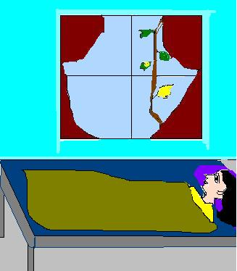

There lived two young artists, Sue and Johnsy, in old Greenwich Village. It had become a colony of poor artists. Johnsy was from Maine, and Sue was from California. They soon became friends. They shared a room on the top floor of a three –storeyed old building.

In November, pneumonia broke out in the city. Johnsy had an attack of this fatal disease. Sue looked after her well. But Johnsy showed no sign of recovery. Her condition grew worse day by day. The doctor said that she had lost the will to live. He further told that no medicine could revive her till she had a will to live. Sue tried hard to revive her interest in life. She used to sing, draw and whistle in her room but Johnsy did not show any interest. Sue heard Johnsy’s whisper. She was looking outside the window and counting backwards. Sue enquired what she was looking at. Johnsy told her that she was counting the falling leaves of the ivy creeper. She also told Sue that she would die with fall of the last leaf. Sue told her that it was silly of her to associate her life with the falling of leaves. It was autumn and falling of the leaves was a natural phenomenon. But Johnsy was not convinced. She formed a strong belief that she would die with the fall of the last leaf.

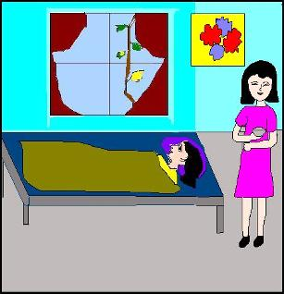

Sue was worried. She did not want her friend to die like that. Sue went to Behrman. He was sixty years old painter who lived on the ground floor of the same building. Behrman had a dream of painting a masterpiece in his life. He never got an opportunity to fulfil his dream. Sue told Behrman about the fancy of Johnsy. She told him how she had associated her life with the falling of leaves. The last leaf was also about to fall.

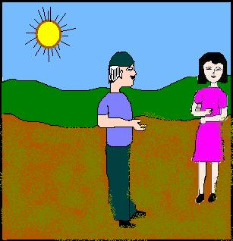

That night it rained heavily and the wind blew very hard. In the morning, Johnsy asked Sue to open the window. Sue was worried but when she opened the window she was relieved to see the last leaf still clinging to the ivy creeper. This changed Johnsy’s belief. She drank soup and combed her hair. Her interest in life had revived. She showed the signs of recovery. The doctor came in the afternoon and declared her out of danger. He told them that Behrman was also suffering from pneumonia.

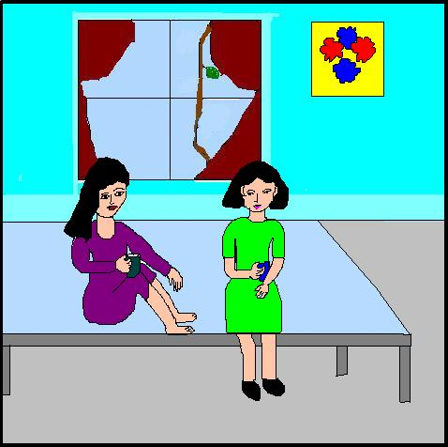

The next day, Sue told Johnsy that Behrman had died of pneumonia. When the real leaf had fallen, Behrman painted a leaf that looked so real that Johnsy could not make out that it was not a real leaf but only a painting. It was a masterpiece.

Behrman had caught pneumonia while painting a leaf on the wall in snow, rain and cold. He was taken to the hospital. But he died there. Sue told Johnsy under what circumstance he caught pneumonia. Thus to save Johnsy’s life Behrman gave his own life. He had always wanted to paint his masterpiece. The last leaf was his masterpiece because it saved Johnsy’s life.