The Happy Prince

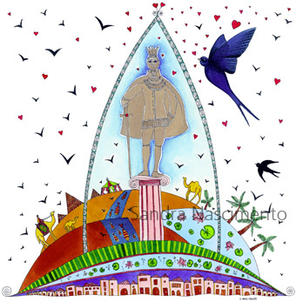
One night a little swallow flew over the city where a beautiful statue stood. The swallow’s friends had gone away to Egypt six weeks before, but he had not because he was in love with the most beautiful reed. The other swallows had told him that his love was ridiculous because the reed had no money and too many relations, and she was always flirting with the wind.
While he was flying he saw the statue. It was covered by thin leaves of fine gold; for eyes he had two sapphires and a large red ruby glowed on his sword. When the prince whom the statue was made after was alive he did not know what tears were - he lived in a palace where sorrow was not allowed. The court used to call him the Happy Prince, and when he died the Town Councilors decided to build the statue, which was set up so high that he could see everything.
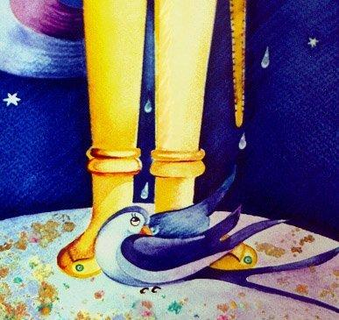
The swallow decided to sleep on the statue’s feet, but just when he was putting his head under his wings, he felt a drop of water, and then another. When he looked up he realized that the Happy Prince was crying because he could see the misery and ugliness of his own city. So the Happy Prince asked the swallow to be his messenger. Through a small window the Happy Prince could see a very poor seamstress who was embroidering passion flowers on a satin grown, and he could also see her ill boy. They had no food to eat, so the Happy Prince told the swallow to take out the ruby from his sword and give it to them.
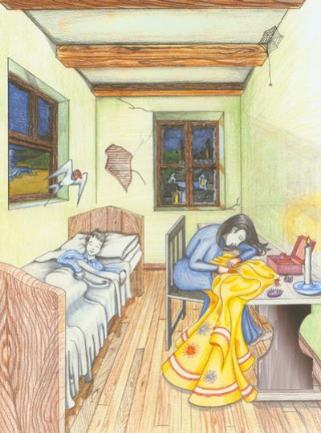

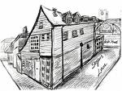
The following night the Happy Prince saw a man in a cold garret trying to finish a play, but he was too cold to write, so the Happy Prince asked the swallow to take out a sapphire from his eyes and give it to him in order to buy wood.
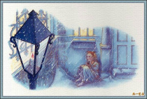
The following day, he saw a match-girl whose matches had fallen in the gutter, whose father would hit her if she did not bring home some money. In order to help her, the Happy Prince asked the swallow to pluck the sapphire from his other eye to give to the girl. As a result of this action he became blind and the swallow had to fly over the city in order to tell him what he had seen. He saw two children crying of hunger and a lot of poverty, so the Happy Prince decided to take out all the golden leaves so as to give them to the poor children.
At last the swallow realized that he would die because of the cold winter, and he decided to stay with the Happy Prince. The Prince asked the swallow to kiss his lips as he loved him. At that moment a crack sounded inside the statue and a young man, happy and healthy, came out of it. The swallow’s kiss broke the spell. Immediately the young prince and the swallow returned to the palace and punished the Town Councilors and the Mayor. After that he lived happily with his citizens and his loyal friend - the swallow.


