Romanian architecture
in the 19th century
Ion Mincu
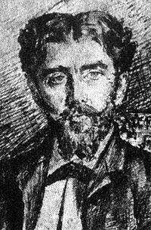

Ion Mincu (born December 20 1852, Focsani - died December 6, 1912,) was an architect, engineer, professor and deputy Romanian. Promoter of a Romanian-style architecture, known as neo-Romanian architecture, Mincu specific integrated into his works of traditional architecture in Romania.

He promoted a Romanian style in architecture, by integrating in his works the specific style of traditional Romanian architecture. As a recognition to his importance in the Romanian school of architecture, since 1953, the Ion Mincu University of Architecture and Urbanism in Bucharest bears his name.

He was the teacher of Toma T. Socolescu, another remarkable Romanian architect.

From 1895 to 1899 he was member of the Parliament of Romania.

Biography

- 1863 - 1871 - studies at Unirea Highschool, in Focsani
.
- 1871 - 1875 - studies at the National School of roads and bridges, in Bucharest, becoming an ingineer.
- 1877 - 1884 - continues his studies in Paris, at "École des Beaux-Arts", becoming an architect.
- 1883 - is awarded by the Central Association of the French Architects.
- 1892 - 1912 - teaches architecture and becomes one of the founding members of the Architecture School of the Romanian Architects Association.
- 1903 - 1912 - he is the president of the Romanian Architects Association
- 1895 - 1899 - deputy in the Parliament of Romania

Personal Information:
Full name:Ion Mincu
Nationality: Romanian
Birth place:Focşani
Birthday:20 december 1852
Date of death: 6 december 1912
Place of death:Bucharest

Work
Buildings:Palace of Justice
I hope you will find my project interesting
George

