Our School Routine

Our Academic Hours starts at 8 a.m. but our day’s activities start from 5 a.m. We go to morning p.t. first and then come back to hostels for getting fresh and then we have our breakfast. Our assembly starts at 8.15 and ends at 8.40 a.m. Now it’s time to study in classrooms. Each period is of 35 minutes. We have total 8 periods in a day. So total periods per class is 48 per week. We have six days week. Our break starts at 11 a.m. and is of 15 minutes. We have snacks as biscuits or bananas. After lunch there are four more periods and at 1.35 p.m. our classes are off. Our lunch continues for 1 hour as there are more than 500 students to dine. The boys’ mess and girls’ mess are separate.

All day long we have P.E. lessons as we have to run a lot. For Music, Art, Computer and S.U.P.W. work we have to move here and there. In morning we do p.t. and in evening from 5 p.m. to 6 p.m. we play a lot of games every day.

We have Math lesson every day. The boys love doing Math sums but a few girls can do well in it. We all are scared of our Math teacher as he loses his temper soon. Often he gets irritated if any student gives wrong answer. Our S.U.P.W. teacher gives us handwriting work but our Languages teachers have a lot of lessons to teach so they can’t give us handwriting every day. Sketching and art work are favourite with us and we all love doing artistic work. We run hurriedly towards our Art room when the period comes but gradually in higher classes interest is lessened. We have no literacy lessons. Our Music lesson comes twice a week but in arrangement periods when a teacher is absent our Music Sir takes us to his room. Only a few students are allowed to play musical instruments. We can sing songs and compose music. We participate in cultural programmes. Our school activities come to end late night as after school hours we have remedial teaching everyday and an evening study. For class- X and XII there is a night study in addition. In our Social Science book we have separate part on History. We particularly read about early civilizations. Now history has become more interesting as it is taught by an interactive way. Often we are asked to play roles of kings, British officers, and villagers and so on. It is really fun. As far as foreign language is concerned we read only English as our secondary language. We read story books in English. We have text- books of English that are full of pictures and stories. If someone asks about our wish we would say that all periods should be of Art, Music, Computer and P.E. Our favourite lesson is English as we are taught interesting stories by our teacher.

We have many footballs to play with and those footballs are issued by our P.T. teacher. But generally boys like playing netball or handball.

We pray in assembly, then at the start of our lessons, in mess during meals.

In our school there is no boy or girl who belongs to Christian religion but a few migrated students from Andhra Pradesh are Christians. For last few Christmas is being celebrated for them in school. But Last year we had winter vacations in December so we could not celebrate it here. Our school is a Government School so every religion is given importance.

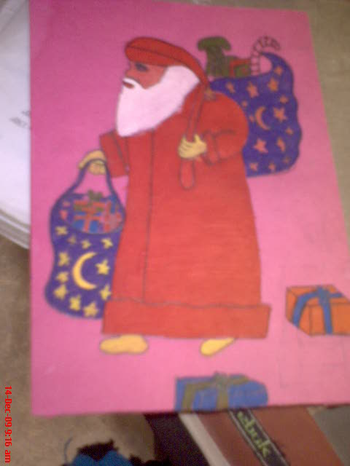

We love preparing Christmas cards and give them to our Christians friends.