Can we do that?

Often I go to nearby village and happen to watch people working in village or fields adjacent to our School. They are so absorbed in their works that I pity them. Still they are earning a little to support their large families.

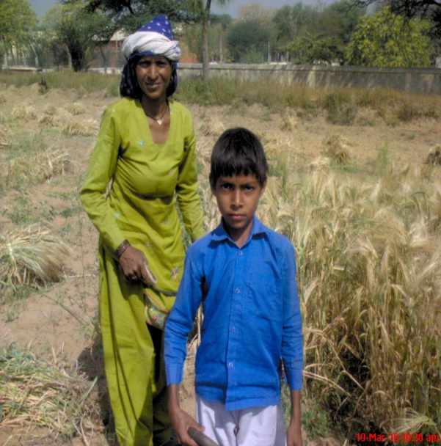

Still they are complacent enough contrary to us! We are ever complaining about petty things. People working in sun, rain, cold, little boys and girls toiling along with their parents. Little fellows are kept for work and not allowed to go school during harvesting days. Many students of my school also belong to farmers’ families but their parents never compel them to work in fields. Lucky fellows indeed!

I ask a question to myself, if I would be in their place how I could have done such laborious tasks. Definitely I would have also learnt to work hard like them. Now all this physical labour seems impossible to us. We sitting like educated, refined fellows in our cool classrooms will not like to engage ourselves in menial tasks anybody would tend to think like this about us but it is not so. Whenever the time calls upon us we are ever ready to deliver the beat to our limited capacities. We do all works and are capable to do them. Indeed living away from busy city life we are learning something valuable and of paramount importance.