What I observe..

After a long stay in School campus we are free to go home in the month of May. You can see the students’ faces having a glow inexplicable. Carrying their baggage they seem to be running towards the main gate as if they are newly discharged patients!

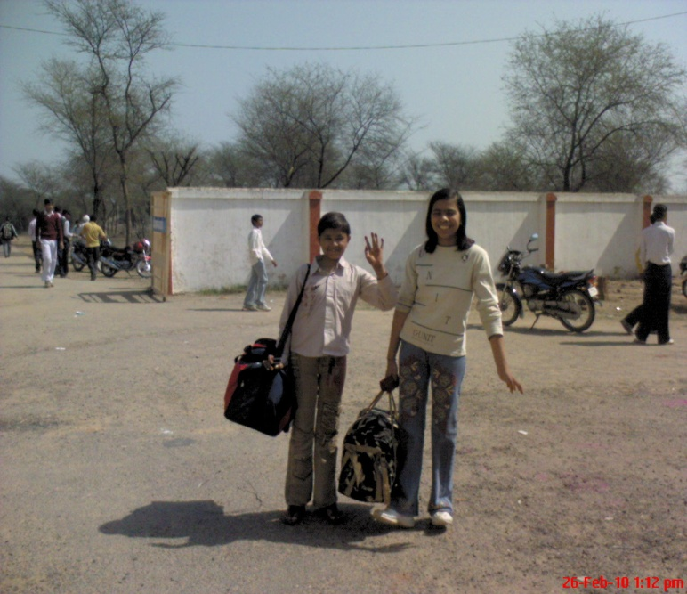

Not only May but every occasion of going home gives pleasure to them. I asked one of the girls if she had no attachment to the place she is living in, she replied with a calm voice that of course she had but parental affection is what she needed the most. The teachers however hard they may try cannot replace our parents. In a few hours the hostels are empty and the last student left feels so miserable that it is quite difficult to console him or her. It seems that he or she is the worst sufferer in this whole world. Smiling faces will bid you farewell! Every heart is throbbing fast in the excitement to going home. Sometimes students even forget to carry away their baggage. We wish each other and hope to reach our homes safely. I am also lost in sweet memories of my home, my mother cook delicious dishes for me; my father brings me sweets, dresses or anything I wish. I am the princess for those all days of my short stay at home. My neighbours coming to know about my well being. One thing I enjoy the most is my uninterrupted watching of my favourite TV shows. My brother dares not disturb me or I would tell my father! But pleasures are short-lived by nature. Vacation passes away too soon! Again drooping faces and grudges. We have to come back no option, parents bring back children dragging! Not even a single student is ever willing to return. Teachers are happy to have us back but obviously we are not! Again the tight schedule to be followed, no privileges, no special care, again spirit of Democracy strongly disliked by us. So our life revolves around our School and home. This is the world we live in, filled with our little pleasures and wishes.- Kirti