Things we feel attached to

It’s not the building of a school that binds the students. A building is merely bricks, stones, plaster, windows and other physical appearances so how can it appeal to a sensitive child. Sometimes buildings are like cages golden that enclose us and separate us from Mother Nature. A child tends to feel more secure in close touch of Nature so do we.

Our campus has nothing so significant to be proud of but surely it is the natural beauty added by tall, sturdy trees, beautiful green fields that bind us.

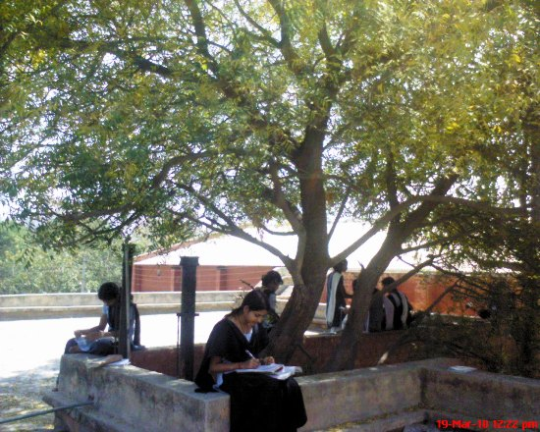

See this wonderful neem tree as old as the building itself. There is no place as soothing as this one under this tree. However hard may we try to learn in our classrooms we cannot concentrate. As soon as we sit under the cool shade of tree we learn and concentrate better. The chatter of monkeys, the dancing peacocks, screeching parrots are added attractions!

We spent full seven years here amidst the animate and inanimate things. Now when we do retrospection we find that the things that had everlasting impact on us were not people but other things related to our surroundings. We will miss this serenity pervading the whole environment in our later life and it would never be replaced by anything.