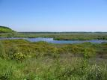
The Nature Reserve Srebarna
By Dzhansu 6 b class

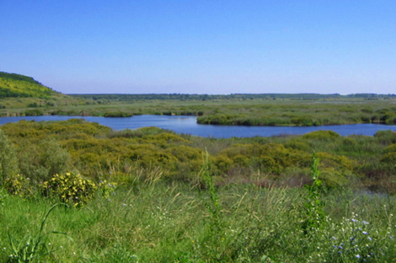
Srebarna is situated in the northeast of Bulgaria, by the river Danube, 18km west of the town of Silistra, near the village of Srebarna. It includes Lake Srebarna and its surroundings. In 1983 Srebarna Nature Reserve was included in the UNESCO World Heritage List. There are 139 plant species, 11 of them are in danger of extinction. There are 41 mammal, 21 reptile, 12 amphibian and 19 fish species that inhabit the reserve. The reserve is famous for 54 bird species that nest on its territory - Dalmatian Pelican, Pygmy Cormorant, Great While Egret, etc.
