Start your school life in Maria Rosa Molas

My school is called Maria Rosa Molas. It is in Zaragoza in Via Ibérica 25. It's easy to get to school and there is a public parking near the school.
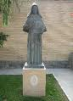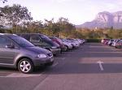
Some important people were students at this school like the football players Angel Lafita or Villarroya. There is a large and beautiful church and an interesting museum of fossils and minerals where you can see a lot of stones of all sizes and colors and some curious fossils.
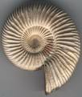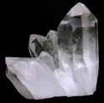

School is characterized by a good level of education and the teaching of human and Catholics values.
I usually leave home at 7.40 and I return at 5.20, but twice a week I come back at one.
In my school we wear a uniform. We wear white polo shirt, grey trousers and a dark blue pull.
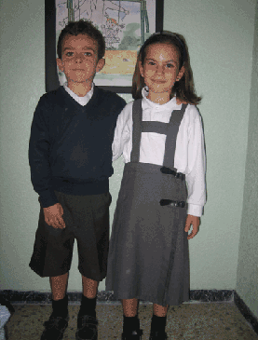
All the subjects are very interesting.
Every day I have lunch at home because I live near my school.
After school, I do my homework at 6 o´clock every day. Twice a week I play football. On Friday evenings I have English classes at home at 4 o´clock. About 9 o´clock I have dinner. Then I read a book and watch TV. At 10.30 I go to bed.
