My grandmother´s natillas

Ingredients : (for 6 people)

_500 ml milk _1/2pod vanilla
_6 egg yolks _some orange zest
_130g sugar _some cookies

Instructions:

1. Mix egg yolks and sugar well together in a large rounded bowl

2. Heat milk with vanilla and orange zest. Let it cool

3. When milk is not too hot, pour it over eggs and sugar mixture stirring all the time.

4. Pass this mixture through a sieve

5. Return mixture to the pan and heat it very slowly, stirring until it thickens.

6. Pour the “natillas” into small bowls and put a cookie over each one

Other information:

Recipe adapted from _ Wild food from Land and Sea by Marco Pierre White.
Ebury Press, London, 1994.
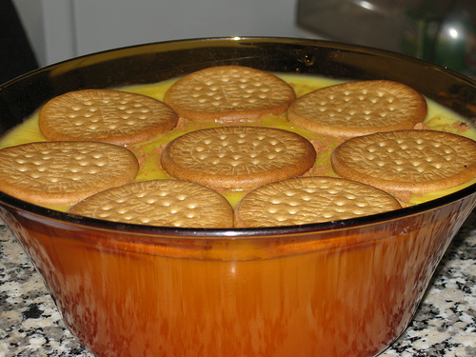

Álvaro Valero Muñoz 3º ESO B

