By José de los Santos Miguel
Spanish Omelette

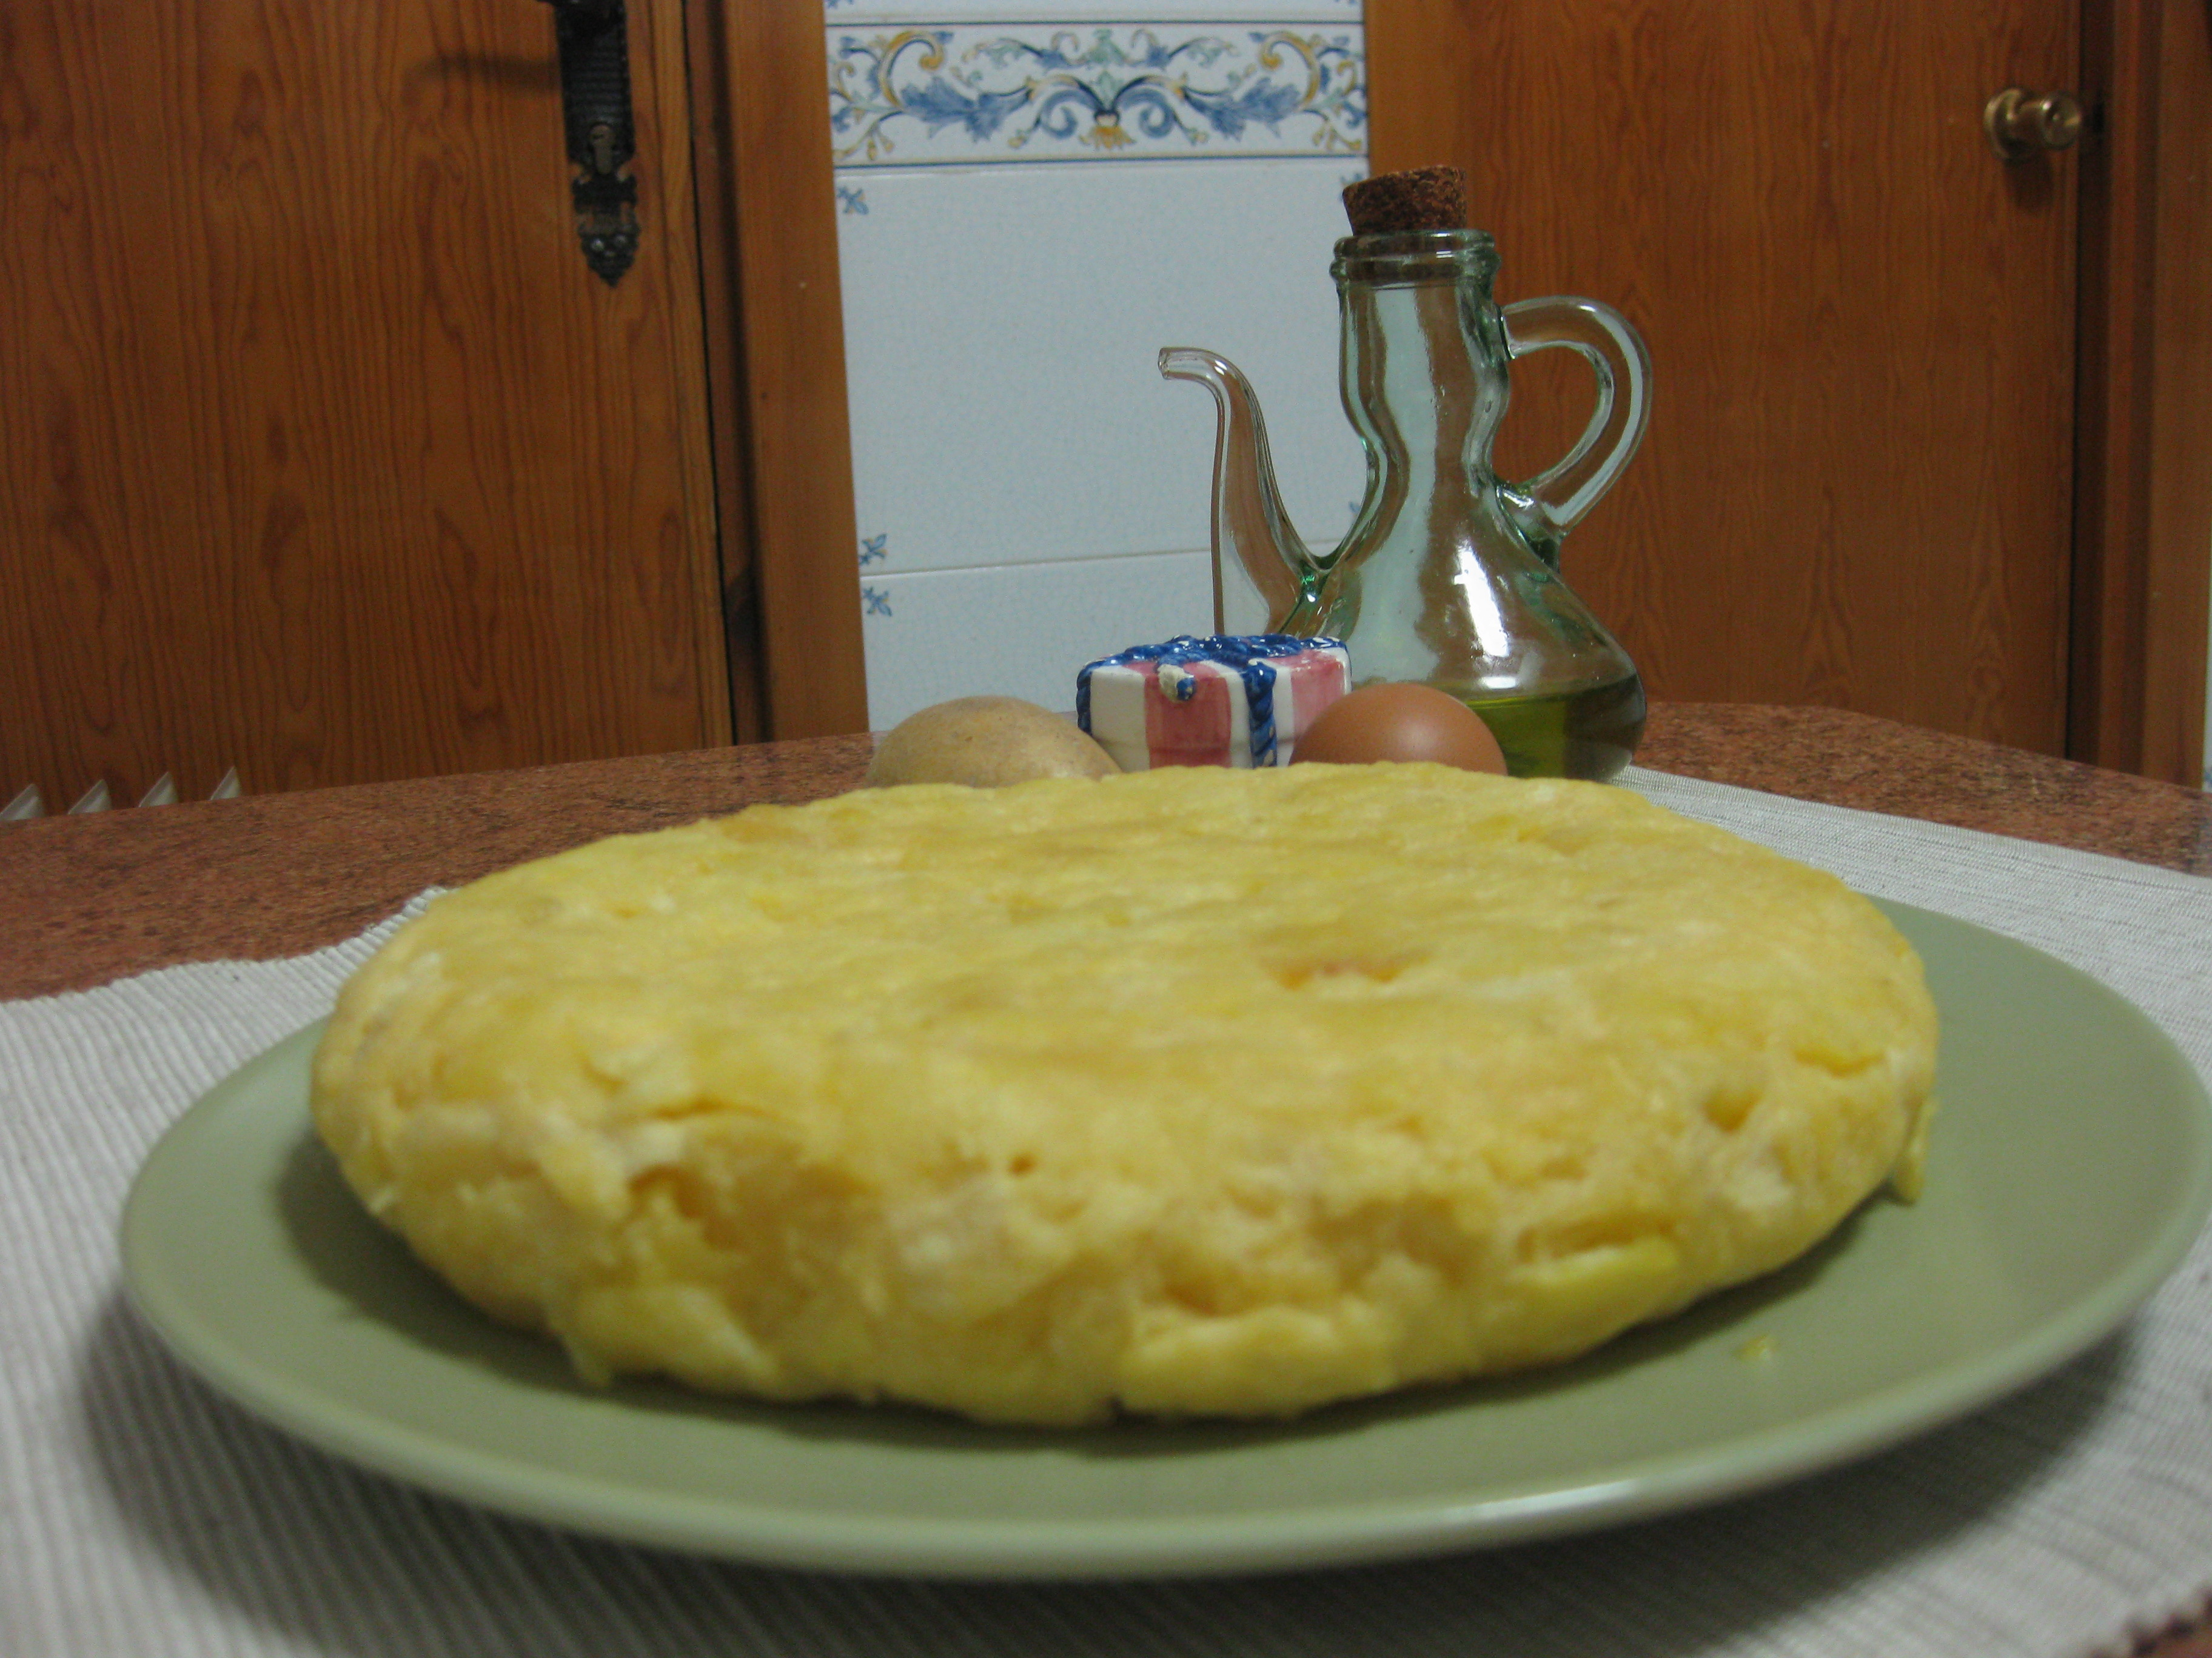
Ingredients:
-One kilo of potatoes
-Six eggs
-Half an onion
-Olive oil
-Salt
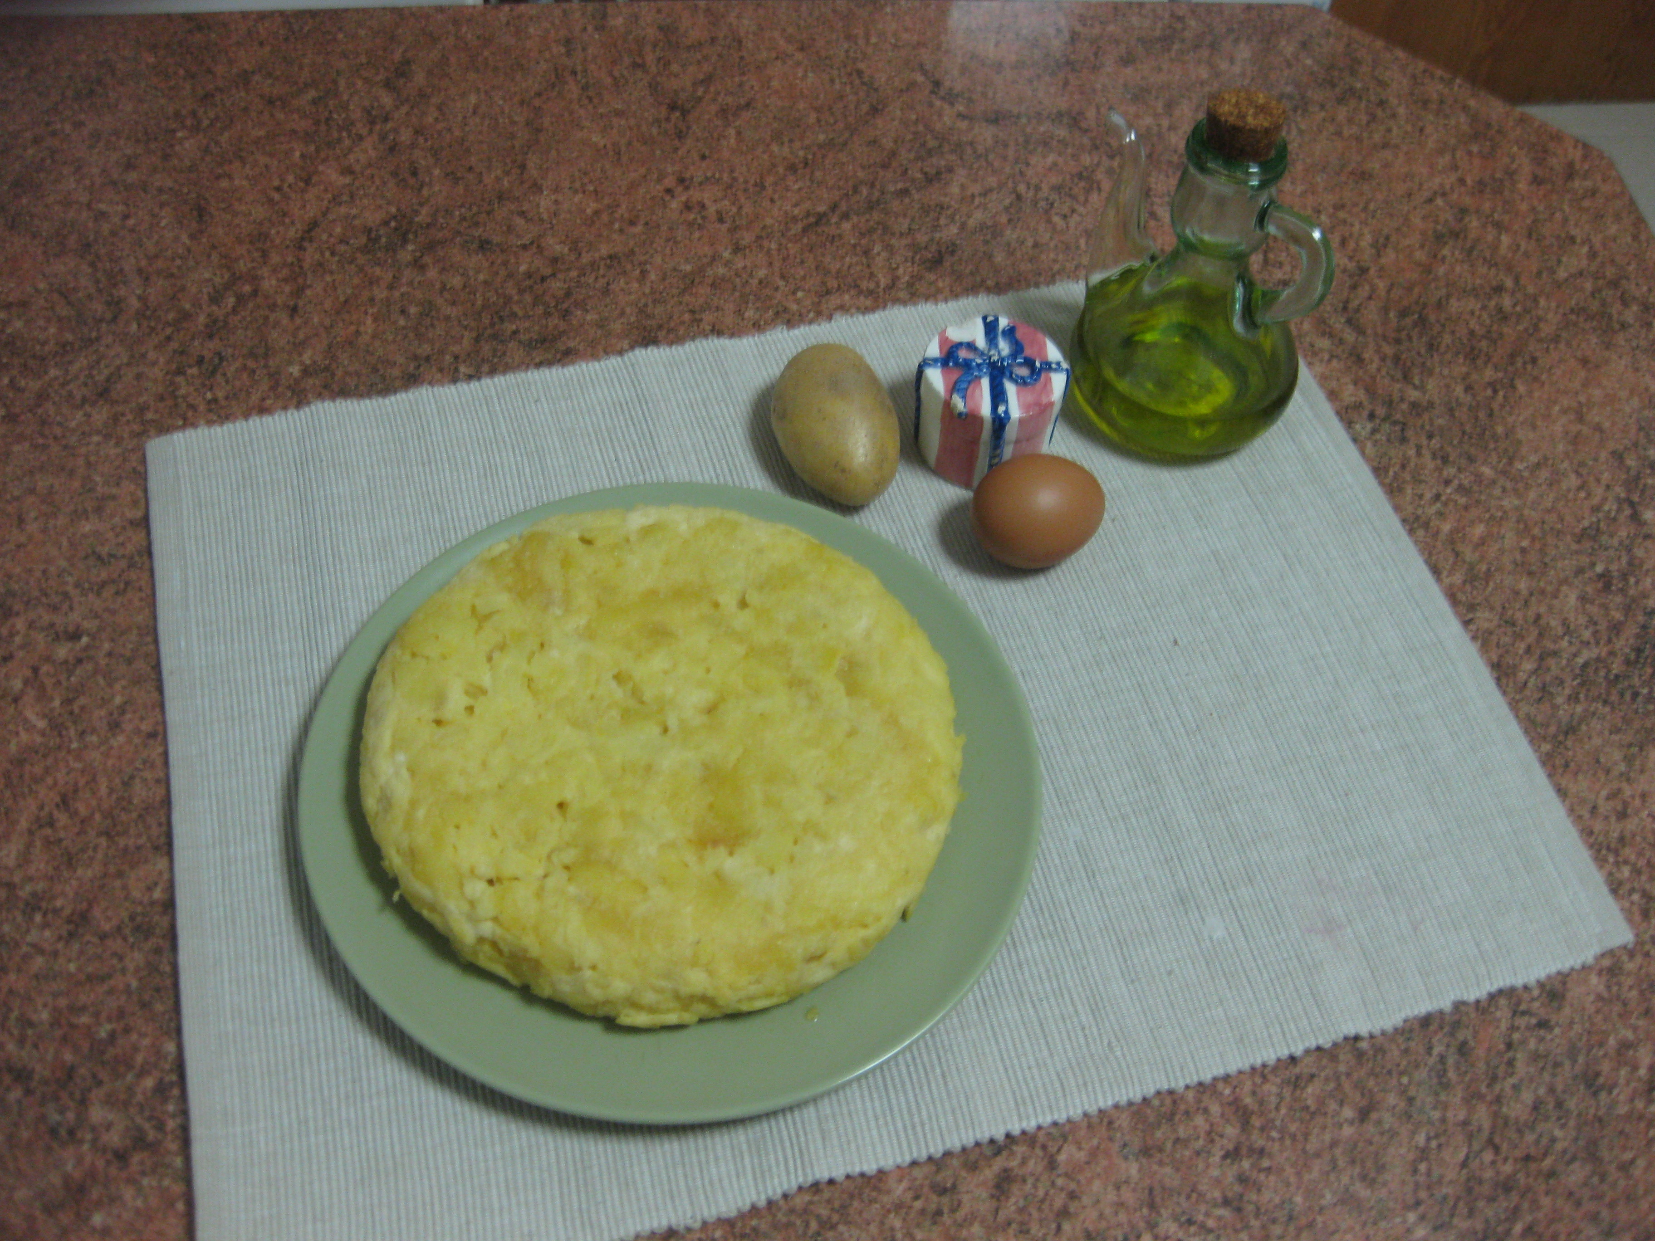

Category: Typical Spanish food
Serving: For 4-5 people
Time: 30-40 minutes
Difficulty: ***
Preparation:
1: First you have to peel the potatoes and them you must wash them.
2: Then, you have to cut them in thin slices.
3: You have to put oil in the frying pan and heat it. While heating oil cuts the onion into slices.
4: Then put the potatoes and onion in the frying pan and add salt. Cook at low temperature.
5: You cook it for 20 minutes and stir it several times.
6: Put the eggs in a bowl and whisk them very well. Add the fried potatoes in the bowl and leave a bit of oil in the frying pan.
7: Then check the mixture into the frying pan, we turn it upside down with the help of a dish and the omelette is ready to eat.

