Assignment 1: Who was St. Julie Billiart?
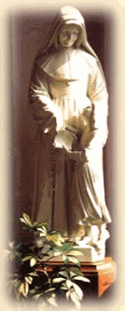
ASSIGNMENT: Follow the link below and read the information under “Who was St. Julie?” and be prepared to answer the questions below.

http://www.notredameonline.org/StJulie.html

Open a separate MS Word document and answer the following questions:
1. Having completed today's short reading, did you learn anything new about St. Julie or the Sisters of Notre Dame?
2. Did anything surprise you?
3. St. Julie was officially declared a saint in 1969. From your knowledge of St. Julie's life, what most stands out in your mind as to why she was declared a saint?

Follow your teacher’s directions to submit your responses.

HOMEWORK:
To continue exploring the life of St. Julie you are to read the comic book-formatted Julie Billiart, foundress of the Sisters of Notre Dame de Namur. This book is found at the same link above. Go to the St. Julie page and scroll down to “St. Julie Project”. Beneath it you will see “Assignments”. There are 5 parts to the comic book—all in .PDF files. You may want to download them onto your computer so that you will not have to be on line all the time you are reading it. If you do not have Adobe Reader, you can download that program free of charge at Adobe.com.
1. Begin reading the comic book.
2. Use the Study Guide that is posted with it to find information that you will need later.
3. Please finish reading the first 2 parts of the comic book by the time you start Assignment 2 and all of the comic book by the time you start Assignment 3.

