Assignment 2: Cuvilly
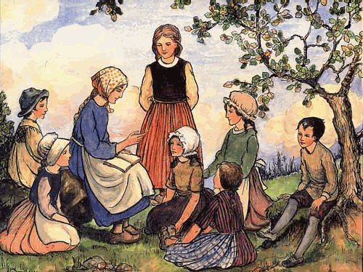

By now you should be well on your way in reading the comic book, Julie Billiart, foundress of the Sisters of Notre Dame de Namur.
Today you will visit three links to explore Cuvilly, France—the town where St. Julie was born. Here are your directions:

ASSIGNMENT:
1. Go to the website at this link: http://www.multimap.com/map/home.cgi?client=public&lang=&advanced=&db=FR
It takes you to a map tool. In the upper left hand corner find the “Search” tool. Type in “Cuvilly” for “Town” and select “France” for country. Click “Find”. Two options will appear. Hold the mouse over each. Click the “Cuvilly, Oise” option. Above the map you will find a tool that will let you zoom out. Zoom out gradually, and explore the area by using the directional arrows at the edges of the map. In a new MS Word document list the towns/cities that you have seen mentioned so far in your reading of the comic book. You should be able to name at least four from your reading of the first two parts of the comic book.
Save your work and go on with this assignment.

2. Go to the website shown below (by right clicking, then click "open link").
http://users.skynet.be/fa772331/pelecuvilly05.htm

3. When you reach the site, scroll down to the end of the first page. On the right you will see a symbol which will enable you to watch a slide show of a celebration which took place in St. Julie's birthplace, Cuvilly, France. Push play. Pay attention to all the pictures. (The symbol for the slide show will be in the bottom right hand corner of each page. Keep clicking your way through the presentation.)

4. Answer the questions below in the same MSWord file where you listed the cities/towns from the map of France.
1. What was your impression of the special event which took place in St. Julie's birthplace, Cuvilly?
2. Why would Sisters go to Cuvilly, France, to celebrate St. Julie? What might it mean to a Sister of Notre Dame to be there?
3. What were your favorite photographs from these events? Copy/paste four pictures into your response and write under each picture the reason why you chose it.

5. Follow your teacher’s directions to submit your work.

Homework: Complete the reading of the St. Julie comic book and the Study Guide that goes with it. Follow your teacher’s directions for submitting your work on the Study Guide.

