Assignment 4: Namur
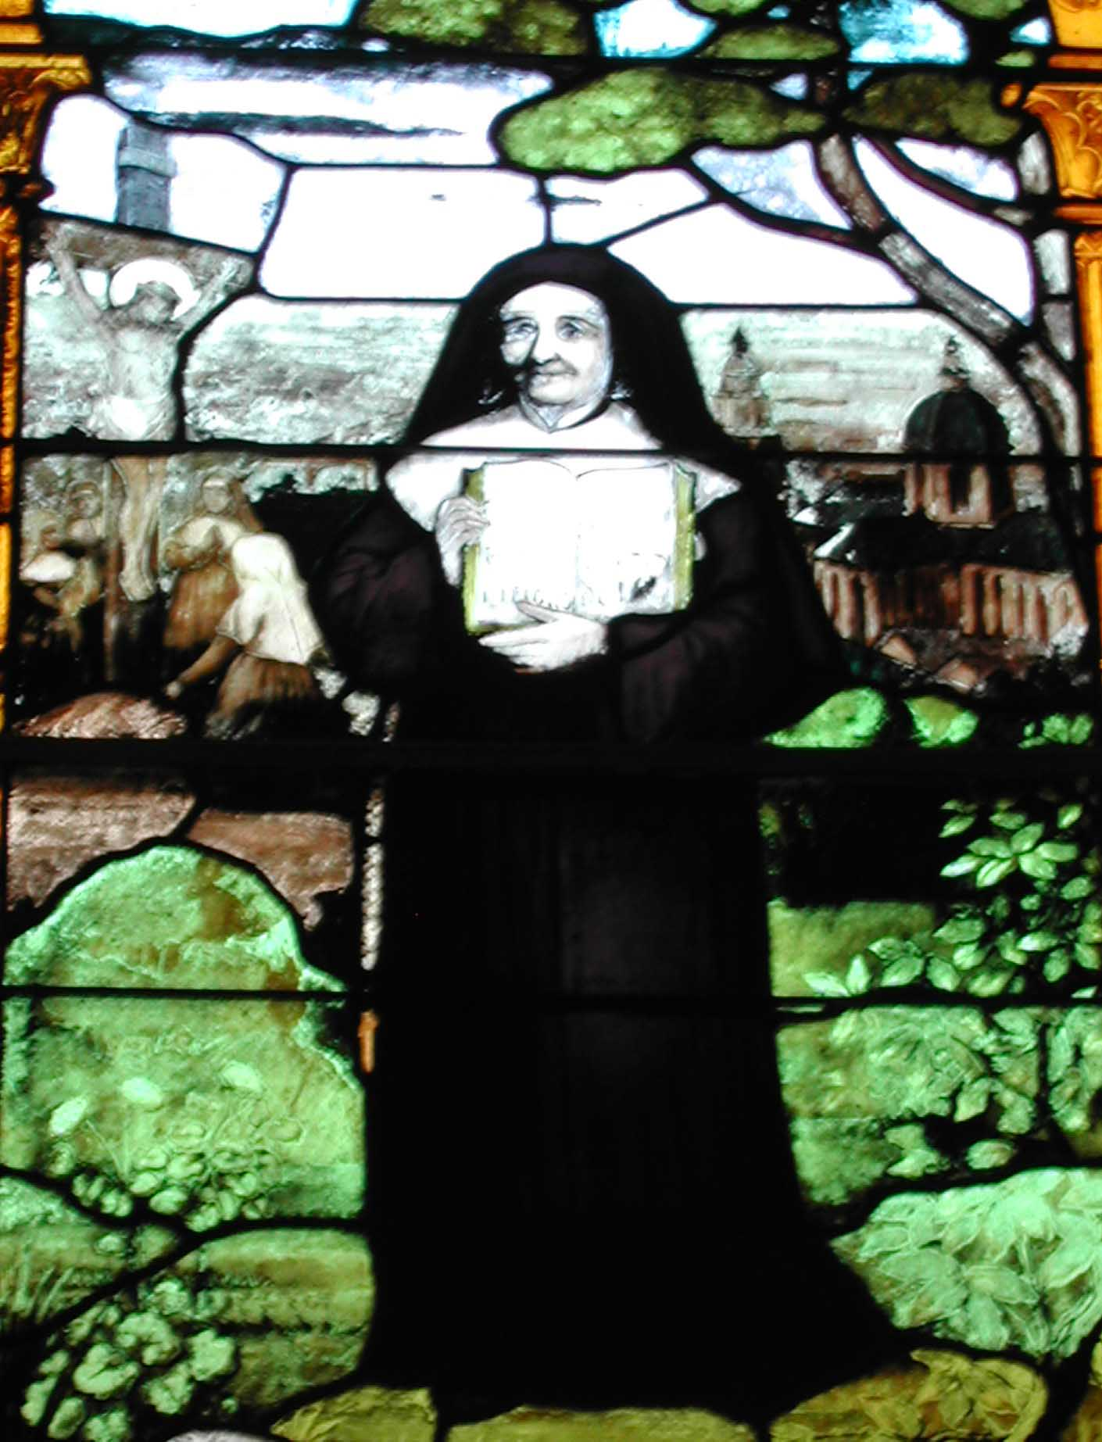
(This window shows St. Julie’s founding vision to the left and the Cathedral in Namur to the right)

Today you will be making a virtual visit to the city of Namur, Belgium.
This is the location where the Sisters of Notre Dame settled their Motherhouse after having been forced to move from Amiens, and so it is the city for which the Sisters are named (Sisters of Notre Dame de Namur). Use your imagination as you spend time at this site: pretend that you are St. Julie as she travels from Amiens and arrives in Namur for the first time.
Bon voyage!

ASSIGNMENT:
1. Click on this link and get directions from 12 Rue Neuve, Amiens, Picardie, France to Rue Julie Billiart, 17 Namur, Belgium:
http://www.mapquest.com/directions
(Hint: you will need to click “international” under “Directions” and choose Europe.)

2. Open a separate MS Word file and answer:
1. How far did St. Julie and the other sisters have to travel to get to Namur?
2. What modes of transportation were available to them?
3. What are your thoughts about what it took for them to move the entire community to Namur in January-March 1809?
(Save your work! You will continue this document.)

3. Go to this link: http://www.trabel.com/namur/namen.htm. You will find the website for Namur, Belgium. Many of the places pictured were in existence during St. Julie's time; explore the website to get a sense of the city of Namur. Be sure to click "monuments" as well as any other links you might see. Find the reference to the Sisters of Notre Dame de Namur and explain it in your MS Word document.

4. Next, visit the site of the current Sisters of Notre Dame school, L'institut Notre Dame at http://www.ndnamur.com/ . Click "Visite Virtuelle" at the he left to view the slide show of the city and school. Also click “Solidarité” on the left and scroll down through the photos.

5. Select four pictures you particularly like - from either the city or the school website. Copy/paste these into your MS Word document. Write at least a sentence for each picture explaining why you selected each picture.

6. Finally write a sentence (or more) stating what you think St. Julie would say about how her work has grown in Namur today.

7. Follow your teacher’s directions to submit your work.

HOMEWORK: Pretend you are preparing to do a documentary on the life of Julie. You have a chance to interview her before you start your work. What questions would you ask her? Who else would you want to talk to? What would you ask them? What do you think is important to include in the documentary? Why are those things important to you? Do an outline of the documentary. This assignment is to be done in MS Word. Follow your teacher’s directions for submitting your work.

