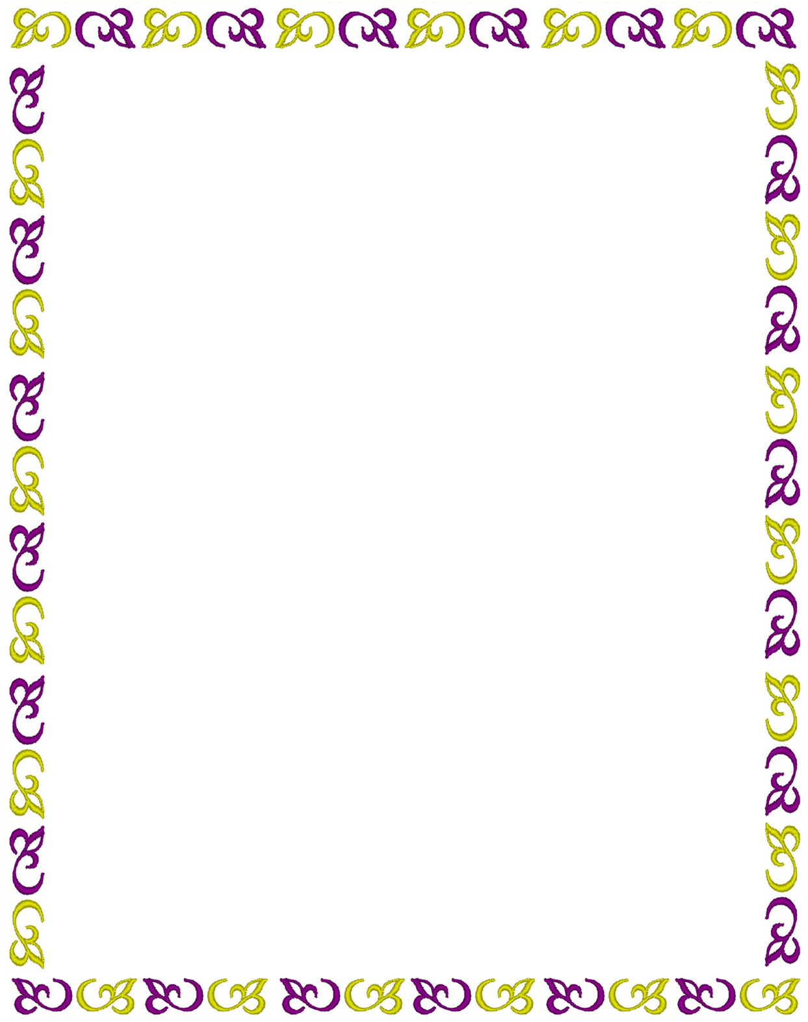
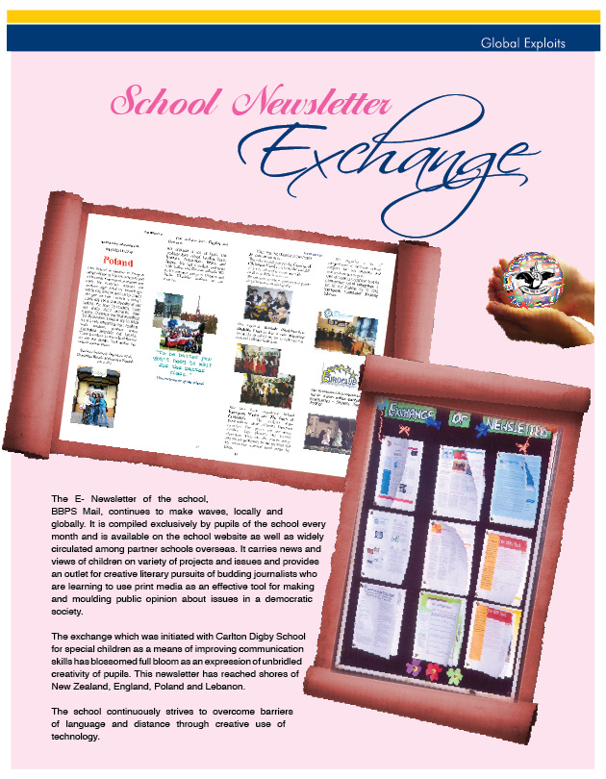

Activity Cover Sheet
Please complete a separate sheet for each activity

Activity number
School Name: | BAL BHARATI PUBLIC SCHOOL, DWARKA
Title of activity: | E- NEWSLETTER EXCHANGE
Teacher responsible: | Ms S. Kakkar, Ms Deepti Sharma, Ms Neerja Marwah and Master Kunal Dhir and Krit Goyal (student editor and reporters)
Other staff involved: | Ms Audrey from Carlton Digby School, Ms Lyn Potter from Marcelin Art College, Kruczek Grażyna from Gymnazium Psary - Poland, Mr Rob Ford from Wooton Basset School UK
Subjects involved: | English, ICT, photography, PSE
Brief details of the aim, content and outcomes of the activity | “The illiterate of the 21st century will not be those who cannot read and write, but those who cannot learn, unlearn, and relearn.”    The E-Newsletter of the school BBPS Mail continues to make waves locally and globally. It is compiled exclusively by pupils of the school on monthly basis. It is available on the school website as well as widely circulated among partner schools overseas. It carries news and views of children on variety of projects and issues. It provides an outlet for creative literary pursuits of budding journalists who are learning to use print media as an effective tool for affecting public opinion about issues in a democratic society.  The exchange which was initiated with Carlton Digby school for special children as a means of improving communication skills has blossomed into a full bloom of expression of unbridled creativity of pupils. This newsletter has reached shores of New Zealand, England, Lebanon and Poland.  Some of the encouraging responses to our newsletter are chronicled below .The school continuously strives to overcome barriers of language and distance through creative use of technology. Virtual interaction and exchange of ideas with peers across the world has proved to be boon for churning of literary pursuits which continue to set new milestone with each issue of BBPS mail.
Countries explored |   India, UK, New Zealand, Australia, Lebanon and Poland
Link school(s) | Carlton Digby School UK, Winterbourne School UK, Baldwin college UK. Marcelin art college NZ, Gimnazium Psary - Poland
Other sources of information | Emails, newsletters received from other schools, personal interaction with international visitors
Time period of activity: | Round the year
Number of students involved in this activity: | Whole school
Age range of students involved: | Class 9 pupils created newspaper which was read by whole school
Type of Evidence included: | - Copies of Newsletter  - E-mails for exchange of newsletters  - Feedback from readers
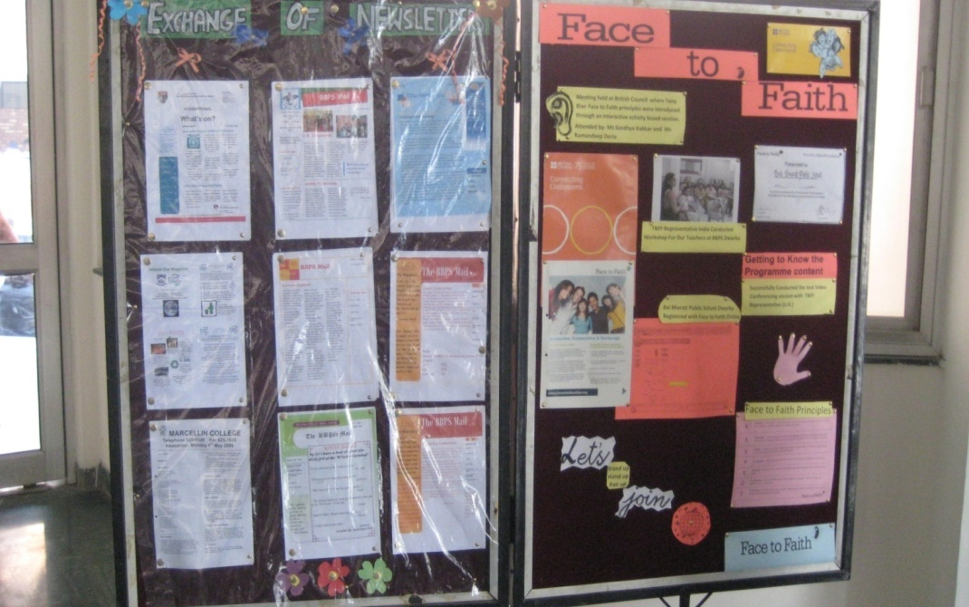
DISPLAY OF
NEWSLETTER EXCHANGE

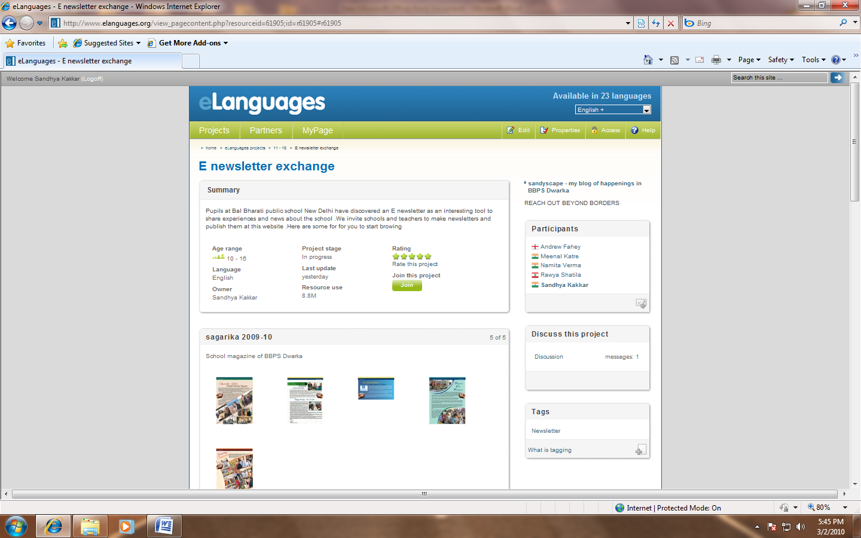

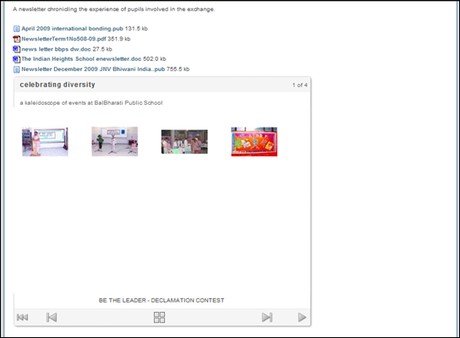

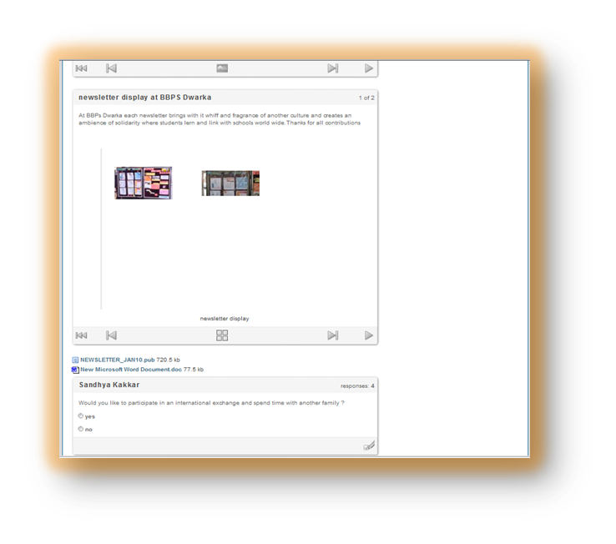

FEEDBACK FROM READERS
The school continuously strives to overcome barriers of language and distance through creative use of technology. Virtual interaction and exchange of ideas with peers across the world as proved to be boon for churning of literary pursuits who continue to set new milestone with each issue of BBPS mail.
