EASTER BREAD RECIPES ACROSS EUROPE
French Easter Bread/Brioche
Ingredients:
- 2 eggs
- 1 cup + 6 Tbsp water
- 1/2 cup butter
- 1 1/2 tsp salt
- 4 Tbsp sugar
- 4 cups bread flour
- 4 Tbsp dry milk
- 2 tsp yeast
Directions
- In a breadmaker, add all ingredients in the order listed and turn to dough with yeast setting.
- After the dough rises, put in a buttered brioche pan, a loaf pan, or any other shape you desire. Let dough rise again.
- Beat one egg with 2 tsp sugar. Brush on top of the loaf. Bake in a preheated oven - 350 degrees, for 15-20 minutes, or until golden brown.
- Note: for the traditional brioche shape, detach a piece of dough equal to about 1/4 the entire dough mass. Roll it into a ball. With your finger, push down the small ball into the center of the larger dough ball (in the brioche pan), making sure you touch the bottom of the pan to seal the two pieces together
Russian Easter Bread/Kulich
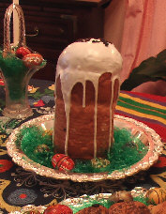
Chef Zoe Sharpe’s Russian Easter Bread/Kulich

Ingredients
- 4 ½ cups bread flour
- 1 ¼ cups milk
- 4 tbsp. butter
- ¼ cup sugar
- 1 tsp. salt
- 1 tbsp. brandy
- 1 tsp. vanilla
- 2 eggs
- ½ cup blanched and slivered almonds
- ½ cup golden raisins
- ½ cup candied fruits dusted with flour
Directions
- Mix ingredients in bread machine, or by hand.
- Allow dough to rise.
- Bake at 350 degrees until beginning to brown.
Polish Easter Bread/Babka
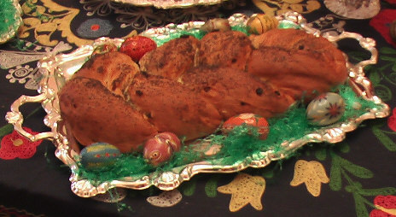
Chef Zoe Sharpe’s Polish Easter Bread/Babka

Ingredients
- 3 eggs plus water to equal 1 1/3 cups
- 4 cups bread flour
- 1 ½ tsp. salt
- ¼ cup sugar
- 1 stick butter
- ¼ cup dried yeast
- 1 cup golden raisins
Directions
- Mix ingredients in bread machine, or by hand.
- Allow dough to rise.
- Bake at 350 degrees until beginning to brown.

Greek Easter Bread/Tsoureki
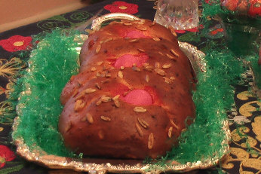
Chef Zoe Sharpe’s Greek Easter Bread/ Troureki

Ingredients
- 1 cup milk
- 4 cups bread flour
- 1 tbsp. yeast
- 2/3 cups sugar
- ½ cup chopped almonds
- 2 tbsp. slivered blanched almonds
- 1 tsp. salt
- zest of half an orange
- 1 tsp. anise seed
- 2 tbsp. olive oil
- 2 eggs
Directions
- Mix ingredients in bread machine, or by hand.
- Allow dough to rise.
- Bake at 350 degrees until beginning to brown.

Portuguese Easter Bread Recipe
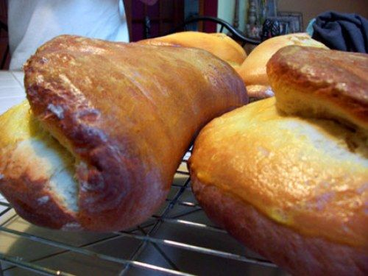

Ingredients
- 1 package active dry yeast (2 1/2 tsp)
- 1/4 cup water, warm (115F, use thermometer!!)
- 1 cup sugar, take out a tablespoon and put it aside
- 1/2 cup peeled, boiled and mashed up potatoes (any type of starchy kind)
- 1 tsp fresh lemon juice
- 1/4 cup milk, warm (110F)
- 1 tsp salt
- 3 large eggs (at room temp)
- 1/4 cup butter (at room temp)
- 4-6 cups all purpose flour (varies)

How to make Portuguese Easter Bread
Easter Bread is a big deal in my house. After losing my grandmother’s recipe, my mom has been unable to replicate the perfect loaves that we would gobble up at all hours of the day. The sweet bread is almost like a Challah, but not as fluffy. It’s a heartier bread that is dense and thick and perfect with a piece of cheese. I started making it last year and was told by my family that the bread was damn near perfect. I gave the recipe to my mom and she made some this year, but it didn’t rise well and she was frustrated. Together we made a new batch that was amazing. You can make your own too!
- In the bowl of a stand mixer place warm water, 1 tablespoon of sugar and the mashed potatoes. Let stand for 5-7 minutes, until bubbly. Add remaining sugar, lemon juice, milk, salt, and eggs (mix one at a time!) and 2 cups of flour, mixing very thoroughly with the paddle attachment of the mixer. Once all mixed up, switch to dough hook and add 1 3/4 cups more flour and butter, cut into small pieces. Mix on low speed until smooth, then add remaining flour a few tablespoons at a time until dough comes away from the sides of the bowl and clings to the dough hook. This could mean almost 6 cups total of flour or 4. I don’t know why (probably humidity and other mysterious things), but I usually make it with 5 and at my mom’s place we only needed 4. It helps also to touch the dough while in the mixer - if it clings to the dough hook and is springy when you touch it, proceed to the next step.
- Place the ball of dough on a lightly floured surface and knead for 3-5 more minutes to ensure smoothness- you want a nice, elastic dough. Place dough in a large bowl that has been oiled (tablespoon of olive oil should do it) and cover with plastic wrap. Let rise until doubled, 2-3 hours in a warm place.
- Turn dough out on a lightly floured surface and knead for a few minutes and divide dough in half. The dough can be shaped into two loaves as desired or shaped into rectangles and placed in two greased loaf pans. Place free form loaves on a parchment-lined (important to use parchment paper) baking sheet. Cover dough with a clean dish towel and let rise for 45 minutes. While waiting, preheat the oven to 350F.
- Brush dough with a mixture of one egg and 2 tablespoons of water for a glossy glaze, if desired. Bake for 35-40 minutes, until golden. Loaves will sound hollow when tapped on the bottom. Cool it completely on a wire rack before slicing. Makes 2 large loaves.

1. Eastern European Egg Twist Recipe
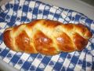© 2009 Barbara Rolek licensed to About.com, Inc.
This rich, eggy, slightly sweet yeast bread exists in almost every culture. Bohemians and Czechs call it hoska, Poles, who call it chalka, adopted it from their Jewish countrymen who refer to it as challah, and on and on. Leftovers make great French toast and bread pudding.

2. Bulgarian Easter Bread Recipe - Kozunak
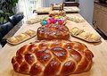
This Bulgarian bread, known as kozunak, is featured at Christmas, Easter and other special occasions. It is an egg-rich braided loaf stuffed with rum-soaked raisins.

3. Croatian Easter Bread Dolls Recipe - Primorski Uskrsne Bebe

Croatian Easter Bread Dolls take center stage on a table all decked out in Easter linens, silver and crystal. Kids love them!

4. Czech Easter Cake Recipe - Velikonocní Bochanek
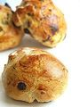© Flickr
This recipe for Czech Easter Cake or velikonoční bochánek (veh-lih-kaw-nawtch-nee baw-khah-nek) is identical to Czech Christmas bread or vanocka except for the shaping.

5. Hungarian Easter Bread Recipe - Fonott Kalacs
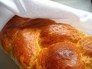
This recipe for Hungarian egg twist or fonott kalacs is a slightly sweet braided loaf with raisins served for Easter, Christmas or any time of year. In general, kalacs (kaw-lahch) refers to any yeast-raised cake or sweet bread.

6. Lithuanian Easter Bread Recipe - Velykos Pyragas
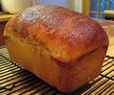
Lithuanian Easter bread is similar to many other Eastern European offerings -- a sweet yeast dough with raisins. It's delicious on Easter morning slathered with butter and a good accompaniment to the hard-cooked colored eggs everyone "clinks" together to see whose egg is the strongest.

7. Polish Babka Recipe - Babka Wielkanocna
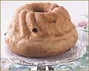
Polish babkas or babas, literally meaning "grandmother," are so named because they are typically baked in a fluted pan resembling an old woman's full skirt or a grandmother's top khot. Half cake and half bread, babkas exist in other Eastern European countries as well. They are completely different in the Jewish tradition, but just as delicious. This Easy Babka Recipe requires only one rise and uses only three eggs as opposed to 15 egg yolks in the traditional version!

8. Romanian Easter Bread Recipe - Cozonac
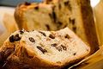Flickr by yujai
Romanian Easter bread is called the Italian panettone of Romania because of its shape and similar texture. Bulgarians serve the same bread but call it kozunak. When Romanian Easter bread dough is filled with farmers cheese, it becomes the delicious pasca, which, in turn, is similar to Polish kolacz.

9. Russian Easter Bread Recipe - Kulich
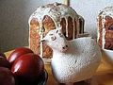
Russian Easter bread takes the form of kulich, a tall, cylindrical sweet yeast-risen bread. On Easter morning, Russian ladies engage in a little good-natured rivalry centering around who has the tallest kulich while waiting for the priest to bless the

