Edmund Hillary
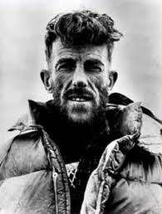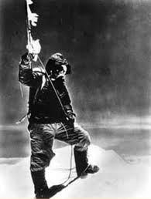
Sir Edmund Percival Hillary (20 July 1919 – 11 January 2008), was a New Zealand mountaineer, explorer and philanthropist. On 29 May 1953 he and Sherpa mountaineer Tenzing Norgay became the first climbers known to have reached the summit of Mount Everest. They were part of the ninth British expedition to Everest.
Hillary became interested in mountaineering while in secondary school, making his first major climb in 1939.
Mountaineering or mountain climbing is the sport, hobby or profession of hiking, skiing, and climbing mountains. Mountaineering began as attempts to reach the highest point of unclimbed mountains. Depending on the chosen route (eg.: over rock, snow or ice), mountaineering it has branched into: rock-craft, snow-craft and skiing. All require experience, athletic ability, and technical knowledge to maintain safety.
The British Everest expedition from 1953, led by John Hunt totalled over 400 people, and like many such expeditions, was a team effort. The expedition set up base camp in March 1953. Hunt named 2 teams for the assault: Tom Bourdillon and Charles Evans; and Hillary and Tenzing. Only Hillary and Tenzing reached the summit.
After reaching the summit, they spent only about 15 minutes there. Hillary took the famous photo of Tenzing posing with his ice-axe, but since Tenzing had never used a camera, Hillary's ascent went unrecorded. Additional photos were taken looking down the mountain in order to re-assure that they had made it to the top and that the ascent was not faked. The two had to take care on the descent after discovering that drifting snow had covered all their tracks.
Hillary reached the South Pole overland in 1958. He would later also travel to the North Pole.
Following his ascent of Everest he devoted much of his life to helping the Sherpa people of Nepal through the Himalayan Trust, which he founded.
Sir Edmund Hillary was the first man to stand at both poles and on the summit of Everest.
By Ioan.

