Thailand - Loy Krathong Festival
Photo Gallery of Loy Krathong Festival.
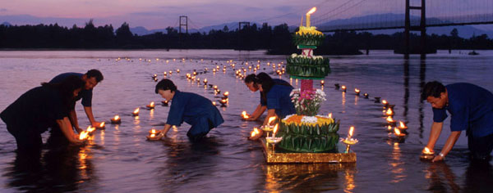

One of the most popular and wonderful festivals in Thailand is this " Loy Krathong Festival ".
It's a Thai traditional event and taken place on the night of full moon in the middle of November (12th month of Thai lunar calendar) every year.
It's held in each area through the country

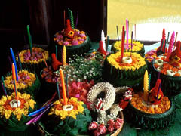

"Loy" means "to float" and "Krathong" is a lotus-shaped boat decorated with banana leaves, flowers, candles, incense sticks and so on.
On the full moon night, when the river is high over the country, people launch their Krathongs on rivers, canals or small ponds to thank to the Goddess of water (Khongkha or Ganga) and put away sins and bad luck.

[Loy Krathong] Krathong
" Krathong " is a lotus-shaped boat decorated with banana leaves, flowers, candles, incense sticks and so on, or in short, " lantern ".
You will see some pictures from a " Krathong Contest " in Bangkok.
(It looks like this kind of contest is held around the period of Loy Krathong Festival. )
In recent days, Krathongs are made from/of natural things such as flowers, potato and wood.
They are too wonderful Krathongs to be launched on a river....
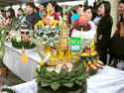 | 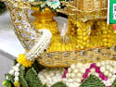 | 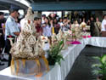 | 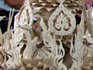
Krathong 1  About The Suphannahongse, see Royal Barges National Museum. |  | Krathong 2
  (Copy of Royal barges, The Suphannahongse) | (Close-up: the white or yellow small pieces are flowers.)
  (Looks like this is a copy of Royal barges, The Suphannahongse, also) | (Close-up: looks this is made of thin wood.)
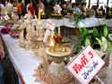 | 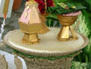 | 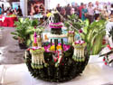 | 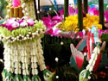
Krathong 3 |  | Krathong 4
  (Looks this is made of wood.  The board right bottom shows the upper number is the entry number of a Krathong and the lower is the team name who made it.) | (Close-up: this is just a decoration...?)
  (Decorated with flowers.) | (Close-up: coloured by Thai flowers.)
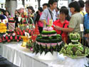 | 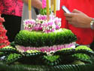 | 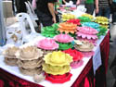 | 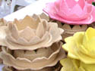
Krathong 5 |  | Krathong 6
  (Made from a lot of banana leaves. This is simple but wonderful.) | (Close-up: decorated with banana leaves and flowers.)
  (Made from Thai potato.) | (Close-up: very simple and gentle to launch on the river against nature.)
Back to top

Back to top

[Loy Krathong] Loy Krathong Song
You can listen to the song of Loy Krathong on the website of Loy Krathong. :)
TAT (http://www.loikrathong.net/)
Thai language | English
วันเพ็ญเดือนสิบสอง น้ำนองเต็มตลิ่ง  เราทั้งหลายชายหญิง  สนุกกันจริง วันลอยกระทง  ลอย ลอยกระทง ลอย ลอยกระทง  ลอยกระทงกันแล้ว  ขอเชิญน้องแก้วออกมารำวง  รำวงวันลอยกระทง รำวงวันลอยกระทง  บุญจะส่งให้เราสุขใจ บุญจะส่งให้เราสุขใจ  วันเพ็ญเดือนสิบสอง น้ำนองเต็มตลิ่ง  เราทั้งหลายชายหญิง  สนุกกันจริง วันลอยกระทง  ลอย ลอยกระทง ลอย ลอยกระทง  ลอยกระทงกันแล้ว  ขอเชิญน้องแก้วออกมารำวง  รำวงวันลอยกระทง รำวงวันลอยกระทง  บุญจะส่งให้เราสุขใจ บุญจะส่งให้เราสุขใจ | November full moon shines,  Loi Krathong, Loi Krathong,  and the water's high  in the river and local klong,  Loi Loi Krathong,  Loi Loi Krathong,  Loi Krathong is here and everybody's full of cheer,  We're together at the klong,  We're together at the klong,  Each one with this krathong,  As we push away we pray,  We can see a better day.

