I think that I shall never see   
a poem lovely as a tree.  
A tree whose hungry mouth is preset  
Against the earth's sweet flowing breast;  
A tree that looks at God all day  
And lifts her leafy arms to pray;  
A tree that may in Summer wear  
A nest of robins in her hair;  
Upon whose bosom snow has lain;  
Who intimately lives with rain.  
Poems are made by fools like me,  
But only God can make a tree.

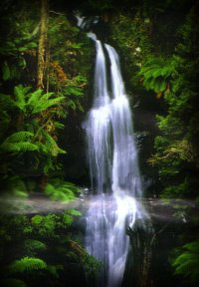

**Plant Species Found in our School Campus**

|  |  |  |  |
| --- | --- | --- | --- |
| **S.No** | **Local Name** | **Latin Name** | **Type** |
| 1 | Mango | *Mangifera indica* | Tree |
| 2 | Sago Palm | *Cycas revoluta* | Tree |
| 3 | Papaya | *Carica Papaya* | Tree |
| 4 | Ashoka | *Saraca indica* | Tree |
| 5 | Golden shower | *Cassia fistula* | Tree |
| 6 | Banyan | *Ficus bengalensis* | Tree |
| 7 | Jamun | *Eugenia jambolana* | Tree |
| 8 | Peepal | *Ficus religiosa* | Tree |
| 9 | Lantana | *Lantana aculeata* | Shrub |
| 10 | Jungle Flame | *Ixora sp.* | Shrub |
| 11 | Shoe Flower | *Hibiscua rosa-sinensis* | Shrub |
| 12 | Brilliant Gardenia | *Gardenis lucida* | Shrub |
| 13 | Poinsettia | *Euphorbia pulcherrima* | Shrub |
| 14 | Tree of sorrow | *Nyctanthes arbor-trists* | Shrub |
| 15 | Heavenly Blue | *Thunbergia grandiflora* | Shrub |
| 16 | Silver Queen | *Agalonema marantifolium* | Shrub |
| 17 | Painted Lady | *Philodendron* | Flowering Plant |
| 18 | Begonia | *Begonia semperflorens* | Flowering Plant |
| 19 | Marigold | *Tagetes erecta* | Flowering Plant |
| 20 | Pansy | *Viola tricolor* | Flowering Plant |
| 22 | Sunflowe | *Helianthus annus* | Flowering Plant |
| 23 | Aster | *Callistephus chinensis* | Flowering Plant |
| 24 | Aeschynanthus | Aeschynanthus marmoratus | Grass |
| 25 | Indian Grass | *Sorghastrum nutans* | Grass |

**Welcome to the Vegetable Garden in the Boy’s Hostel**

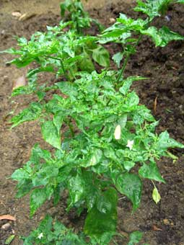 **Common Name**: **Chilli  
  
 Scientific Name**:  ***Capsicum annuum***

**Description:** It is an erect, much branched plant commonly 30-50cm tall with glossy, somewhat elongated heart-shaped leaves. Flowers with white petals occur singly. Fruits are pod-like berries. Immature green fruits turn red or yellow on maturity. Seeds are numerous and borne in compact rows

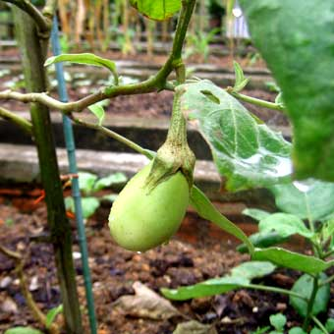 **Common Name:**  Brinjal, Eggplant

**Scientific Name:** *Solanum melongeana L. (Solanaceae)*  
  **Description:**

It is a low-growing bushy annual. The fruit is a smooth, ovoid or elongated, white or purple berry.

**Uses:** The long white variety is popular among the Chinese and eaten cooked as a vegetable or stuffed with minced meat. The egg-shaped dark purple variety is mainly consumed by Indians.

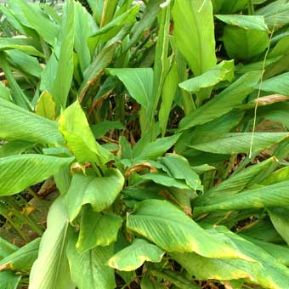 **Common Name**: **Tumeric, Kunyit   
  
 Scientific Name**: ***Curcuma domestica Valeton*  
  
 Description:**   
 This erect perennial has tender erect leaves and ornamental inflorescences. The narrow, freely branched rhizomes are orange in colour and widely cultivated as a spice.

**Uses:**Its peeled and finely grated rhizomes, together with other spices including clove, coriander, cumin, ginger, capsicum and cinnamon constitutes the curry powder.

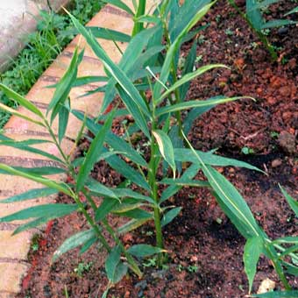 **Common Name**: **Ginger  
  
 Scientific Name**: ***Zingiber offcinale***

**Description:**

This perennial herb has aerial shoots arising from a thick, fleshy, branching rhizome which is the part used. The light green leaf blades are alternate, oblong in shape and strongly pointed. The plant rarely flowers and vegetative propagation is necessary. There are many races differing in shape of foliage and in size of rhizome.

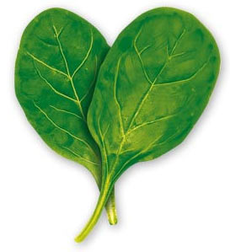

**Common Name**: **Spinach  
  
 Scientific Name**: ***Spinacea oleracea***

**Description:**  
The plants are similar in characteristics, usually having alternate and simple leaves. The inflorescence is cymose, often bracteate, and flowers are small and inconspicuous.

**Uses:**It is thus more nourishing than other green vegetables. It is a valuable part of the diet in anaemia, not only on account of its iron, but also for its chlorophyll. Chlorophyll is known to have a chemical formula remarkably similar to that of haemoglobin, and it is stated that the ingestion of chlorophyll will raise the haemoglobin of the blood without increasing the formed elements.

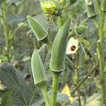 **Common Name**:  **Lady's Finger, Okra   
 Scientific Name**: ***Hibiscus esculentus Linn***

**Description:**  
A coarse, erect, annual up to 2m tall, with a large yellow flower having a maroon eye. The stem is slightly hairy. The leaves are large. The fruit is a pointed and more or less cylindrical. The immature pods are ready for harvest are dark green, covered with upward pointing hairs. It is very mucilaginous and contains numerous round seeds

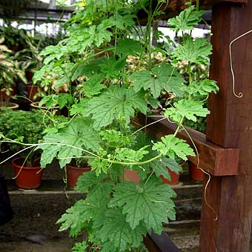**Common Name**: **Bittergourd   
 Scientific Name**: ***Momordica charantia***

**Description:**  
 A slender climbing annual with long stalked leaves. It has solitary male and female flowers, borne on the leave axils. The warty looking fruit is usually oblong and resembles the ordinary cucumber in shape. The fruit is emerald green when yound and turns orange-yellow when ripe.

**Common Name**: Radish **Scientific Name: *Raphanus L.***  
 **Description:**   
 The radish is a cool season, fast-maturing, easy-to-grow vegetable. Garden radishes can be grown wherever there is sun and moist and fertilRadishes have often been dismissed as decoration and garnish. They are actually members of the cruciferous vegetable family so eat the greens. Because they vary in keeping quality, radishes are classified as winter or summer. Summer radishes are the small ones of bold red, pink, purple, white or red and white. They may be globe-shaped or elongated, fiery hot or mild.

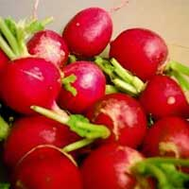

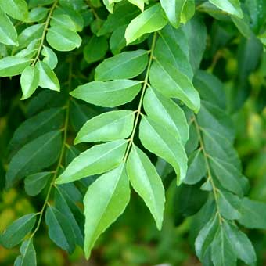 **Common Name**: **Curry Leaf Tree**

**Scientific Name**: ***Murraya koenigii*  
 Description:**

**Murraya koenigii** or Curry-leaf tree, a native of India and Sri Lanka , is a small tree with very pungent aromatic leaves. The leaves are used in curries. This plant comes from the citrus family

Curry leaves are extensively used in Southern India and Sri Lanka (and are absolutely necessary for the authentic flavour), but are also of some importance in Northern India. Together with South Indian immigrants, curry leaves reached Malaysia, South, Africa and Réunion island. Outside the Indian sphere of influence, they are rarely found.

**Medicinal Plants in ‘AYURA’ our Herbal Garden**

1. **Kachnar**: ***Bahunia variegate***

Roots are carminative

Flowers: laxative, reduce obesity

1. **Bhang*:******Cannabis sativa***

Dry leaves: used to prepare painkiller, soporific, antidiarrhoeal

Resin: charas

Dried unfertilized female part: ganja

1. **Reetha: *Sapindus mukorossi***

Natural cleaning agent

Environmental friendly

Keeps shine of garment

1. **Periwinkle**: ***Catharanthus roseus***( Sadabahar)

Compound: Vincristine and Vinblastine

Helps to cure leukemia, Hodgkins disease

1. **Tulsi**: ***Ocimum sanctum*** (Basil)

leaves and seeds: treatment of fever, colic pains, cough and cold,

relieves from effect of poison

1. **Aloe Vera:**

Contains Aloin that helps to heal burns and sores, dandruff,

Stomach disorders

1. **Safed Musli: *Chlorophytum tuberosum***

Roots: used to improve immunity, treatment of arthritis

and physical weakness

1. **Shatavri: *Asparagus racemosus***

Used to treat infertility, stomach ulcer

1. **Amla: *Phyllanthus emblica***

Has Phyllembin which is haematinic and antiemetic

1. **Arjun: *Terminalia arjuna***

Leaf, Root: used as cardiac stimulants and for healing wounds

**Organic Farming**

**Our School believes in organic farming. Pesticides and fertilizers are used only under unavoidable circumstances.** ALDRIN and MALATHION are at times used

**BIOCIDES and MANURE**

1. AZADIRACHTIN Technical from Neem Seed Kernal (30%-45%)purity

Neem based pesticide formulations, from 1,500 ppm to 50,000 ppm with high stability

Neem husk based Bio-fertilisers & Neem cake

Cold pressed neem oil containing 2,000 ppm Azadirachtin

2. Extract from ***Chrysanthemum cinererafolium***

3. Use of Cow Dung to replenish soil nutrients

4. Use of ash in controlling insects and it is also good for soil.

We will try to use hostel organic waste for Composting and Vermiculture.

**Animal Species found in our School**

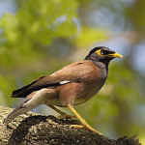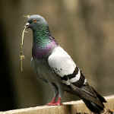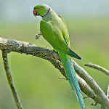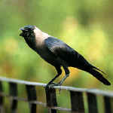

* 1. Scientific name: *Acridotheres tristis*   
  Size: 26cms  
  Description: Vinous-brown body, black head and yellow orbital area. Sexes alike.  
  Habits: Bold and aggressive, noisy. Usually in pairs. Often feeds on the ground and has a varied diet which includes kitchen waste. Roosts communally in great numbers. Nests in abandoned tree holes or buildings.  
  Habitat: Found around human habitation. Open country, farmlands, cities and hills up to 3100m  
  Range: Widespread resident across the country
* 2. Scientific name: *Columba livia*   
  Size: 33cms  
  Description: Steel blue-grey with 2 broad wing bars, broad blackish band at tip of tail. Feet red. Feral birds widely occur in cities and come in varied plumages including very dark birds. Sexes similar.  
  Habits: Gregarious and bold. Large flocks attend favoured feeding areas which include granaries and cultivation. Feeds on seeds and shoots. Much given to aggressive courtship display. Nests on ledges/holes.  
  Habitat: The natural habitat consists of rock faces but feral birds occupy humans constructions. Found at elevations up to 3400m.  
  Range: Widespread resident across the country - one of the most commonly met bird anywhere in India.
* 3. Scientific name: *Psittacula krameri*   
  Size: 41cms  
  Description: Slim green parakeet with a bright red beak and greenish grey feet. Lacks maroon shoulder patch. Males have a black and rose collar which the female lacks.   
  Habits: Noisy and gregarious, the species moves in fast moving flocks to feed on a variety of plant matter including fruits and crops. Well adapted to city life, Rose-rings are also popular in the cage-bird trade. Roosts communally in huge numbers and nests in tree holes.  
  Habitat: Woodlands, mangroves, grassland, open farmland, parks, gardens and human vicinity.  
  Range: Widespread resident across the country and up to 1600m in the hills
* 4. Scientific name: *Corvus splendens*  
  Size: 43cms  
  Description: Unmistakable. Note greyish collar on black plumage. Sexes alike.  
  Habits: Bold, smart and very adaptive, this gregarious species is an omnivorous and opportunistic feeder. Many roost is large colonies though breeding pairs roost together in their territory. Pair bonding is strong. Nests in trees and is brood-paracitized by the Asian Koel.  
  Habitat: Near human habitation including very small settlements.  
  Range: Widespread resident across the country and up to 2000m in the hills

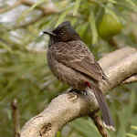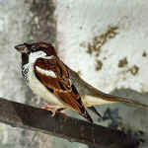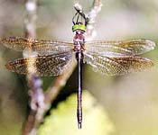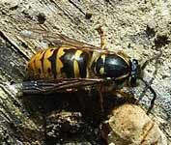

* 5. Scientific name: *Pycnonotus cafer*   
  Size: 21cms  
  Description: A dark and crested medium sized bird with black head and throat and red under tail coverts. Sexes alike.  
  Habits: A bold, pugnacious, cheerful and vivacious bird, Red-vented Bulbuls are usually seen in pairs or small parties. This species is highly adaptive and can be found in both cities and in deep forests. Their catholic taste in food and ability to build a nest in the most unsuitable spot has something to do with their success.  
  Habitat: Scrub, forests , secondary growth, towns and cities.  
  Range: Widespread resident across the country and up to 2300m in the hills. Four races in the country with some plumage differences.
* 6. Scientific name: Passer domesticus  
  Size: 15cms  
  Description: The cinnamon-brown male has grey upper tail coverts, white ear coverts and large black patch in centre of breast. The duller female has black streaks on back and two whitish wing bars  
  Habits: Familiar companion of humans - chirpy and cheerful. Numbers seem to be declining lately and one cause could be lack of suitable nesting sites. Mainly a seed-eater, House Sparrows have a mixed diet which includes insects. Usually seen in pairs, they move in small flocks and roost communally. Nests exclusively in human dwellings.   
  Habitat: Grassland, farmlands, towns, cities, human habitations  
  Range: Widespread resident replaced by the Eurasian Tree Sparrow in the hills and in the extreme north-east.
* **7. Scientific name:** Petalura gigantea

**Description** Males have an abdomen length of 6 - 7.5 cm, a wingspan up to 11 cm and petal-shaped claspers at the end of the abdomen. Females have an abdomen length of 8 - 9.5 cm and a wingspan up to 12.5 cm, and no claspers. Both sexes have widely-spaced eyes and have a predominantly brownish-black segmented body with light yellow markings along the back and sides. The larvae are also very large, up to 5 cm in length. When the dragonflies emerge from the larvae, they leave behind characteristics shells

* **Scientific name** Vespula vulgarisd)

DescriptionThe common wasp is a familiar and much feared social insect . They are quite large insects, with an obvious 'waist' between the [thorax](http://www.arkive.org/species/ARK/invertebrates_terrestrial_and_freshwater/Vespula_vulgaris/more_info.html#glossary#glossary) and [abdomen](http://www.arkive.org/species/ARK/invertebrates_terrestrial_and_freshwater/Vespula_vulgaris/more_info.html#glossary#glossary). They have bright yellow and black bands along the body, two pairs of wings and fairly long, robust [antennae](http://www.arkive.org/species/ARK/invertebrates_terrestrial_and_freshwater/Vespula_vulgaris/more_info.html#glossary#glossary). The sting is located at the tip of the abdomen. The queens (reproductive females) are larger than workers (non-reproductive females)

## 