Vedic Mathematics Lesson by :

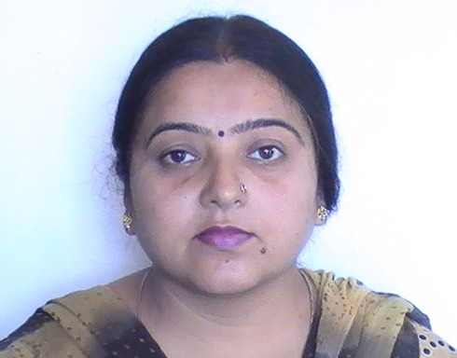

Mr. Ajay Sharma Mrs. Anupam Dogra
(Year 8 Teacher) (Year 5 Teacher)

Introduction To Vedic Mathematics

Vedas are the ancient world literature. These Vedas originated from our country. India is also known as “country of Vedas” in world. Vedic mathematics is an introduction to an ancient civilization. Vedic maths is a new and unique system based on simple rules and principles which solve all kinds of mathematical problems. In Vedic mathematics there are sixteen sutras or formulae and about thirteen sub-sutras. The word sutra pronounced ‘sootra’ is from ancient India and its means a “Thread of knowledge”. Vedic mathematic methods has shown that a high degree of mathematical ability can be attained from an early age while the subject is enjoyed for its own merits.

Multiplication of single digit numbers
Nikhilam Sutra

Example : Multiply 7 by 6

Step1 : Subtract the single digit numbers (7 and 6) from 10 and write the remainder.

10 – 7 = 3
10 – 6 = 4

Step II : Make two parts i.e. Left side part or Right side part.
Left side part / Right side part

Step III : (a) To obtain right part digit Multiply the remainder . If the product is more than 10, write its unit digit on right side and take carry to left side.
- To obtain left part digit subtract the sum of remainder from 10.
Left side part Right side part
Sum of remainder = 3 + 4 = 7 3 × 4 = 12
10 – 7 = 3 2
1 (carry to left side)

Step IV : Add the carry to left side (if any) and write the result.

3 + 1 2
4 2 = 42

OR

Step III : (a) Same as above.
- Subtract 10 from sum of two given numbers.

Left side part Right side part
Sum of given Nos.
7 + 6 = 13 2
So 13 – 10 = 3 1 (carry to left side)

Step IV : Add carry to left side (if any) and write the result.

3 + 1 2
4 (2)=(42) Ans.

Exercise-1

Find the product of

- 9 × 8
- 6 × 5
- 7 × 3
- 9 × 6
- 8 × 7

Urdhara – Tiryaghbym Sutra

Example I : Multiply 14 × 13

Step I : Multiply the left hand most digit.
1 × 1 = 1

Step II : Cross Multiply the digits and add the two products.
1 × 3 + 1 × 4
3 + 4 = 7

Step III : Multiply the right hand most digits
4 × 3 = 12

Step IV : Write these as left term/middle term/right term

$\frac{\text{14}×\text{13}}{1 (\text{left} \text{term}) 7 (\text{middle} \text{term}) \text{12} (\text{right} \text{term})}$

Step V : Shift the carry from right term to middle term.

1 /7 + 1 / 2
1 / 8 / 2 = 182 Ans.

Exercise-2

Find the product of :
- 16 × 12
- 17 × 13
- 15 × 14
- 19 × 13

Multiplication of two (or more) digit number

TypeI : When one of the two numbers nearest to base 100?

Multiply 97 by 58

Method

Step1 : Subtract two digit numbers from 100. Write the remainder
100 – 97 = 3
100 – 58 = 42

StepII : It has two parts. Left digit part and right digit part.
Left digit part Right digit part

StepIII: (a) To obtain right digit part multiply the remainder. If the product is more than 100, write unit and tens digit on right side and take carry to left side.
- To obtain left digit part, subtract the sum of remainder from 100.
Left digit part Right digit part
Sum of remainder = 42 + 3 42 × 3 = 126
= 45 = 26
100 – 45 = 55 1 (carry to left side)

StepIV: Add the carry to left side (if any) and write the result.
55 + 1 = 56 26
26 = 5626 Ans.

Exercise-3

- 42 × 97
- 99 × 33
- 57 × 99
- 53 × 96
- 47 × 97
Type II
Multiply 62 × 75

StepI : Multiply the left hand most digit
6 × 7 = 42

StepII : Cross multiply the digits and add the two product
6 × 5 + 7 × 2
30 + 14 = 44

StepIII : Multiply the right hand most digits.
5 × 2 = 10

StepIV: Write these as left term/ middle term/ right term

$\frac{\text{62}×\text{75}}{\text{42} (\text{left} \text{term}) \text{44} (\text{middle}\text{term}) \text{10} (\text{right} \text{term})}$

StepV : Shift the carry from right term to middle term and from middle term to left term.
42/44/10

42/ 44 + 1 / 0

42/ 45/ 0

42 + 4 / 5 / 0 = 46 / 5 / 0 = 4650 Ans.

Exercise-4
- 58 × 58
- 53 × 53
- 47 × 57
- 45 × 68
- 23 × 28

