Famous Historical Monuments of India

Introduction:-
Indian architecture covers a long period of more than five thousand years. The Indian archaeological heritage includes temples, mosques, religious monuments, tombs, gateways, places, caves etc. The grand monuments was built by the rulers of ancient and medieval India. The construction of historical monuments, refers the different style.

Importance of Historical Monuments:-
The monuments are the most authentic and a great source for reconstructing history of the past.
- Ancient monuments are the priceless heritage of our country.
- Monuments tell us about the engineering skills and the building techniques of a particular period.
- It shows the different styles of architecture such as
  - The North Indian temples shows the Nagara style.

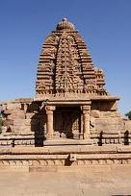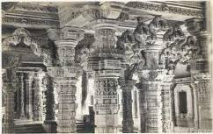
  - The South Indian temples shows the Dravida style.

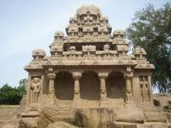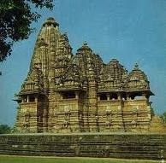
  - Mughal or Islamic Architecture includes Domes, Arches and Minar in their style.
- It gives us a lot of information about our ancestors and the way they spent their lives.
- Monuments reminds us about our ancient glory.

