**Maharaja** **Aggarsain School and Wade Deacon High School**

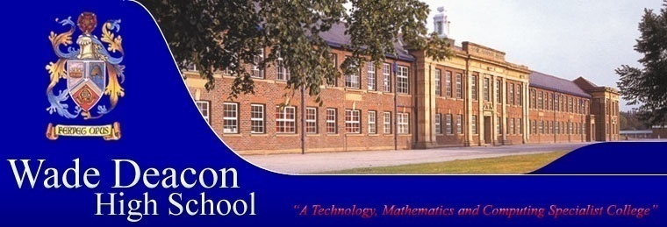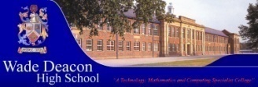**joint 'Technology & Cultural Identity' Project**

|  |  |  |  |  |
| --- | --- | --- | --- | --- |
| Year group | Material Area | Activity Description | Shared Outcomes | When? |
| 8  Aged 12-13 years | Textiles | Learners will be engaging in a culturally themed design and make project as part of their curriculum. Images of ‘depiction of Diwali’ posted on the eLanguages website by learners from Maharaja Aggarsain School in New Delhi, will be used by Year 8 learners at Wade Deacon to influence their designs of cushions. Pupils also create a moodboard based on Indian culture and festivals to help inspire their design work. A variety of decorative techniques are used to help develop a final product.  Pupils in both bands also made some diyas out of air dry clay, to celebrate Diwali on bonfire night (both celebrations were on the same day this year.) | Photographs of the made product and the influential image will be posted on the eLanguages website. | A variety of learners will be working on this project throughout the academic year (September – July) and the images of the completed items will be uploaded hopefully in November in time for Diwali. |
| 8 | Textiles | Traditional Indian decorations called Torans, are being used to inspire a new Textiles project for A band pupils. Pupils are working in groups and learning how to create rangolis to trace onto silk in preparation for silk painting. Once silk painted the pupils are adding sequins and shisha mirrors. Pupils will also learn how to make tassels to hang from the toran. Once completed the wall hangings will decorate the Textiles room. | Photographs of the made product will be posted on the eLanguages website. | Pupils in A band are trialling this scheme of work for six weeks (November – December). If the project is successful it will be run again in the last rotation (June – July) in conjunction with food technology. |
| 8 | Food Technology | Geraldine Rouski will plan and deliver a scheme of work focusing on Indian cuisine. There will be a discussion on the eLanguages website about Indian food between learners from both of our schools. This might take the form of a questionnaire or the sharing of their favourite recipe. | Photographs of learners’ work will be posted on the eLanguages site. | June-July 2011 |
| 10  Aged 14-15 years | Textiles Technology | GCSE students will be undertaking their coursework assignments and some will focus on the production of Traditional Indian Costume. They will contact students at the Maharaja Aggarsain School in order to become well informed on any aspect of their research through the use of the eLanguages website. | Photographs, video clips and discussion on the eLanguages website. | February – May 2011 |