Delhi- A Bird watchers paradise

The city is filled with the beautiful creatures and you are sure to spot eagles, pigeons, vultures, peacocks and sparrows quiet easily. These birds can be seen all over the city, right from India Gate to the Airport. They are the most common birds in Delhi.

Apart from these, Delhi also boasts of a huge number of migratory birds that flock here though the year, in search of more acceptable climates.

During the winter months of October through to March, the forests and green spaces of the capital are filled with the sounds and calls of birds from all over the world. The heavy monsoon in Delhi apparently creates an enormous amount of food, which attracts the birds from across the world. The birds which are seen in and around the city generally hail from Central Asia, Eastern Europe and Siberia. The most common migratory birds in Delhi are warblers, falcons, cranes and kites. Several species of duck make their way to capital and can be seen flocking the ponds and lakes of the city.
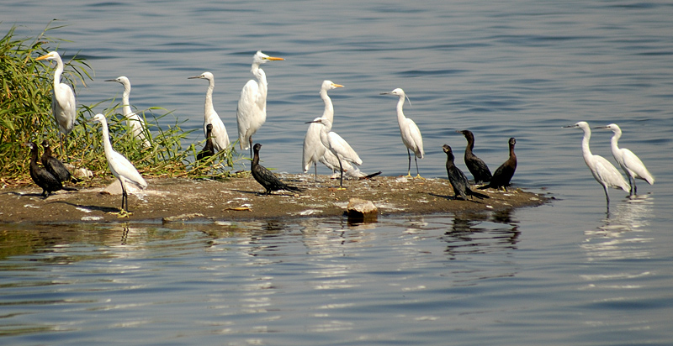
The larger white one with a yellow beak is the Great Egret, the one with the darker beak is the Little Egret and the black one is the smaller version of the Indian Cormorant

Other Migratory birds that touchdown in Delhi are the sand piper, the red shank, the godwit, the Brahamanai duck and the bar-headed goose, which flies down from Ladhakh and Leh.
But even as the Capital readies to receive winged wonders, figures present a disturbing tale. Slowly, but surely, the population of migratory birds spotted on Delhi's skyline is dwindling. The spot-billed pelican, the lesser kestrel, the Sarus crane, the sociable lapwing, the Indian skimmer and the bristled glass-warbler. Once upon a time, Delhi proudly proclaimed that it was home to these exotic birds. Today, these six species find a place alongside 76 endangered species in India.
Nothing seems to be going in favour of the feathered friends which visit the city. With pesticides polluting the Yamuna, the plankton and zoo-plankton which water birds feed on have made them susceptible to disease. Proliferation of eucalyptus trees in the city has affected birds which thrive on the insects which dwell in tress such as the neem and peepal.
For the record, of the 1,300-odd species of birds found in India, 79 are 'globally-threatened' species, 52 are 'near-threatened' species and nine belong to the 'critical' category. But that's just part of the bad news. India's bird population also includes 10 'endangered' species, 57 'vulnerable' species, two 'conservation-dependent' species and a data-insufficient species. All in all, 12 per cent of the world's birds are under threat.
Besides Sanctuaries, the Delhi zoo becomes alive to the colour and cacophony of thousands of migratory birds which have flown in from Europe, Russia, the Gulf and Southeast Asia in large numbers.
After covering a distance of 3,000-5,000 km, these birds start reaching Delhi at the beginning of winter and stay back till summer starts. They start their homeward journey by the end of March every year.
Prominent among the winged visitors this time are pintails, shovelers, common teals and dabchiks. Giving them company are white storks, black-necked storks, white ibises, spot-billed ducks and little cormorants.
These birds are of different sizes and colors. Some are vegetarian and others eat fish, frogs, small creepers and reptiles.
The migratory birds come here to protect themselves from the intense cold in the country of their origin.
**************************************************************************

