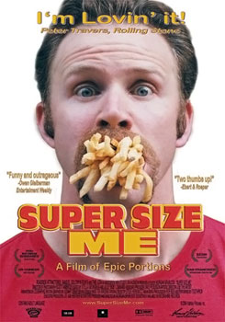Learning the difference between nutritional foods and foods that have no nutritional value (or junk foods) can be an enlightening experience for many youngsters.

How does Junk food affect our health?

To answer this question, ABSS students watched "Super Size Me",

(some scenes were deleted), an American Documentary film that

follows a 30-day period during which a 32-year-old man eats only

[McDonald's](http://en.wikipedia.org/wiki/McDonald%27s) [food](http://en.wikipedia.org/wiki/McDonald%27s_products). He dined at McDonald's restaurants three times

per day, eating every item on the chain's menu. He would always

choose to "super-size" his meal. He consumed an average of 5,000 [kcal](http://en.wikipedia.org/wiki/Food_energy) per day during the experiment. As a result, he gained 11.1 kg, a 13% body mass increase, experienced [mood swings](http://en.wikipedia.org/wiki/Mood_swing), and fat accumulation to his liver. It took him fourteen months to lose the weight gained from his experiment.

*Teachers stressed out that Junk food isn't just greasy burgers from fast food restaurants. Junk food includes overly salty* [*foods*](http://www.ehow.com/food-and-drink/) *such as potato chips. Foods loaded with sugar such as packaged cupcakes and candies are also junk food. Foods that are high in saturated fats, sodium and refined sugar usually provide little or no nutritional value. The body can't convert junk food into bone, muscle or healthy organ cells.*



After watching "Super Size Me" students were asked to sum up the film mentioning the bad effects of junk foods on body and brain.

Students as well, did research on the internet and found more information about the impact of soda drinks, potato chips, candies and other Junk foods on our health and brain and they shared them.

How does "Pepsi" Affect Your Brain?

Pepsi has basically nothing good for you in it, it’s all made up of chemicals there's nothing pure in it (like most fizzy drinks.) The caffeine in it is just over a cup of teas worth in every glass, caffeine is a nerve stimulant that can cause headaches, hyperactivity and a crash, same as sugar.   
  
Phosphoric acid over time can lead to heart palpitations.

Your heart rate goes up when you drink it and all other fizzy juice

instead of going down like it does with water, pure fruit juice

and even tea.

If you want to know what Pepsi does then clean your car

windshield with it or put some on a rag and wipe the grease

off the engine of your car. That's what it does to your stomach!  

Okay, but let me provide you something for Pepsi - well,

our physiological system is designed to withstand such minor

acidic inputs. Call it Nature's mechanism, but our body is well

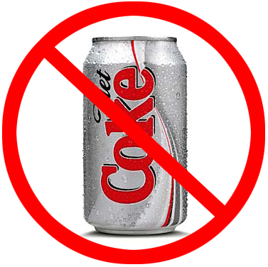prepared for such stuff.  
But of course, too much of nothing is good. In fact too much of such drinks affect your bones too, reduces the calcium in the bones.  
So, I believe an occasional Pepsi won't do you much harm. Chilled of course.  
  
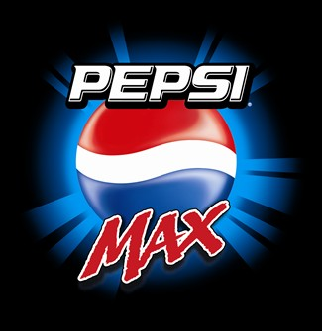 Done By: Karim Badr

Grade 4 (10 years)