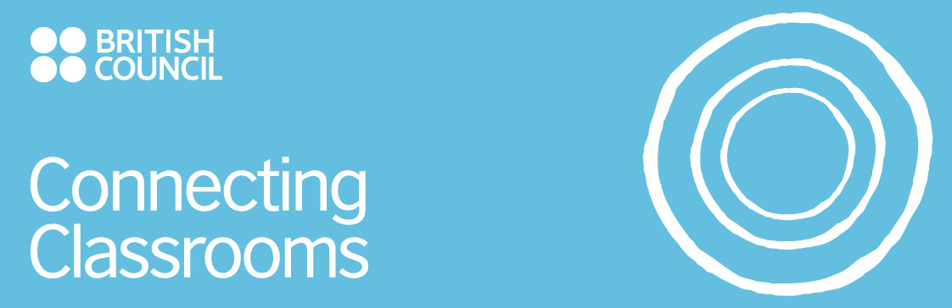  Partnership Plan  Academic Year 2010-2011  Please ensure you submit a copy of this form to ccsupport@britishcouncil.org  Deadline: | Lead Co-ordinator Name:  School/local authority: Robert May’s  Address: West Street Odiham  Hants RG29 1NA  Email address: marecage@btinternet.com  Phone no: 00 44 1256 702700  Lead Co-ordinator Name:  Ahmed Mouhy-dine  School/local authority:  Academie Tadla-Azilal  Address: Academie Regionale pour l’ Education et la Formation – Region:Tadla-Azilal Beni-Mellal  Email address: ahme_dine@yahoo.fr  Phone no: 00 212 661115685
  Country cluster 1  Hampshire UK | Country cluster 2  Tadla-Azilal Morocco

Overall project aims and objectives

To create a better understanding of the different cultures of our respective countries and in
particular to examine in detail various aspects of pupils’ school and family lives (citizenship)
We hope that our project will give our pupils a greater sense of tolerance towards other people as well as a greater understanding of the world outside their own classrooms (to improve human life)
To make pupils aware of other languages and to practise and improve their English and French language skills through reading and research (language mastery)

Communication Plan for the cluster partnership

How often will you communicate as a cluster? | UK and Morocco – at least once every 2 weeks via email/elanguages site  Meeting once every 5/6 weeks  Once every 2 weeks  Email/elanguages site  Hampshire – marecage@btinternet.com  Tadla-Azilal - ahme_dine@yahoo.fr  00 44 1256 702700 (Robert May’s School)  00 212 661115685 (Académie Régionale pour l’ Education et la Formation)  Contact the British Council Project Manager and ask for help in contacting partner
How often will you meet as a cluster?
How often will partner schools contact one another?
What will be your usual means of contact? (e.g. email, phone…)
Which email address are coordinators contactable on?
Which phone number(s) are coordinators contactable on?
If your partner cluster coordinator is unable to get hold of partners what should they do?
In the event that you are unable to contact your partner cluster as agreed please state how you will manage this and which cluster representative will take over management of the link?
Hampshire – the management link would be taken over by Sue Rafter – headteacher
Tadla-Azilal – this would be passed on to Mr Mouhy-dine’s deputy

Overall project theme, framework, activities and summary

Our world
1. All about me – my life
My school (general details) and my classroom
What I can see from my classroom window
My family my friends my pets ….. my interests
My day … my home - what I can see from my bedroom window

2. Moving on – our world
Our religion – how we worship and pray
Our weather and seasons
The food we eat
The holidays/festivals we celebrate
The languages we speak
Our local region
Our school system
The clothes we wear

3. The bigger picture – our country
Mini-projects of a more general nature based on the following topics ….
History – kings and queens
Geography – rivers and mountains
Music - contemporary
Art
Dance
Science – insects and animals
Literature and stories

Activity | Area of curriculum | Who will it involve (students, teachers, wider community | When will it happen? (include timeline) | How will you know that it has worked and how will you measure success?  e.g. questionnaires, interviews, student voice.
Uploading information and pictures onto elanguages  about the cluster schools – their uniforms – their rules and photos of their classrooms, their school routine | General and IT | IT classes in primary schools and secondary school | January-February 2011 | Pupils and teachers in UK and Morocco will be able to look at each others’ schools and find out initial general information about each other. This will generate questions and will be a starting point for contact between the schools.
Mini project – view from my classroom.  Pictures and photos will be sent to our partner schools with short written descriptions | Art/IT/Photography/  English | Art/IT/Photography classes throughout the cluster schools | February-March 2011 | Pupils will be asked to discuss/examine main differences and report back findings
Letters/posters about myself.  Pupils will send letters to their partner schools – these will be written in French or English and illustrated and will describe themselves in more detail – ie their age, family, friends, pets and main interests  They will also produce short films/podcasts/vokis – the best will be uploaded onto elanguages | Art/English/IT/French/  Drama/PSHE | Years 3 and 4 in UK– can produce theirs in English  Years 5 and 6 and secondary pupils can use French  Moroccan schools can use either French or English | March-May 2011 | Pupils will use materials to produce a display for their own school on their partner school – this information will be displayed in reception areas
Big Dance | Music/PE | Students and teachers | 20 May 2011 | Videos will be put onto the elanguages site
My home, the view from my bedroom window, how I spend my weekend and how I will spend my summer holiday – podcasts, posters, letters, booklets, films, video diaries, vokis | English, art, drama, IT, PSHE | Years 3 and 4 in UK– can produce theirs in English  Years 5 and 6 and secondary pupils can use French  Moroccan schools can use either French or English | June-July 2011 | Pupils will use materials to produce a display for their own school on their partner school – this information will be displayed in reception areas
Themed country week  Assemblies – poetry and literature – art - music  Main cultural information to be exchanged/displayed | Geography/Music/Art/  English | Students and teachers | Annual event  June 2011 – Morocco/England week  June 2012 – Algeria and Tunisia/Wales,Scotland and Ireland  June 2013 – Africa/Europe week
Celebrations and festivals  Partners upload pictures/information on all major religious festivals/customs as they occur during the year to form a big picture | IT/RE/PSHE | All students and teachers | ongoing 2010-2013

Please input here all schools involved in the project and the email address (name at least one teacher from each school in the cluster with contact details).

Name of school | Name of lead teacher | Position at school | From which country cluster | E-mail | Tel number
Mayhill Junior School | Andria Willis | Languages and International Co-ordinator | UK | andriawillis@virginmedia.com | 01256 702973
Long Sutton Church of England School | Tess Chevallier | Languages and International Co-ordinator | UK | tess@chevallier.co.uk | 01256 862238
Hook Junior School | Ellie Francis | Languages and International Co-ordinator | UK | eleonor.francis@hook-jun.hants.sch.uk | 01256 762468
Whitewater Church of England School | Matthew Irving | Headteacher | UK | matthew.irving@whitewater.hants.sch.uk | 01256 762637
Greenfields Junior School | Lucy Edwards | Languages and International Co-ordinator | UK | lucy.edwards@greenfields-jun.hants.sch.uk | 01252 843822
Robert May’s School | Susan Marsh | Languages and Project Co-ordinator | UK | marecage@btinternet.com | 01256 702700
Lycée Hassan II | M'Barek Akaddar | teacher | Morocco | Akaddar13@hotmail.com
Collège ALQods | Latifa EL Khiam | teacher | Morocco | elkhiamlatifa@yahoo.fr
Lycée My, Rachid | Abdelhakim Chhibou | teacher | Morocco | Abdelhakim69@hotmail,fr
Lycée Bir Anzaran | Hassan Mourabiti | teacher | Morocco | mourabiti@gmail,com
Collège ALMansour Dahbi | Abdelaziz Khardefi | teacher | Morocco | khardefi3000@yahoo,com
Ecole Charif AL Idrissi | Abdelilah Touraibi | teacher | Morocco | abd_essamade@Hotmail,com
Lycée Ahmed Alhansali | Mouloud Azzouzi | teacher | Morocco | azzouzimouloud@gmail.com
Lycée Ouzoud | Rachid Zahir | teacher | Morocco | rach,zahir@gmail,com
Lycée Sad Bin Alouidan | Mohamed Moubarik | teacher | Morocco | mmobarik67@menara,ma

The British Council is registered under the Data Protection Act. Some of the information provided on this form will be recorded on computer but will only be used in the administration of the scheme for which you have applied. Any information held in relation to your application may be accessed and inspected by you on request, in accordance with the Data Protection Act.

