**An interview with Orhan Patoğlu-2nd February of 2010- The Interviewer: Alican Özcan from 11-H Class**

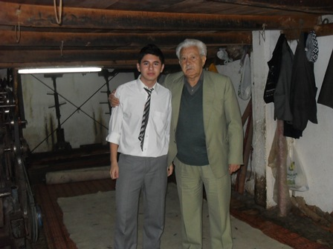**Student:** **How long have you been doing this job?**

**Patoğu:** I was born in 1934 in Akhisar. In 1953, I started to earn my living with felting so I have been doing this job for 56 years. Actually, I can also say for 66 years because I started to do this job with my father when I was a little child.

**Student: Have you ever thought to do another job different from your father’s?**

**Patoğlu:** When I finished primary school, I went to Vocational School and after three years I got a certificate for carpentry. Then, I started to work as an apprentice in a carpenter shop.

**Student:** **How did you change your mind?**

**Patoğlu:** When I got my first allowence, I went to my father’s shop directly. I told him I got 2,5 lira for one week and he smiled me. He said ‘If you do felting, you earn the same money only in one day.And I can teach you this craft. Think carefully and decide yourself’

**Student: Can we say you became the felter with the help of you father’s efforts?**

**Patoğlu:** Exactly true. I went to my father’s shop the other day and told him I wanted to became a felter just as him.

**Student: Didn’t you have any hobbies in those years as a young person?**

**Patoğlu:** Of course,I had. I had a great ambition for football and I played football in our town’s team as an amateur for 8 years. Then, I joined the army and when I returned I tried a few different jobs but at last I decided on felting.

**Student: Do you have any story or memory about felting?**

**Patoğlu:** I remember the story my father mostly uttered on cold winter days when I was a litte child.

The story is : ‘Once a well – known craftsman called Ebu Said Libabid decided to make felt. After stamping on the wool for a long time nearly 40 days , he noticed that the wool didn’t turn out to be as stiff as he had expected. For this reason , he felt very upset and started crying. His tears dropped onto the wool he had been standing on.Suddenly , he noticed that the wool wetted with his tears was stiff enough. As a result of this, he realized that wool should be wetted in the process of making felt.’

**Student: As you know too, each craftman has a secret in doing their job. What is your secret in felting?**

**Patoğlu:** Firstly, clean and washed wool is necessary for felting. But, it is better that the wool is washed before clipping. Sheep are clipped twice a year ang when we get the clean wool, we fluff it in the machine or with bow.

**Student: What is the process of felting?**

**Patoğlu:** A straw-ground cloth is laid on the floor. And then wool is evenly spread on it and rolled up tightly. It is tied tightly at either end. Now it is shaped like a cylinder. It is pressed and rolled by two craftsmen at the same time all day. As the shape gets thinner,it is tied more tightly.By checking the thickness of the cloth,the expert decides if the wool has turned into felt.When the process comes to an end, the wool is untied. To make decorations and figures in a felt piece of fabric, red,blue and green-dyed wool is spread on prior to the white on. These figures ranges from a green cypress to a colourful flower.

**Student: What kind of things can we do with felt?**

Patoğlu: The shephard’s cloak is the most common. It can be used as a bed and a quilt.It is comfortable and warm enough for a shepherd to have a lie-down and sleep in. And the other common felt product is the rug villagers mostly use. There are also felt artifacts done to use in industrial area or home cleaning. People used to use ‘milk felt’ to keep the milk from dust or cold and ‘sweat fel’ on the backs of the animals. But these are not so common today. People now mostly prefer miniature conical hats, cloak or bags as souvenirs.