**FISHING IN TURKEY**

Turkey has been known as a country of fishing and fishery products since ancient times. Surrounded by seas on three sides, Turkey is boasting numerous lakes and rivers where wide variety of fish live.

In Turkey, a handline is generally used by resident anglers. The effectiveness of this method, as well as using rod and reel, varies according to the species, region, environment.

There are mainly seven districts for fishing in Turkey. These are:

1- Black Sea

2- Strait of Istanbul

3- Marmara Sea

4- The Çanakkale Strait

5- Aegean Sea

6- Mediterranean Sea

7- Central and Eastern Anatolia

[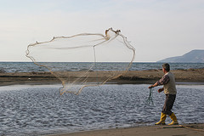](http://www.flickr.com/photos/18755124@N00/78104910/)

The man is spreading net

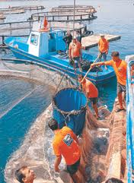 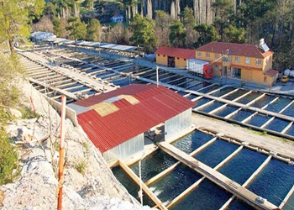

There are approximately 350 fish farms in Turkey

