Thai Papaya Salad (Som Tam Esan)

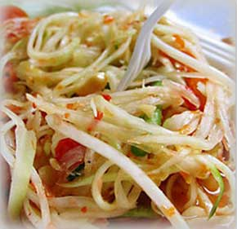

[Thai salad](http://www.thai-food.in.th/Thai-salads-and-Thai-vegetables.html) is delicious served with steamed sticky rice (khao neow). The papaya must be dark green and firm.  
1 medium dark green papaya/pawpaw  
4 garlic cloves (kratiem)  
6 green Thai chilies (prik khee noo)  
2 tomatoes, cut into wedges  
1/2 cup chopped green beans, in 1-in (2.5-cm) pieces  
2 tablespoons anchovy sauce  
1/2 teaspoon salt  
1/4 cup (2 fl oz/60 ml) lime juice or tamarind juice (ma-khaam piag)

Peel the papaya and rinse with running water to remove the acid. Remove the seeds and shred the papaya with a grater. Set aside.

Place the garlic cloves and the chilies in a mortar and mash with a pestle until crushed into chunks. Place the papaya and the remaining [ingredients](http://www.thai-food.in.th/Thai-Ingredients.html) in the mortar and gently combine all [ingredients](http://www.thai-food.in.th/Thai-Ingredients.html) by mixing with the pestle and a spoon. Serve cold.