Traveler’s E- Brochure

**2012-13**

Rajarshi Sanyal

Tribeni Tissues Vidyapith

2012-13

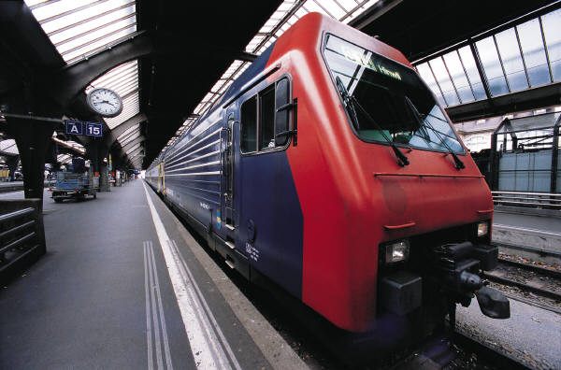

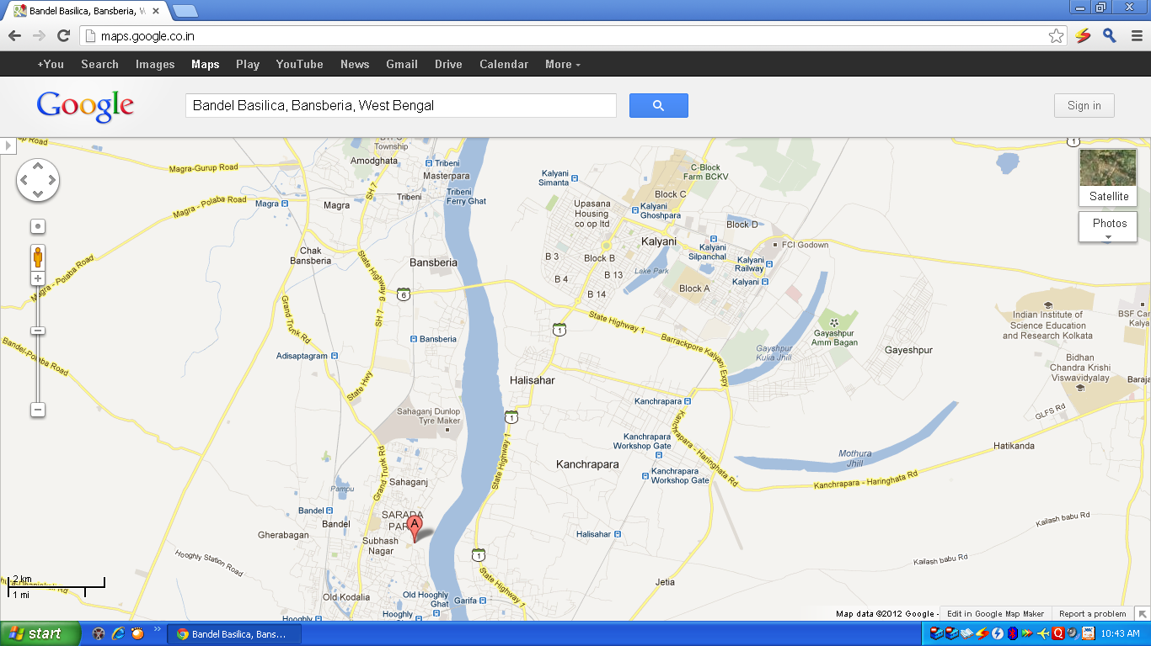

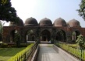

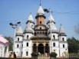

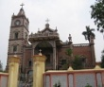

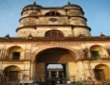

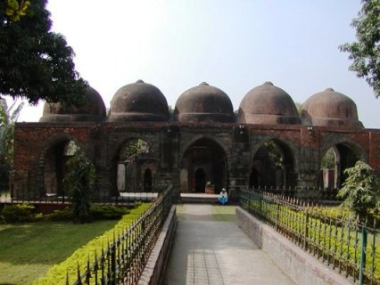**ZAFAR KHAN GHAZI DARGAH :** This mosque and attached dargah, built by Zafar Khan Ghazi, is situated at Tribeni in Hooghly district. It is considered to be amongst the earliest surviving Muslim monuments in Bengal. An inscription dates the mosque to 1298 i.e. within a century of Bhaktiyar Khalji's sudden occupation of Bengal in 1205, and within 20 years of Zafar Khan's occupation of this region in 1267. In some ways the structure represents a transition from stone post-and-lintel temples of the Pala-Senas to the brick dome-and-arch structures favoured by Bengali Muslim rulers. Here, stone columns and bases (probably reused from temples) support brick and sandstone arches and domes.

**TIMING: 5:00 a.m. to 12:30 p.m and 3:30p.m. to 10:00 p.m**

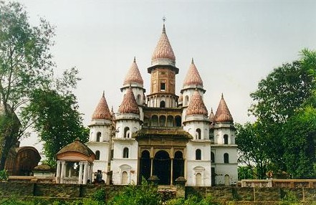

**HANGSESWARI TEMPLE – Hanseswari temple** is a Hindu Temple of goddess [kali](http://en.wikipedia.org/wiki/Kali) in the town of [Banshberia](http://en.wikipedia.org/wiki/Banshberia) at [Hooghly District](http://en.wikipedia.org/wiki/Hooghly_District), [Indian](http://en.wikipedia.org/wiki/India) state of [West Bengal](http://en.wikipedia.org/wiki/West_Bengal). Basberia presently an industrial town positioned in between Bandel and Tribeni. The temple complex has another temple — [Ananta Basudeba temple](http://en.wikipedia.org/wiki/Ananta_Basudeba_temple) — besides the main temple. Also near is the [Swanbhaba Kali temple](http://en.wikipedia.org/w/index.php?title=Swanbhaba_Kali_temple&action=edit&redlink=1) built by Raja Nrisinhadeb Roy Mahasay in 1788. The Hanseswari temple has a distinctive architecture different from the usual pattern present in this area, consisting 13 minars or Ratnas, each built as a blooming lotus bud. The inner structure of the building resembles human anatomy.It was started by Raja Nrishinghadeb Roy Mahasay and later completed by his widow wife Rani Sankari.

The architecture of the temples is the representation of "[Tantrik](http://en.wikipedia.org/wiki/Tantra) Satchakrabhed".

**TIMINGS : 4:30 a.m. to 12:00 p.m. and 2:30 p.m to 7:30 p.m**

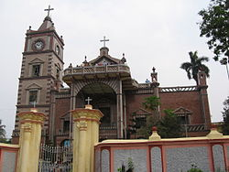

**BANDEL CHURCH :** The **Bandel Church** is one of the oldest [Christian](http://en.wikipedia.org/wiki/Christianity) [churches](http://en.wikipedia.org/wiki/Church_(building)) in [West Bengal](http://en.wikipedia.org/wiki/West_Bengal), [India](http://en.wikipedia.org/wiki/India). It stands as a memorial to the [Portuguese](http://en.wikipedia.org/wiki/Portuguese_India) settlement in[Bengal](http://en.wikipedia.org/wiki/Bengal). Built around 1660, it is dedicated to [Nossa Senhora do Rosário, Our Lady of the Rosary](http://en.wikipedia.org/wiki/Mary_(mother_of_Jesus)). It is one of the most prominent historical churches in West Bengal.

**TIMINGS: 8:00a.m to 5:00p.m**

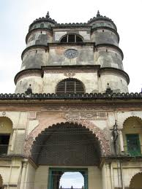

**IMAMBARA :** This Imambara building was built in 1841 by Hajee Mohummud Mohsin and completed in the year 1861. The building cost came to more than two lakh rupees in those times and has a clock which was bought from England.This is a two storied building with a wide entrance and giant towers. The Bandel Mosque, within this building, has interiors which are decorated with marble layouts, lanterns and candles and walls inscribed with words from the Holy Koran.

The mosque is situated at the northern edge of the Imambara building and at the south there is an enclosed compound with the graves of Hajee Mohummud Mohsin and his relatives.

Hajee Mohummud Mohsin, who built the mosque had donated all his money and properties for good deeds, mostly for education, public health etc.  
The deed of appropriation was sealed and signed by Hajee Mohummud Mohsin, Dated 9th Bysakh 1213 B.E., corresponding with 20th April 1806 A.D.

**TIMINGS : 8:00a.m to 6:00p.m**