WORLD CUP 2014 DRAW

Country |  | AM Group
Algeria | 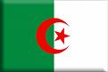
Argentina | 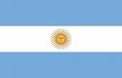
Australia | 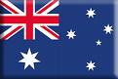
Belgium | 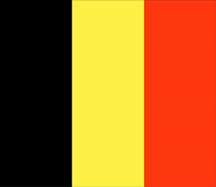
Bosnia-Hercegovina | 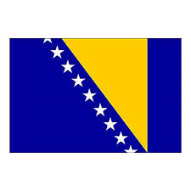
Brazil | 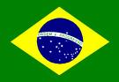
Cameroon | 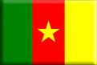
Chile | 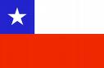
Columbia | 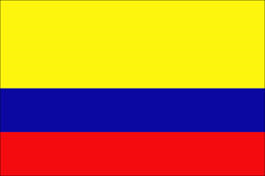
Costa Rica | 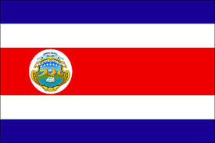
Croatia | 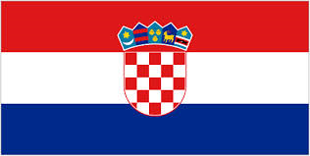
Ecuador | 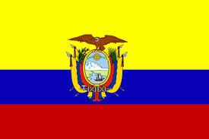
England | 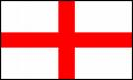
France | 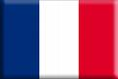
Germany | 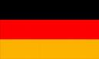
Ghana | 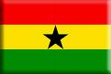
Greece | 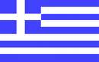
Honduras | 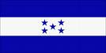
Iran | 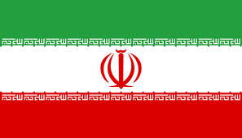
Italy | 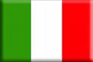
Ivory Coast | 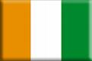
Japan | 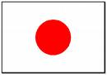
South Korea | 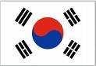
Mexico | 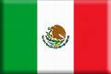
Netherlands | 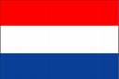
Nigeria | 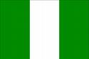
Portugal | 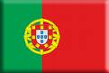
Russia | 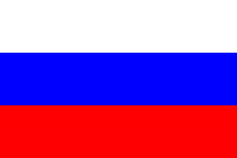
Spain | 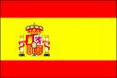
Switzerland | 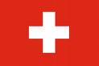
Uruguay | 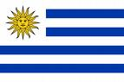
USA | 