Thomas Edison testing a phonograph. / National Library of France

In an 1898 in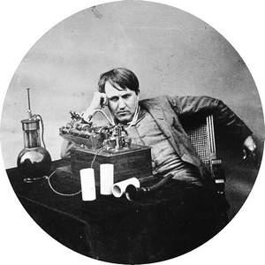terview, Edison said, “I never did anything worth doing by accident, nor did any of my inventions come indirectly through accident, except the phonograph.”

On Feb. 19, 1878, Edison was granted apatent for the phonograph, a machine that was inspired during a work session in July 1877 to develop a machine that could record telegraph messages. Edison and his team were stuck on their progress to make a machine that could record the clicks of a telegraph key onto paper strips. Late on a summer evening, during a midnight brainstorming session, Edison threw out the idea of recording the sound of a voice.

Just the year before, Alexander Graham Bell had patented his version of a telephone, beating out Western Electric founder Elisha Gray by filing a few hours earlier, and Edison had a genius for adapting and pushing technologies.

Edison proposed attaching a needle to the back of the diaphragm in a telephone mouthpiece and inscribing the vibrations created by talking onto a moving strip of paper. Edison and his team shifted their efforts and within an hour had a device. Speaking slowly, Edison recited, “Mary had a little lamb” into the mouthpiece. When they pulled the paper tape back across the needle, they heard “ary ad ell am” squeaking through the mouthpiece.

The first midnight recording session lasted until dawn broke, as Edison’s team worked on different configurations.

They ended up replacing the paper strip and rollers with tinfoil wrapped around a cylinder, and Edison thought that there might be acommercial opportunity to sell his phonograph as a dictation machine for businesses.

When Edison demonstrated the invention to editors from Scientific American in December 1877, the resulting article prompted demand. Edison created the Edison Speaking Phonograph Co. with investors, but Edison was not seriously engaged in its success until Emile Berliner, a German immigrant living in Washington, DC, invented a disc recording system, the gramophone, in 1887.

Edison’s new phonograph, introduced in 1889, recorded and played music very well, but did not work well for dictation, which was the intent. Edison resisted using his device for entertainment, but others did. And competitors saw an opportunity, including Berliner, who formed the Berliner Gramophone Company in 1895 to record and sell music. (Berliner is also an early inventor of the helicopter.)

Edison went on to hold nearly 1,1oo patents, and create businesses that applied them to opportunities, but it was his “accidental” invention of the phonograph that brought him his first fame. The sheer volume of his inventions and interests restricted his involvement with the phonograph, and the recorded music industry emerged from the entrepreneurial application of the phonograph and gramophone.

In addition his inventions, Edison is remembered for his wonderful aphorisms that impart digestible wisdom a hundred years later, such as this comment during a 1929 press conference: “None of my inventions came by accident. I see a worthwhile need to be met and I make trial after trial until it comes. What it boils down to is one per cent inspiration and ninety-nine per cent perspiration.”

And this observation: “Everything comes to him who hustles while he waits.”