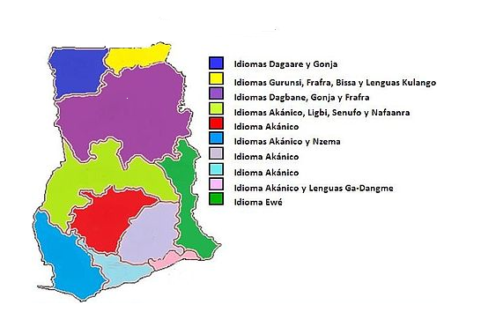 IDIOMAS EN GHANA

The official language in Ghana is English