**BAL BHARTI PUBLIC SCHOOL , DWARKA**

EMERGENCY PREPAREDNESS

MAKING AN EMERGENY KIT AND PLANNING AN ESCAPE ROUTE

by: bbps , dwarka

BBPS DWARKA,NEW DELHI, INDIA

ALWAYS BE

PREPARED

BECAUSE YOU

NEVER KNOW

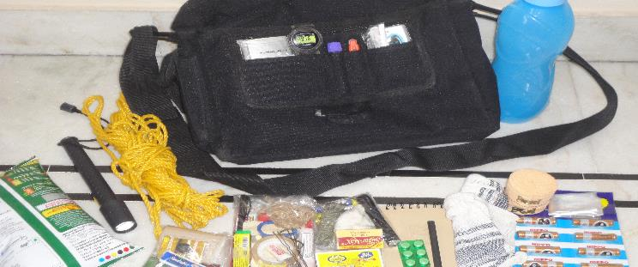

A disaster supplies kit is simply a collection of basic items your household may need in the event of an emergency .Try to assemble your kit well in advance of an emergency. You may have to evacuate at a moment’s notice and take essentials with you. You will probably not have time to search for the supplies you need or shop for them.You may need to survive on your own after an emergency. This means having your own food, water and other supplies in sufficient quantity to last for at least 72 hours. Local officials and relief workers will be on the scene after a disaster but they cannot reach everyone immediately. You could get help in hours or it might take days.

* A basic emergency supply kit could include the following items:
* water, one gallon of water per person per day for at least three days, for drinking and sanitation
* food, at least a three-day supply of non-perishable food
* Battery-powered or hand crank radio and a NOAA Weather Radio with tone alert and extra batteries for both
* Flashlight and extra batteries
* First aid kit
* Whistle to signal for help
* Dust mask to help filter contaminated air and plastic sheeting and tape
* Moist novelettes, garbage bags and plastic ties for personal sanitation
* Wrench or pliers
* Manual can opener for food
* Local maps
* Cell phone with chargers, inverter or solar charger
* multipurpose tool
* • Sanitation and personal hygiene items
* • Copies of personal documents (medication list and pertinent medical information, proof of address, deed/lease to home, passports, birth certificates)

MAKING AN EMERGENCY BACKPACK YOURSELF

kkkkkkkkkkkkkkkkkkkkkkkkkkkkkkkkkkkkkkkkkkkkkkkkkkkkkkkkkkkkkkkkkkkkkkkkkkkkkkkkkkkkkkkkkkk

overview of a homemade kit

NOTE : THE ITEMS CAN BE EDITED AS PER THE NEEDS

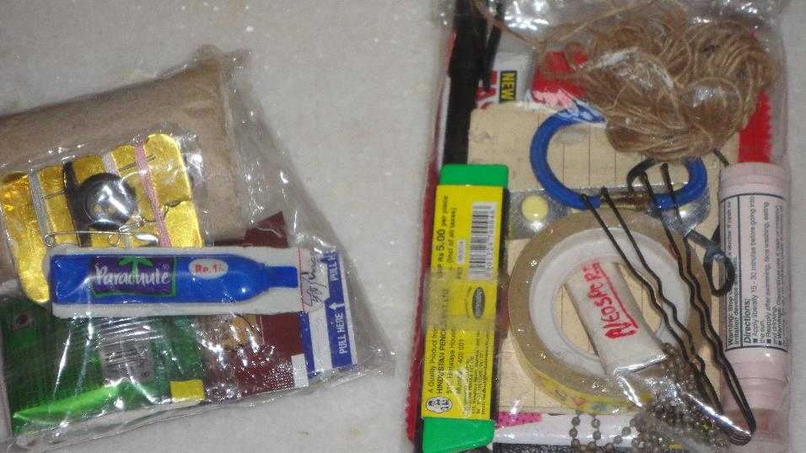

LEFT KIT CONTENTS : oil, sewing kit, instant coffee, tea bags, band aids, bandage , sugar

USES : 1. oil can be used for various purposes like healing of a wound , oiling something , etc.

2. sewing kit is for sewing stuff or clothes for repairs and making shelter

3.tea and coffee with sugar for drinking

4.band aids and bandage for first aid

RIGHT KIT CONTENTS: cutter, pen, Neosporin, pills for vomiting, jute twine, chap stick, bob pins, multitool (cant be seen ), rubberbands, write in rain paper, anti bugs fast card

USES: 1.cutter used for cutting

2. pen for writing on waterproof paper

3. neosporin for applying on wounds

4.jute twine for tying and can be used as tinder

5. chap stick can be used to put on wounds for healing jute twine can be put in it and can be used as candle

6.bob pins for making shelter and anti bug card for getting rid of bugs

7.multitool for various purposes

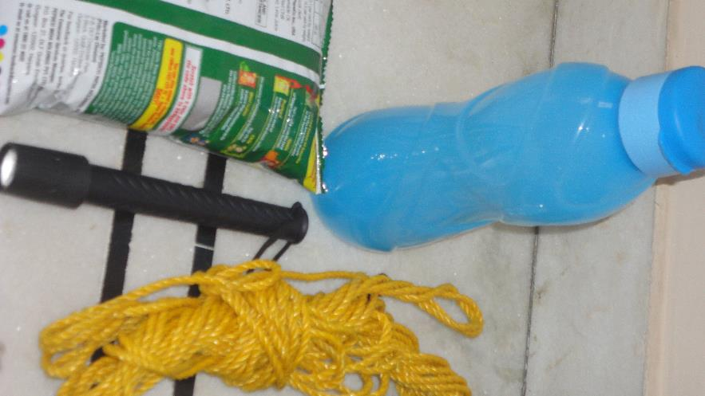

ITEMS : water , food , rope , flashlight

USES: rope for tying and making sling or shelter

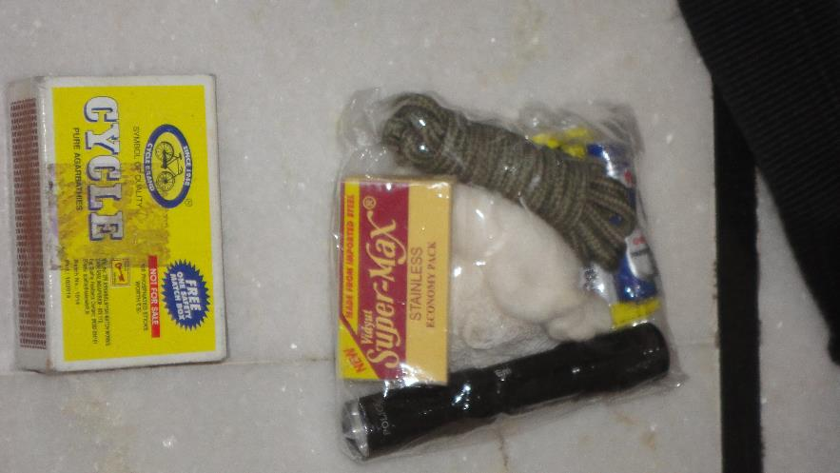

ITEMS : matchsticks, sanitized blade , cotton, bandage, miniature flash light, extra battery, paracord

USES : 1.matchstick for burning

2. blade for cutting skin or removing something from body

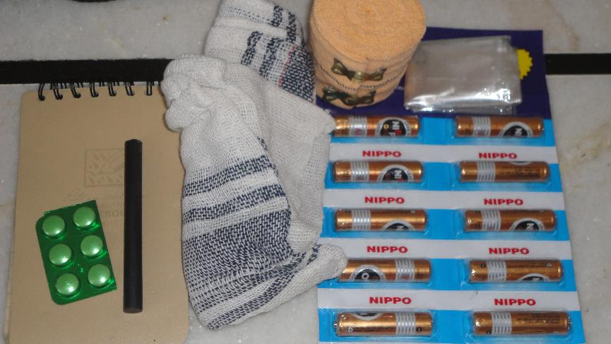

ITEMS : spare batteries, painkillers , ferroceirum fire starter, waterproof paper notebook, cloth, crepe support, plastic bags

USES : 1. fire starter for creating fire

2.crepe and pills for medical purposes

3. cloth for cleaning ,tying , etc

4.plastic bags for holding water, etc

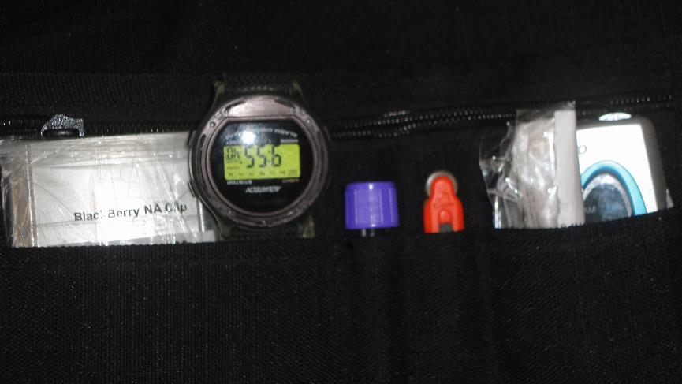

ITEMS: nailcutter, spare watch, fire starter, spirit, radio, whistle, cream, tinder, box with money

USES: 1. spirit as antiseptic,2. cream for moisturising