CARMEL HIGH SCHOOL
Basaveshwaranagar, Bangalore-79

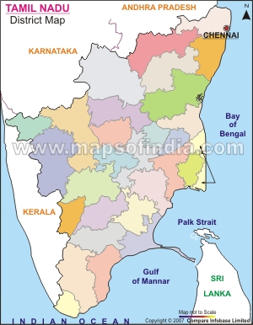

A
Project on
colours and costumes of
TAMIL NADU

By

Mrs.N.kalyani
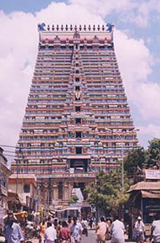
Colours and costumes of Tamil Nadu
India is a country replete with diversities. One can find diversity in states, language, food and costumes. Our motherland is a melting pot of all cultures. Varied colours mingle with one another to form the famous tri-colour of India that is saffron, white and green- the colour of our national flag.
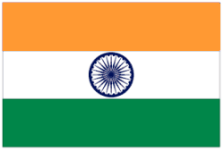

Home Of Dravidian Cultural Heritage
Tamil Nadu is the home of the Tamils and their Dravidian culture. Human activity in this area may have begun as early as 3, 00,000 years ago. Historians are of the opinion that the first Dravidians were a part of the Indus Valley Civilization and came to the south after the invasions in the north, around 1,500 BC. The main language spoken here is Tamil, followed by English. While around 88% of the state's population follows Hinduism, Christianity, and Islam are also followed here

Tamil Nadu is a traditional land, where one can still witness ancient culture heritage's relevance in modern times. Temples in Tamil Nadu were the fulcrums of society and even today art forms that have their origin in religious worship continue to colour daily life. Providing contrast to the temple heritage is the city of Pondicherry with its French flavour. Yet, another facet of this surprisingly diverse state is two Hill stations - Ooty and Kodaikanal. Both are little patches of England, being much loved by the expatriate population of the Raja
Tamil Nadu is known for its traditions and culture. The advent of festivals marks the reaffirmation of the cycle of life with its joys and sorrows. Some of these ceremonies are purely pastoral, expressing the joy of life. Others are connected with myths and legends, sacred in our memories. Yet, others are temple festivals, calculated to inspire the citizens with high ideals of ethics. Nevertheless, all of them are associated with religion in some form or other. They are all made fascinating both to the eye and to the mind by appropriate rituals, music, dance, colours, costumes and other belongings. Festivals renew bonds both within the family and with the community
COSTUMES OF TAMILNADU
Costumes of Tamil Nadu can classified into various categories. They are
Historical
Traditional
Tribal
Dances that is classical and folk dances.
Modern urban rural present day
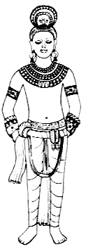
The history of Tamil Nadu is very ancient and it is believed that human activity in this area began as early as 300, 000 years ago. It is also suggested that the first Dravidians of Tamil country were part of the early Indus Valley settlers and moved south during the advent of Aryans around 1500BC. However the documented history goes back only to the 4th century BC. There are references in the early Sangham literature to the social, economic and cultural life of people. The proximity to the sea established the Tamil Country on the maritime map of the world even before the dawn of Christian era. The Tamils had trade links with ancient Egypt, Greece and Rome.
Chola king
Prior to the Christian era, the Cheras, Cholas and Pandias ruled Tamil Country. This was the classical period of Tamil literature, the Sangham Age that continued three centuries after Christ. The domains of these three dynasties changed many times over the centuries. At times other dynasties like Pallavas and Chalukyas came into power. All these dynasties engaged in continual skirmishes; but their steady patronage of arts served the expansion of Dravidian culture.
The Cholas took several measures to the welfare of the people. Karikala Chola constructed a barrage across the river Cauvery. Tanjavur and Kumbakonam were prominent Chola centers.
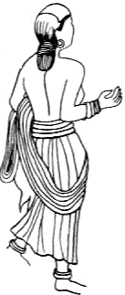
During the later half of 4th century AD, Pallavas the great temple builders emerged into prominence. Dravidian architecture reached its epitome during Pallava rule. The monuments at Mamallapuram, Kailasanathar Temple at Kanchipuram and the Kapaleswarar temple at Chennai are only a few examples. The Pallavas were constantly in war with Chalukyas.
Women in chola earlier chola period
By the end of 11th century AD, Chalukyas rose into power together with the Cholas and Pandyas. Eventually Cholas became prominent and ruled Tamil Country for the next two centuries. Under Rajaraja Chola and Rajendra Chola Sumatra, Java, Lakshadweep and Sri Lanka became part of Chola Empire.
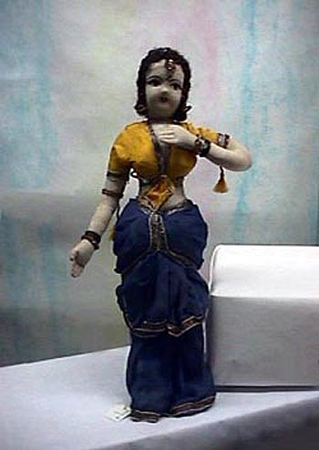
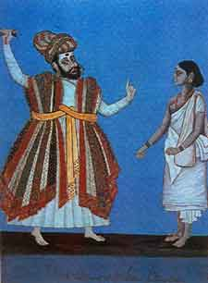
In the 14th century Muslim invasion weakened Cholas and led to the establishment of Bahmani Kingdom. An alternate Power in the south during this period was Vijayanagar Empire that absorbed all strongholds of Cholas and other local Hindu rulers to check the Muslims. Governors called Nayaks were engaged to run different territories of the empire. With capital at Hampi, Vijayanagar Empire was the most prosperous dynasty in the south. But by 1564 the empire came to an end at the hands of Deccan Sultans in the battle of Talikota. The empire was split into many parts and was given to the Nayaks to rule.
pallava
Nayak

Tamil Country under Nayaks was peaceful and prosperous. The Nayaks of Madurai and Tanjavur were most prominent of them all. The reconstructed some of the oldest temples in the country.
East India Company established itself in Tamil Nadu and in 1640 they negotiated the use of Madraspatnam (Chennai) as a trading post. Petty quarrels among provincial rulers helped the British to gain administrative control over them. Under the British colonial rule, most of the south India was integrated into the region called Madras Presidency.
With the formation of Indian National Congress in 1885, the freedom movement gained momentum in Tamil Nadu. Many Tamils played a significant role in the freedom struggle. When India became independent in 1947, Madras Presidency became Madras State. In 1956 the Madras State was re-formed to present day Tamil Nadu on linguistic lines.

Traditional
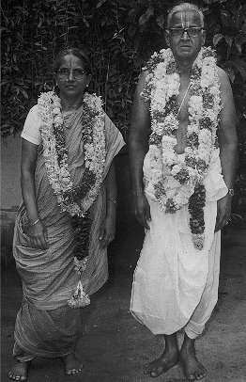
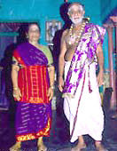
Indian clothing is known for its colorfulness and grace. Outfits for women such as the ‘sari’ bring out the essence of feminism. Men’s clothes are suitable for the warm climate and comfort. Although there is no strict uniformity in dress, certain trends in clothing prevails throughout the country.
BRAHMIN’S FAMILIES IN TRADITIONAL ATTIRE
The ‘sari’ is the most common outfit for women. This is a rectangular piece of cloth five to six yards in length. The material can be cotton, silk or synthetic. Silk ‘saris’ are embroidered at the borders, sometimes with real gold thread . Synthetic ‘saris’ are printed in various designs such as floral, multi-color shaded or animal prints. The sari can fit any size and if worn properly can accentuate the woman’s curves. There are various methods of wearing the ‘sari’. However, the most common method is wrapping the cloth around the waist, making pleats in the front and draping the final length around the shoulder. The ‘sari’ reveals the woman’s midriff and belly button and is worn with a ‘choli’. A ‘choli’ is a tightly fitted, short blouse. It has sleeves either up to the elbows or up to the middle of the upper arm. It accentuates the woman’s breasts. It has buttons either in the front or the back. The material used is cotton, silk or synthetic. In some parts of the country, women wear a ‘ghagra’ with the choli instead of the ‘sari’. The ‘ghagra’ resembles a skirt with sewn-in pleats secured at the waist with the length up to the ankles. This is again made of cotton, silk or synthetic.
Indian men normally dress more for comfort than style. Most common clothing for men is the ‘pyjama’ and ‘kurta’. In the villages, instead of ‘pyjamas’, men wear ‘lungis’. The ‘lungi’ is a rectangle cloth, usually made of cotton’, draped around the waist and pleated in the front at the groin.
Indian clothing, especially women’s outfits, are considered beautiful because of their colorfulness and uniqueness.
Sari is the traditional costume is Tamil Nadu
The word 'sari' is believed to derive from the Sanskrit word 'sati', which means strip of cloth. This evolved into the Prakrit 'sadi' and the sound later decayed into 'sari'. Some versions of the history of Indian clothing trace the sari back to the Indus valley civilization, which flourished in 2800-1800 BCE. One ancient statue shows a man in a draped robe which some sari researchers believe to be a precursor of the sari.
Ancient Tamil poetry, such as the Silappadhikaram and the Kadambari by Banabhatta, describes women in exquisite drapery. This drapery is believed to be a sari. In the Natya Shastra (an ancient Indian treatise describing ancient dance and costumes), the navel of the Supreme Being is considered to be the source of life and creativity, hence the midriff of the dancer is left bare.
Some costume, historians believe that the men's dhoti, which is the oldest Indian draped garment, is the forerunner of the sari. They say that until the 14th century, the dhoti was worn by both men and women.
Sculptures from the Gandhara, Mathura and Gupta schools (1st-6th century CE) show goddesses and dancers wearing what appears to be a dhoti wrap, in the "fishtail" version which covers the legs loosely and then flows into a long, decorative drape in front of the legs. No bodices are shown.
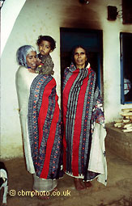
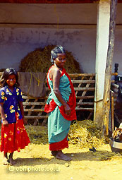
Other sources say that everyday costume consisted of a dhoti or lungi (sarong), combined with a breast band and a veil or wrap that could be used to cover the upper body or head. Some argue that the two-piece Kerala mundum neryathum (mundu, a dhoti or sarong, neryath, a shawl, in Malayalam) is a survival of ancient Indian clothing styles, and that the one-piece sari is a modern innovation, created by combining the two pieces of the mundum neryathum.
Tribal women
Sari worn by a village women . The style of wearing is known as ‘Pinkosu’
It is generally accepted that wrapped sari-like garments, shawls, and veils have been worn by Indian women for a long time, and that they have been worn in their current form for hundreds of years.
One point of particular controversy is the history of the choli, or sari blouse, and the petticoat. Some researchers state that these were unknown before the British arrived in India, and that they were introduced to satisfy Victorian ideas of modesty. Previously, women only wore one draped cloth and casually exposed the upper body and breasts. Other historians point to much textual and artistic evidence for various forms of breastband and upper-body shawl.
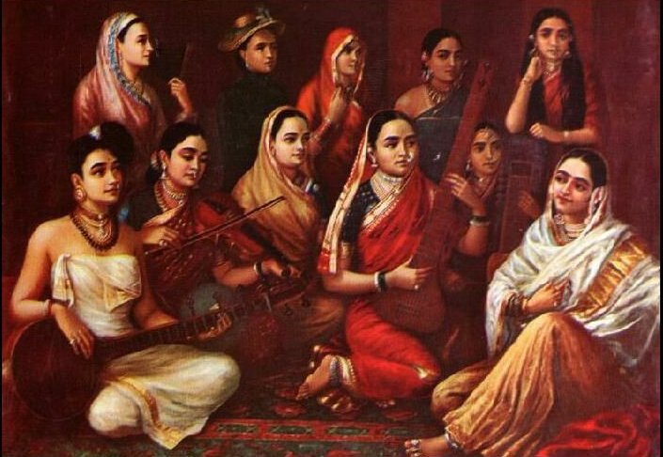
It is possible that the researchers arguing for a recent origin for the choli and the petticoat are extrapolating from South India, where it is indeed documented that some tribal women wore only the sari and exposed the upper part of the body. Poetic references from works like Shilappadikaram indicate that during the sangam period in ancient South India, a single piece of clothing served as both lower garment and head covering, leaving the bosom and midriff completely uncovered. In Kerala there are many references to women being topless, including many pictures by Raja Ravi Varma. Even today, women in some rural areas do not wear cholis. In the privacy of homes, even city women sometimes find it convenient to drape the sari as a cover-all, without the choli.
Women are draped saree in different styles

Attires For Women
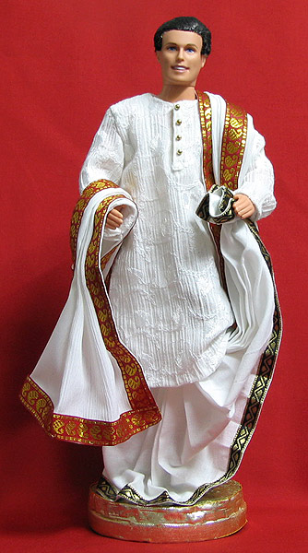
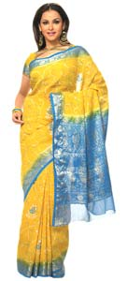
The traditional Tamilian women prefer to drape her heavy Kanchipuram Sari (also spelt as Saree) around herself, the lower part of the calf uncovered, the extra bit of pallu created thereby wound around her waist. What is striking about her is that she wears the most gorgeous of Kanchipuram Sari in the most casual way; its like she's dressed to go to a wedding every day.
A sari is a rectangular piece of cloth, which is five to six yards in length. The style, colour and texture of this cloth vary and it might be made from cotton, silk or one of the several man-made materials. The sari has an ageless charm since it is not cut or tailored for a particular size. In Tamil Nadu, saris are available in a wide variety of fabrics - silks, cottons, chiffons, georgettes and crepes; the list could go on and on.

Men's Wardrobe
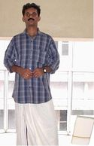
In Tamil Nadu men are usually seen dressed in Lungi along with a shirt and Angavastra. The traditional Lungi originated in the South and it is simply a short length of material worn around the thighs like a Sarong. A Dhoti is a longer 'Lungi' but with an additional length of material pulled up between the legs.
The lungi is a rectangle cloth, usually made of cotton, draped around the waist and pleated in the front at the groin. The Angavastra is a long piece of cloth draped around the shoulders. Previously it was worn instead of an upper garment, but now day's men wear an angavastra over a shirt.
With globalization, dresses are also getting westernized. Though the majority of the women in the state still wear traditional costumes, the men seem to be more comfortable in western clothing and have started wearing shirts and trousers instead of Lungi.

Dances of Tamil Nadu
Tamil Nadu is a traditional land, where one can still witness ancient culture heritage's relevance in modern times. Temples in Tamil Nadu were the fulcrums of society and even today art forms that have their origin in religious worship continue to colour daily life. Providing contras to the temple heritage is the city of Pondicherry with its French flavour. Yet, another facet of this surprisingly diverse state is two Hill stations - Ooty and Kodaikanal. Both are little patches of England, being much loved by the expatriate population of the Raja

Origin And History
The name 'Bharatanatyam' is derived from three basic concepts of 'Bhava' (expression), 'Raga' (a musical note) and 'Tala' (rhythmic beat). Bharatanatyam is based on the theories of the books "Natyasaasthram" and "Abhinaya Darpanam". It was known as "Daasiyattam" since performed by Devadasies in temples of Tamil Nadu long ago. It was a part of the religious rituals and has a long and hoary past. The kings and the princely courts patronised the temples, as well as the various traditions sustaining the dance form.
Bharatanatyam dance form is said to derive its name from Bharata Muni, the author of "Natya Shastra" (treatise on dance) written between 2nd century BC and 2nd century AD. The dance was then called "Sadir". The four brothers Chinnaiah, Ponniah, Shivanandam and Vadivelu collectively famous as the Tanjore Quartrette codified Bharatanatyam in its present form. Their compositions form the bulk of dancing even today. Male gurus called "Nattuvannars" imparted training. This was the time when art received maximum encouragement and dancers were given land and valuables as gifts and were placed in high esteem.
Chidambaram is one of the most ancient and most celebrated shrines in India located in Cuddalore district, Tamil Nadu. It is of great religious as well as historic and cultural significance. Chidambaram is associated with Lord Nataraja or Shiva in his "Ananda Tandava" pose (the Cosmic Dance of bliss) in the cosmic golden hall and the hall of consciousness ('Chit Sabha').
Lord Shiva is worshipped here in the "formless form" of the Chidambara Rahasyam, and the temple is known for its "Akasha" Lingam (Sky Lingam), an embodiment of Shiva as the formless Space. This is one of the few temples where Shiva and Vishnu are enshrined under one roof.
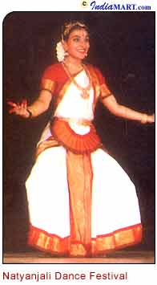
The Natyanjali Festival
Live dance performances have been introduced to the temple recently, in the form of annual dance festivals. The Natyanjali festival dedicated to the Cosmic Dancer (Lord Shiva) is celebrated every year during February-March. Natyanjali festival opens on the auspicious occasion of the Maha Shivaratri day and of course in the right kind of venue - the 'Prakara' of the Chidambaram temple. The magnificent temple dedicated to Lord Shiva, built a thousand years ago, provides a beautiful backdrop for the event.
This is an opportunity for all dancers, from all over India, to perform and to pay their tribute to Lord Nataraja. Natyanjali festival is jointly organised by The Department of Tourism, Government of Tamil Nadu, The Ministry Of Tourism, Government of India and The Natyanjali Trust, Chidambaram. The festival lasts for 5 days.
Folk Dances of Tamil nadu
Tamil Nadu has rich tradition of folk arts and crafts displaying traditional skill and dexterity handed down from generations. The Folk Music and Dances represent the rustic ethos, aesthetic values and melody. The conduct of folk dances and music on occasions of temple festivals and community functions gives entertainment, myth and merry to the villagers. The Therukoothu (Street Play, Thappattai Attam, Karagam and Kavadi, Dummy Horse Dance and Peacock Dance, Oyilattam and Silambam are all rural programmes of art forms, very old but still conducted and enjoyed by people with abiding interest and enthusiasm

Some of the Folk Dances are,
Devaraattam
Karagaattam
Kavadi AattamKummi
Theru Koothu
Other Famous Folk Dances of Tamil Nadu
Karagaattam
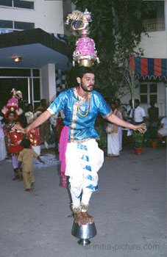
Karagam is a popular folk dance all over Tamil Nadu though its birthplace is said to be Thanjavur. Karagam is performed balancing a pot on the head. Traditionally, the villagers in praise of the Rain Goddess Mari Amman and River Goddess, Gangai Ammana, performed this dance. In 'Sangam' literature, it is mentioned as "Kudakoothu". 'Karagam' has two divisions; "Atta Kragram" and the other "Shakti Karagam" performed with fire pot on the head.
In Mariamman or Durga temple as ritual dance, it is called 'Shakti Karagam'. More often it is danced with decorated pot on the head and is known as "Atta Karagam' and symbolises joy and, merriment. Earlier it was performed only with accompaniment of the Naiyandi Melam but now it includes songs also.
Karagam is performed in the temple and on festivals occasions as entertainment. But Karagams were once performed for 'Mulaipari' ceremony; the dancer used to carry a pot of sprouted grains on the head, and danced balancing it through intricate steps and movements.
Today, the pots have transformed from mud pots to bronzeware and even stainless steel in modern times. The pots are decorated with a cone of flower arrangements, topped by a paper parrot. The parrot rotates as the dancer swings along.
Both male and female performers participate in this. Acrobatics similar to circus are included-such as, dancing on a rolling block of wood, up and down a ladder, threading a needle while bending backwards and so on.

Kavadi attam
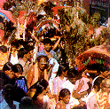
In ancient times people of Tamil Nadu during pilgrimage carried the offerings to the gods tied on either end of a long stick, which was balanced on the shoulders. In order to lessen the boredom of the long travel they used to sing and dance about the gods.
Kavadi Aattam has its origins in this practice. Kavadi Sindhu are special songs, which were composed to be sung while carrying the Kavadi. The Kavadi is a semi-canopy made of bamboo strips and a light pole. The cover of Kavadi in saffron cloth decorated with peacock feathers and balancing pots on both ends embellish the tiny Kavadi. This is mainly a religious dance. The dance is accompanied by worship of Lord Muruga. Pambai and Naiyandi Melam accompany the dance.
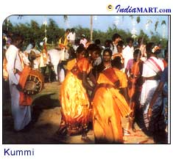
Gummi during pongal
Kummi is another form of village dance, which is the most important and ancient that originated when there were no musical instruments. It is performed by women. There are many varieties of Kummi, such as, "Poonthatti Kummi", "Deepa Kummi", "Kulavai Kummi", "Kadir Kummi", "Mulaipari Kummi", etc.
A Festive Dance
The women stand in a circle and dance clapping their hands rhythmically to lilting songs. This dance is usually performed during temple festivals, Pongal, the harvest festival, family functions like the one to celebrate the coming of age (onset of puberty) of the girl-child etc. The first line of the song is sung by the leading lady, which the others repeat.Other folk dances of tamil nadu
Bagavatha Nadanam
This dance is performed inside a temple, around a lamp. The purpose of Bagavatha Nadanam is to worship Lord Krishna and celebrate his frolics with the Gopikas. This is performed during the festivals of Rama Navami and Gokilashtami.
Bommalattam Or Puppet Show
Puppet shows are held in every village in India during festivals and fairs. Even in Tamil Nadu they are famous and different kinds of puppets are used for this show made of cloth, wood, leather, etc. They are manipulated through strings or wires. The persons stand behind a screen and the puppets are held in front. The stories enacted in the puppet shows are from Puranas, epics and folklore.
Mayil Attam
Girls dressed as peacocks resplendent with peacock feathers and a glittering headdress complete with a beak perform Mayil Attam in the villages during village get-togethers.
Other similar dances are "Kaalai Attam" (dressed as a bull), "Karadi Attam" (dressed as a bear), "Aali Aattam" (dressed as a demon) and "Vedala Aattam" is performed wearing a mask depicting demons.
Oyilattam
Oyil means beauty, hence Oyilattam is called 'Dance of Beauty', which is performed near the temples or public places in the morning and evening hours. Oyilattam is prevalent in the south districts and Kongu Nadu in particular. Traditionally, only men performed this dance but ten years ago women also began to participate. Styles of Oyilattam differ from place to place.
Intricate steps are used in martial arts, such as Silambattam. This dance is performed with rhythmic steps and musical instruments first with few people standing in a row. Then gradually the row will become longer as the new comers and guests all join and dance along as they like. The dancers wear ankle-bells. Normally, the dance is performed with the accomplishment of musical instruments and songs.
Snake Dance
Snake Dance is another famous rural dance form, which arises from the popularity of the snake as a protective divinity, safeguarding the health and happiness of the rural folk. Young girls dressed in a tight-fighting costume designed like the snakeskin usually perform snake dance. The dancer simulates the movements of the snake, writhing and creeping, at times making quick biting movements with head and hands. The raised hands held together look like the hood of a snake.
Urummi Attam
Urummi Attam is a temple art form found only in selected villages in a few districts of Tamil Nadu. This dance is especially performed in Amman temples during the month of 'Adi'. The whirring sound of 'Urumi' providing the melody and the beat of the 'Thappu' providing the rhythm, accompany the dance sequence.
Ottan Koothu
Ottan Koothu is a tribal art form of 'Ottas', a small group of tribals of Tamil Nadu. It is performed by both men and women folk during festive occasions to depict episodes from epics and other ancient stories.
Kamandi Or Kaman Pandigai
Kamandi or Kaman Pandigai is a dance form, which is performed to commemorate the Puranic event when Shiva burned 'Manmada' the God of Love to ashes in anger. The people in the village separate themselves into two parties as 'Erintha Katchi' and 'Eriyatha Katchi' and a heated debate ensues. Kaman and Rati, his consort, are main characters.
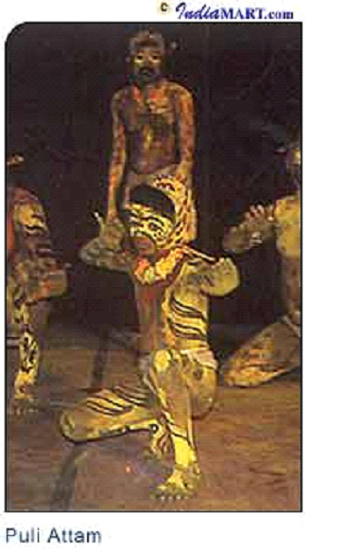
Puli Attam
Puli Attam is performed during temple festivals, which draws large crowds. This folkdance form is performed by young men with painted bodies in colours yellow and black, complete with fangs, head gear with ears, paws with claws and long tail, simulating the prancing, pouncing tiger in every ferocious move amidst wildly beating drums. Usually a goat is brought along with the dancers who pretend to pounce on it and kill it.
Kali Attam
Kali Attam is also known as "Koladi", "Kolkali", "Kambadi Kali" and "Kolaattam". Kali means joy or fun and games. In this dance form sticks of one-foot length are held in each hand and beaten to make a sharp, rasping sound as the dance proceeds with unique steps, twisting and turning.
Both men and women participate in this dance, which is performed during festivals, auspicious days and weddings. The special qualities required to perform this dance are quickness, alertness, while being careful no to hurt the other dancers by the swinging 'Kol'. No special dress or make up is required for this dance.
Sevai Attam
Sevai Attam is performed by village folk belonging especially to Nataka community; it is a dance form devoted to 'Thirumal' (Maha Vishnu). In earlier days this was performed at the rear of a chariot procession either of a king or a deity.
Dancers form a group, with one of them acting the buffoon, dance to the music of percussion instrument like 'Urumi'. The classical songs and the measured steps with graceful movements are the special features of Sevai Attam. In the works of Sangam this had been known as 'Pinther Kuruvai'.

Colours
Clolours can be related with
Festivals
Costumes
Art (kolam)
Food
Flowers
Paintings
Seasons
Festivals
PONGAL
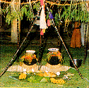
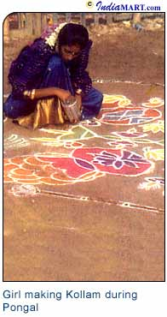
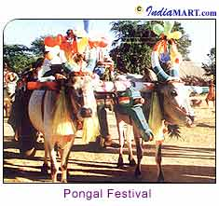
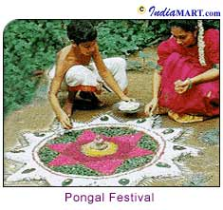
A majority of the population of India depends on agriculture. As a result, most of the festivals are also related to the agricultural activities of the people. These festivals are celebrated with different names and rituals in almost all the states of India. Pongal is an important festival of Tamil Nadu, which is celebrated to mark the withdrawal of the Southeast monsoons as well as the reaping of the harvest. It falls in the month Thai and is strictly a rural festival.
The Legend Behind The Celebrations
There are few interesting legends behind the Pongal celebrations. The most popular among them related to the celebrations of the first day of the Pongal festival goes like this - Lord Krishna lifted the Govardhan Mountain on his little finger to shelter his people and save them from being washed away by the rains and floods.
According to another the third day of Pongal is celebrated because Lord Shiva once asked Nandi, his bull, to go to earth and deliver his message to the people - to have an oil bath every day and food once a month. But Nandi got it all mixed up when he delivered the message, and told the people that Shiva asked them to have an oil bath once a month and eat every day. Shiva was displeased, and told Nandi that since the people would now need to grow more grain, Nandi would have to remain on earth and help them plough the fields.
Mattu Pongal is also called "Kanu Pongal", and women pray for the welfare of their brothers. This is similar to the festivals of Raksha Bandhan and Bhai Dooj celebrated in some states of North India.
About The Festival
The festival is celebrated for four days and the celebrations on the first day of the Tamil month Thai and continues for the three days. The month of Thai is supposed to be very auspicious for every kind of activity. The Sun is worshipped for his rays are responsible for the life on earth.
It is the biggest harvest festival, spread over four days. 'Bhogi ‘is celebrated on January 13,’ Pongal ‘on January 14,’ Mattu Pongal on January 15 and 'Thiruvalluvar Day' on January 16. Thiruvalluvar has done a great contribution to Tamil literature with 'Thirukkural'. There are 1,330 verses in this work and they talk about all aspects of life.
In fact, the name of the festival is derived from Pongal, a rice pudding made from freshly harvested rice, milk and jaggery. The first day, "Bhogi Pongal", is a day for the family. "Surya Pongal", the second day, is dedicated to the worship of Surya, the Sun God. The third day of Pongal, "Mattu Pongal", is for the worship of the cattle.
Cattle are bathed, their horns polished and painted in bright colours, and garlands of flowers placed around their necks. Pongal is associated with cleaning and burning of rubbish, symbolizing the destruction of evil.
All the four days of Pongal have there own individual significance. On the first day, delicious preparations are made and homes are washed and decorated. Doorways are painted with vermilion and sandalwood paste with colourful garlands of leaves and flowers decorating the outside of almost every home. On this day 'Bhogi' or the Rain God is worshipped.
Rituals Followed
A typical traditional Pongal celebration has a number of rituals attached to it. The place where the Pongal Puja is to be conducted is cleaned and smeared with dung, a day prior to the festival. People generally choose an open courtyard for this purpose.
'Kolams' (Rangoli) generally drawn with rice flour are special to the occasion. The idea behind using rice flour is that the insects would feed on it and bless the household. At the centre of it a lump of cow dung holds a five-petal pumpkin flower, which is regarded as a symbol of fertility and an offering of love to the presiding deity. In a similar way the houses are also cleaned, painted and decorated. Kolams (Rangoli) are made in the front yards of the houses and new clothes for the whole family are bought to mark the festivities. Even the cattle are gaily caparisoned with beads, bells and flowers-their horns painted and capped with gleaming metals.

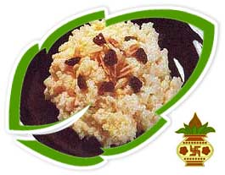
The Tempting Recipes
Sweet rice, known as "Pongal", is cooked in a new earthenware pot at the same place where puja is to be performed. Fresh turmeric and ginger are tied around this pot. Then a delicious concoction of rice, Moong Dal, jaggery and milk are boiled in the pot on an open fire. This Pongal, according to ritual, is allowed to boil and spill out of the pot. Pongal, once ready, is offered to God first, on a new banana leaf along with other traditional delicacies like Vadas, Payasam, etc. Besides this, sugarcane, grain, sweet potatoes, etc are also offered to the Sun God.

NAVARATHRI
BOMMAI GOLU is traditionally a women’s festival that Tamilians celebrate during Dasshera or Navarathri. During this period, it is customary in many homes in Tamil Nadu to display a "Golu".This is an exhibition of various dolls in odd numbered tiers (padis) which are draped with white cloth. These dolls typically depict gods or village scenes and weddings. The golus vary in theme from house to house - from the elaborate, extravagant ones to the simple, traditional and artistic ones.
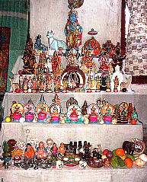
It is significant that the Navarathri Golu is set up with an odd number of steps (usually 7, 9, or 11), and the placemnt of different idols of Gods on them. It commences with the keeping of a “Kalasam” which is a brass or silver pot filled with water and adorned with either a coconut or a pomegranate amidst mango leaves. This Kalasam is kept in the first step.
Golu is adorned with dolls - predominantly with that of the Gods and Goddesses depicting mythology. Common ones being Dasavatharam, Ramar Pattabhishekam, Meenaakshi Thirukalyanam, Murugan and Valli, Krishna in Aayarpaadi etc. It is a traditional practice to have the wooden dolls (Marapaachi - a pair of a boy and girl) as these dolls indicate fertility.
In the evenings, a small lamp is lit, in the middle of a decorated "kolam"(Rangoli), before the golu and devotional hymns and slokas are chanted. After performing poojas, the food items that have been prepared, are offered to the Goddesses
Generally, when one come’s to a person's house to see the Golu, they are given prasad (the offering given to God that day), kumkum (red powder), and a small bag of gifts usually containing a mirror, a comb, a small box of kumkum, and fruits. These are only given to girls and married women.
Golu does not mean that the dolls are kept only on the steps. Innovation plays a vital role. Creativity and divinity combine to form a veritable presentation. Themes such as marriage, school etc are adopted. Every night 'arthi' is taken for the dolls.
On the 9th day (Saraswathi Pooja) of Navarathri, special poojas are offered to Goddess Saraswathi - the divine source of wisdom and enlightenment. Books and musical instruments are placed in the pooja and worshipped as a source of knowledge. Also tools are placed in the pooja as part of "Ayudha Pooja". On this day, people pay obeisance to the implements (ayudham) they make use of during the course of their life - be it at home or at work. Tools such as scissors, knives as well as every tool of the trade, be it factory machinery or computers, are considered sacred and prayers are offered.
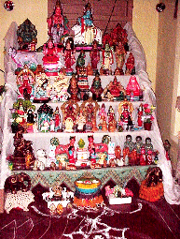
The 10th day - "Vijayadasami" - is the most auspicious day of all. It was the day on which evil was finally destroyed by good. It marks a new and prosperous beginning. New ventures started on this day are believed to flourish and bring prosperity. Kids start tutoring on this day - to have a head start in their education.
In the evening of Vijayadasami, any one doll from the doll exhibition is symbolically put to sleep and the Kalasam is moved a bit towards North. - to mark the end of that year's Navarathri Golu.Prayers are offered to thank God for the successful completion of that year's Golu and with a hope of a successful one the next year.Then the golu is dismantled and packed up for the next year. The main concept of celebrating Navarathri and keeping a Golu is to bring about happiness, good luck and success in one’s life with God’s blessings.

Apart from the above festivals, there are number of festivals exclusively celebrated in Tamil Nadu. Some of they are
- Cape Festival at Kanyakumari
- Chithirai Festival (world famous)
- Dance Festival at Mamallapuram
- Festivals of Dakshinachitra
- Karthigai Deepam (WORLD FAMOUS)
- Kavadi Festival
- Music and Dance Festival, Chennai
- Natyanjali Dance Festival
- Panguni Uthiram Festival
- Saral Festival
- Summer Festival
- Tea And Tourism Festival At Ooty
- Thaipusam Festival
- Varushapirapu (Tamil New Year's Day)
- Velankanni Festival

Chithirai Festival ( World famous)
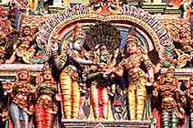
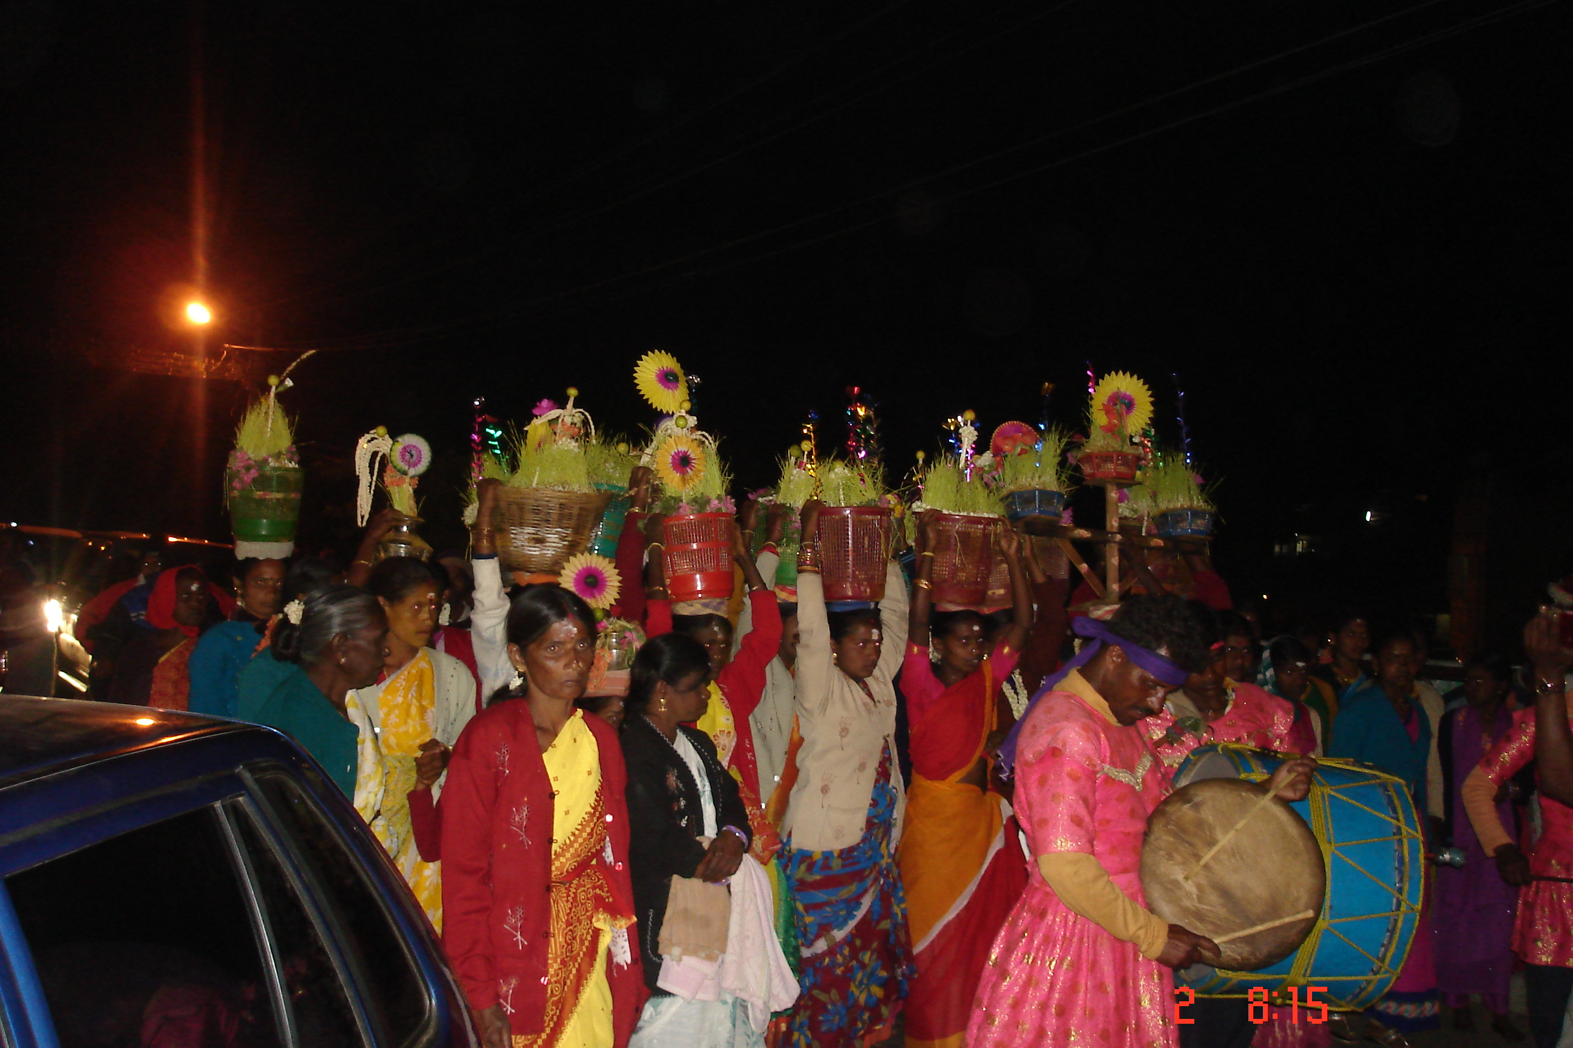
Venue is the famous Madurai temple, 500 kms from Chennai. The festival starts from the Tamil month - Chithirai, and goes on for ten days . The highlight is the procession of Lord "Kallazhagar" ( Lord Vishnu ) the elder brother of goddess Meenakshi, who proceeds from his abode - Azhagarmalai 30 kms from Madurai, to give away his sister in marriage to Lord Sundareshwar. The celebration is filled with pomp and festivity. The " Kallazhagar " entering the river Vaigai is indeed a spectacular sight

Karthigai Deepam( World Famous)
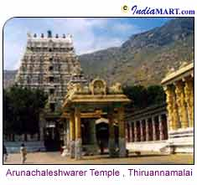
Karthi gai deepam is the oldest festival of South India , which is also the most elaborate and the most important festival. Karthigai Deepam falls in the Tamil month of Karthigai when the star Krithigai is on the ascendant and usually occurs on a full moon day. This festival is also called as "the Festival of Lights".
Speciality Of The Month
The month of Karthigai is of special importance to Tamil people, which derives its name from the star 'Krithigai'. Lord Shiva, with His divine light, created Lord Muruga, in this month.
The Legend Behind The Festival
The popular legend behind the celebrations goes like this- Once upon a time the Devas, the heavenly immortals, put in their best possible efforts to have a complete Darshan of Lord Shiva. During this process Lord Brahma took the form of a swan and Lord Vishnu in the form of a boar conducted an extensive search in the sky and in the neither world did they find him.
Lord Shiva asked Lord Brahma and Lord Vishnu to find out the exact location of his head and his feet. Since Lord Shiva took a gigantic form, they were not able to find him anywhere. Then Lord Shiva appeared before them in the form of a flaming light whose ends cannot be defined on the hill of Thiruvannamalai. Therefore, this festival is also known as Annamalai Deepam. Here, a special torch is lighted on the zenith of the hill and it is believed that Lord Shiva's Jyoti will be visible on this day. The festival is celebrated in a special manner in Thiruvannamalai.
Lord Muruga took the form of six babies in a lake called "Saravana Poigai". On this day, Parvati (his mother) united all his six forms and so Lord Muruga has six faces. Special pujas are performed to Lord Muruga.
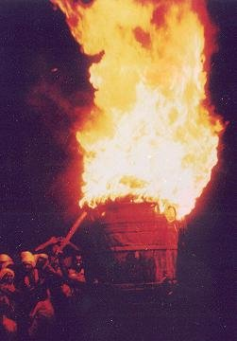
Antiquity Of The Festival
Evidence from Tamil literature proves that this festival is one of the oldest in the state. In ancient Tamil literature, the oldest available work Tolkappiyam gives in concise verse form rules for Tamil grammar as well as other topics. Scholars agree that this work dates back to 2,000 or 2,500 BC. In one of the formulae Tolkapiyar in his treatise uses the phrase "like the lamp's flame pointing upwards." This phrase, says one of the commentators, refers to the beacon lit on the Annamalai Hill, which burns brightly without flickering in the wind, and flares up towards the sky.
In another epic "Jeevakachintamani" written by a Jain poet, Thiruthakka Thevar, the poet describes how people celebrated the Karthigai Deepam festival. In other ancient Tamil literature of the Sangam period, the Karthigai Deepam festival is described vividly.
In "Karnarpadu", the poet in one of the stanzas, describes how in the Tamil month of Karthigai (is ii Kartik month!) during the time of the Krithigai star, the lamps lit by people blossomed on earth, bringing rain in its wake. In another Tamil work, the "Kalavazhi Narpadu" dating back to the third Sangam period (after 1,000 BC) the poet says, "In the battle the blood oozing out from the dead soldiers' bodies is like the red coloured flame of the lamps lit during Karthigai Deepam festival". In another Sangam work, "Pazhamozhi", in stanzas ending in proverbs, one stanza ends with this phrase, "like the beacon on the Hill."
A Longer Deepavali Celebration
This festival is considered as the extension of the Deepavali festival. In some houses, they double the number of lamps every day from the day of Deepavali and this way, they end up with a number of lamps on the day of Karthigai Deepam.
On this day, people clean their houses and draw 'Kolams' (Rangoli) in front of the house and also place some lamps on it. They place the lamps ('Agal') in the puja room and light them and after the 'Deeparathana' (puja) the lamps are moved to the different places in the house. The lamps glow all over the streets on this day.
Celebrations At Tiruvannamalai
Karthigai Deepam is the most important festival, when devotees walk round the hill and worship the Bharani Deepam, which is lit early in the morning on the final day of the festival, in the sanctum sanatorium. The Deepam is lit in a gigantic, circular metal vessel that can hold about 2,000 litres of ghee. It is five and half feet in height and five feet in diameter. For making the wick, 30m of 'Ghada' cloth is used and is burnt with 2 kilos of camphor on the night of 'Karthigai Pournami'. The Jyoti can be sighted from nearly 35-km around.
The lighting of the beacon on the top of the hill is the culmination of ten days of hectic activity in the temple town. The lighting of the Maha Deepam will take place simultaneously with "Deeparadhanam" to the five deities in the temple at the foot of the hill.

Apart from Hindu festivals even Muslims and Christians celebrate festivals which are unique-
Nagore Dargah (MUSLIM)
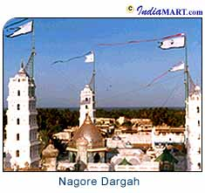
The Nagore Dargah of Meeran Sahib Abdul Qadir Shahul Hamid Badshah is a spiritual shrine in South India. It is one of the popular pilgrimage centers for Muslims in Tamil Nadu. A short drive from Nagapattinam, Nagore makes for a busy pilgrimage, with busloads of tourists arriving from all over the state. The Dargah features beautiful domed arches and lovely minarets. The Dargah is visited by Hindus also and is a fine example of the harmonious co-existence of Hindu - Muslim communities.
About The Dargah
The Nagore Dargah shrines are situated at three locations, Nagore, Vanjur and Silladi. The main campus is at Nagore, spread over an area of about five acres, which is enclosed by a compound wall, with four impressive entrances, one each on the north, south, east and west. In front of the western gate, just outside the compound, is a large tower, 131 feet tall, called 'Periya Minara'. Nagore Dargah literature discloses that Tanjore King Pratap Singh built 'Periya Minara' around 1760 AD, about 200 years after the death of Meeran Sahib. He is said to have built it in appreciation of having received the grace of Meeran Sahib.
The Main Compound
Inside the compound of the main campus, the golden dome building houses three tombs in three separate chambers. The doors of these chambers are made of silver. In the tombs lay buried the mortal remains of Meeran Sahib, his son Syed Mohammed Yusuf and his daughter-in-law Saeeda Sultana Biwi.
Aside the tomb of Meeran Sahib is placed a golden box. The contents of the golden box unexpectedly are a pair of wooden slippers, believed to have been used by Meeran Sahib. The legend says that, once a carpenter suffering from disease approached Meeran Sahib requesting him to cure him, which Meeran Sahib reportedly did by the grace of Allah. The gratified carpenter made from the finest wood a pair of slippers.
Adjacent to the golden dome building is the 'Peer Mandap' where the 'Peer of the Dargah' stays fasting for three days during festive season of the Dargah. Further away is a mosque where prayers are held regularly. Friday congregations in this Mosque are massive. About 2-km away due north from the main campus is the Vanjur Shrine where Meeran Sahib reportedly stayed in meditation for 40 days inside an underground cave. About a kilometre east of the main campus is located the Silladi Shrine, overlooking the Bay of Bengal.
Hindu Rituals Followed At The Dargah
The Nagore shrine is interesting, with strong Hindu influences in both architecture and rituals. Many rituals, like applying sandal wood paste, holy water, prasadam (blessed items collected after worship) and tonsuring the head are borrowed from the Hindu tradition. This is also apparent in the playing of 'Nadashwaram' and 'Shehnai' (Indian wind instruments) music.
The Festival
Every year, during the lunar month of Jumada al-Thani, the Nagore Dargah Shrines celebrate a festive season known as 'Kandhuri Urs'. Pilgrims, including non-Muslims, from far and wide come for 'Ziyarat'. It is obnoxiously painful to note that the votaries worship him, instead of respecting and revering him. Kandhuri Urs marks the death anniversary of Meeran Sahib.
The Urs commences on the first of Jumada-al-Akhira' when pilgrims assemble at Meera Pally (17th century mosque) in Nagapattinam. They proceed towards Nagore in procession with a Rath that carries flags of the Dargah. On reaching Nagore Dargah Complex, the flags are hoisted marking the inauguration of Kandhuri Urs.
Votaries of Meeran Sahib start performing their troth (pledged word). On the tenth day a grand procession again starts at Nagapattinam; this time from 'Koottadi', an open ground solely retained for this festivity. The procession carries Koodu, a pot containing Sandalwood paste. The procession ends at the tomb of Meeran Sahib and the sandal paste is spread over his tomb. On the fourteenth day the flags are quietly pulled down marking the end of the festive season.
Annai Velankanni (CHRISTIAN)
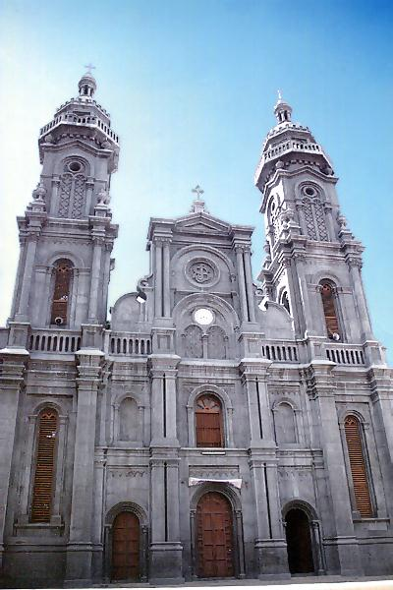
Velankanni (also spelt Velangani) is located 12 km south of Nagapattinam, on the Coromandel Coast, in Tamil Nadu. The shrine is dedicated to Our Lady of Health, the Madonna of Velankanni and is popularly called as 'Sacred Arogya Madha Church' and people of all faiths and religions visit it.
About The Church
The church has an imposing facade with tall spires and the wings present the shape of a cross. In a niche in the alter is enshrined the statue of Our Lady of Health. Many bring with them small gold and silver replicas of parts of the body to donate to the church. There is a small church museum which has a display of the offerings made by those whose prayers were conceded.
Legend Connected Behind The Construction Of The Church
It is here that in 1560, Virgin Mary is said to have appeared to a shepherd, asking him for milk to quench the thirst of baby Jesus. When the shepherd returned to his master, after performing the good deed, his pitcher kept filling up with milk. Consequently, a small thatched chapel was built at the site. At the end of the 16th century, Virgin Mary materialized again, in front of a lame boy, who, after the divine visitation, regained the use of his limbs. This occasioned the construction of an actual church.
The legends that go behind the construction of this Church are many-the most famous being that of the ship-wrecked Portuguese sailors, who in the 18th century, vowed to build a great shrine for the Virgin Mary, for saving their lives in a terrible storm.
On 8th September 1869, a Portuguese ship sailing from Macao to Goa, got caught in a massive storm in the Indian Ocean. The sailors, prayed to Virgin Mary to rescue them, promising to build her a magnificent church if she did so. Some time later, their wrecked ship was deposited on the shores of Velankanni. The sailors not only built a Basilica in Velankanni, but also returned year after year, bringing from their trips, exquisite items to decorate the church.
The Portuguese annexed the area and brought it under the jurisdiction of the Diocese of Mylapore. To commemorate the miraculous escape of the Portuguese sailors, every year a fascinating festival is held here.
The Outstanding Feature Of The Shrine
The outstanding feature of the shrine is the miracle angle attached to it. Ever since the sailors were saved three centuries ago, by dint of their prayers, Velankanni has acquired a formidable reputation of curing sicknesses and maladies, thus earning the sobriquet, 'Lourdes of the East'.
The tradition is to offer to Our Lady of Health, a candle in the shape of the respective ailment- a red heart in case of cardiac complications, a liver in case of jaundice, yellow lungs in case of tuberculosis and so on. In case of the ailment getting cured, the Virgin Mary and the church are to be thanked by offering a solid silver replica of the part of the body that has been cured.
Festival Celebrated
Every year a fascinating festival (29th August to 8th September) is held and pilgrims from all over the country and even abroad flock to the site, bathe religiously in the sea, have their heads shaved, (the hair later being auctioned by the priests), and then walk on their knees or roll up to the shrine, lending a unique Indian touch to the entire ceremony. The shrine also has its share of Hindu pilgrims.
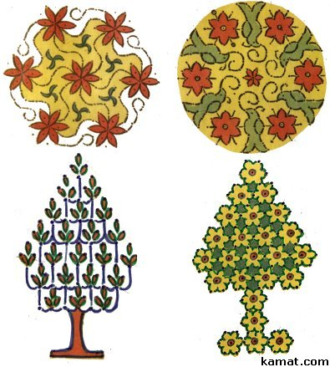
Costumes (already discussed)

Art (Kolam)
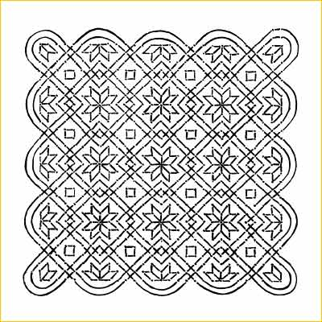
Kolam refers to decorative artwork drawn on the floor in front of houses and in front of deities in Puja rooms. Kolam is considered as an important form of artistic expression in India. Undoubtedly, Kolam can be called a most essential part of South Indian culture and it serves to embellish the doorstep and make it look more inviting. Moreover, it is a symbol of good fortune.
The Tamil month 'Markazhi' (mid December to mid January) is particularly important month for Kolams, when fairly large sized Kolams are put in front of the houses.
The Use Of Colours
The original Tamil Kolam merely consists of white dots around which the intertwined lines are drawn, whereas the North Indian "Rangoli" is made up of various colours. In recent times, the use of colours has become popular even in South India .
The Art Of Kolam
The "Kolam" is the most important kind of female artistic expression in India. It is a time old cultural tradition of South Indian families. Young girls learn this artwork from their mother, grandmother and aunties. The skill in drawing Kolams is still one of the criteria on the basis of which a potential bride is judged in rural areas.
Early at sunrise, women and girls clean the ground in front of their houses with water and cow dung in order to draw a Kolam there. They first outline an intricate geometrical pattern with individual dots, and then draw lines around these dots. Ideally, a Kolam consists of one single uninterrupted line.
The Kolam is an almost mathematical type of art that has its own fixed rules. According to these rules, the most intriguing patterns may be composed. Originally, Kolams were strictly geometrical, but gradually a more representational style has emerged which is used especially on festival days. Corresponding to the festival that is celebrated, the adequate paraphernalia, such as lamps ("Kuttuvilakku"), Shivalingas, temple cars, etc. are portrayed.
Use of Rice Powder in Kolam
In former times, Kolams also had another purpose: since previously rice powder was used for this transitory kind of art, the drawings also provided nourishment for smaller animals, such as birds or ants. Nowadays, however, quartz powder is used instead.
Rice powder serves to feed ants to show one must take care of other forms of life. The dry, coarsely ground rice flour is placed between the thumb and the forefinger and rubbed together and moved along a predetermined design by the drawer. This is an art taught at a young age and is difficult to master unless one practices.
The Designs
The entrance decoration is a gesture of welcome. It is a symbol of inviting Goddess Mahalakshmi to home everyday. The designs are symbolic and basically common to the whole country, like geometrical patterns with line, dots, squares, circles triangles, the 'Swastika', lotus, trident conch shell, leaves, trees and flowers. No gaps to be left anywhere between the line for evil spirits to enter.
Kolam is not only aesthetic pleasing to the eye, but makes home attractive and spiritual. "Navagraha Kolam", "Iswarya Kolam" are spiritual Kolams. For opening ceremonies, hotel promotions, "Bharata Natya Arrangetrams", Kolams are very popular. Foreigners also enjoy this traditional art.
Food
Cuisine of Tamil Nadu
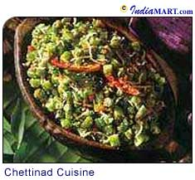
Tamil Nadu provides visitors with a wide variety of delicious food both for the vegetarians as well as the non-vegetarians, though most food in Tamil Nadu consists of grains, lentils, rice and vegetables. Spices are added to give a distinctive taste. Rice is the staple diet of the state. Idly, Dosa, Vada, Upma, Sambar, Rasam and Coconut chutney are the other common delicacies. Chettinad cuisine is a specialty in Tamil Nadu and is a delight for those who like hot and spicy non-vegetarian food. This type of food has several variations of fish, mutton, and chicken dishes of which the Chettinad Pepper Chicken is a specialty. The Tamil style of Mughlai food can be savoured in the Biryani and 'Paya' (a kind of spiced trotter broth eaten with either Parantha or 'Appam' (a type of Dosa)). Tamil Nadu, especially Chennai, is famous for its filter coffee, as most Tamils do not prefer instant coffee.
Chettinad cuisine
Hot 'n' Spicy
Known for its spicy, hot fare, Chettinad cuisine hails from the deep southern region of Tamil Nadu. Chettinad cuisine is far cry from the bland cuisine of traditional Tamilian Brahmins-it is one of the spiciest, oiliest and most aromatic in India.
Although the Chettiars are well known for their delicious vegetarian preparations, their repertoire of food items is famous and includes all manner of fish and fowl and meats, as well as delicate noodle-like dishes and carefully preserved sun-dried legumes and berries that the Chettiar ladies make into curries. Oil and spices are liberally used in cooking and most dishes have generous amounts of Peppercorn, Cinnamon, Bay leaves, Cardamom, Nutmeg, green and red chilies.
The main attraction of Chettinad cuisine is its variety, nutritional balance and the sudden surprises it springs on you. Their garlic pickles are out of this world. A lot of the food is very aromatic and heavily spiced, especially with pepper.
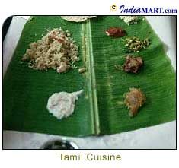
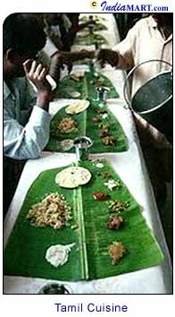
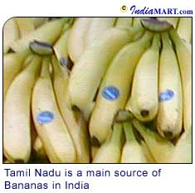
Other popular foods of Tamil Nadu
Popular Dishes
Some of the popular dishes in Chettinad menu are 'Varuval' - a dry dish fried with onions and spices (chicken, fish or vegetables sautéed), Pepper chicken, Poriyal - a curry, and 'Kuzambu', which has the ingredients stewed in a gravy of coconut milk and spices. Special mention must be made of their 'Kola Kolumbus' (Kofta gravies) and the sweet and savoury 'Paniyarams' (Dumplings). Breakfast or Tiffins include Idly or Idli (steamed rice cakes), Dosa (a pancake made from a batter of rice), Vada (deep fried doughnuts made from a batter of lentils), Pongal (a mish mash of rice and lentils boiled together and seasoned with ghee, cashew nuts, pepper and cummin seeds), and Upma (cooked semolina seasoned in oil with mustard, pepper, cummin seed and dry lentils). There are several variations of the dishes mentionedabove which are eaten with Coconut Chutney, Sambar (seasoned lentil broth) and 'Mulaga Podi' (a powdered mix of several dried lentils eaten with oil).
The Making Of Filter Coffee
Tamil Nadu, especially Chennai, is famous for its filter coffee as most Tamils have a subtle contempt for instant coffee.
The making of filter coffee is almost a ritual, for the coffee beans have to be first roasted and then ground. The powder is put into a filter set and boiling hot water is added to prepare the decoction and allowed to set for about 15 minutes. The decoction is then added to milk with sugar to taste. The final drink is poured individually from one container to another in rapid succession to make the ideal frothy cup of filter coffee.
Regular Tamilian Meals
Tamilians are essentially rice-eating people and they have preparations made of rice for all the meals of the day. Lentils too are consumed extensively, as accompaniment to the rice preparations. Being on the seacoast, coconut is also used a lot in Tamil kitchens, as are fish and other seafood. While tamarind is used for adding that distinctive tang, peppercorns and chili, both green and red, are used to make the food hot. To neutralize the effect of the chili, and soothe the stomach, curd is used in a variety of dishes. Other spices like mustard, cumin, garlic etc. are used for tempering and seasoning.
Though several communities in the state are strictly vegetarian, there is a whole range of non-vegetarian dishes - exotic, succulent, and full of fire. Fish and other seafood like crab are also cooked in the traditional Tamil kitchen with spices and traditional seasoning.
A Traditional Tamil Nadu Meal
In Tamil Nadu, food has a ritual purpose that reminds the individual exactly where he or she belongs on the culinary map of community consciousness. This is best seen during those occasions when members of any family or community get together to celebrate an occasion.
A Plateful
The 'Sappad' or food that is served on a banana leaf (even the size of the leaf varies from one community to another) is displayed like an identity card. One look and a guest will know the community, the status, the exact wealth of the family, and from which part of Tamil Nadu they originate.
The top half of the leaf is reserved for accessories, the lower half for the rice, and in some communities, the rice will be served only after the guest has been seated. The lower right portion of the leaf may have a scoop of warm sweet, milky rice 'Payasam', which should be lapped up quickly.
While the top left includes a pinch of salt, a dash of pickle and a thimbleful of salad, or a smidgen of chutney. In the middle of the leaf there may be an odd number of fried items like small circles of Chips made either from Banana, Yam or Potato, thin Papads, or frilly wafers, or Vada.
The top right hand corner is reserved for the heavy artillery, the curries, hot, sweet, or sour, and the dry items. If it is a vegetarian meal, the vegetables are carefully chosen, between the country ones-Gourds, Drumsticks, Brinjals - and the English ones, which could be Carrot, Cabbage, and Cauliflower.
If it is a non-vegetarian meal, in some cases, a separate leaf is provided for the fried meats, chicken, fish, crab, and so on. But again, the variations are presented carefully, one dry one next to a gravied one.
Major Culinary Delights
There may be a side attraction such as a 'Puran Poli' or sweetened Dal stuffed into a pancake, Sweet rice or any one of the famed rice preparations such as 'Pulisadam', bath particularly if the family comes from Thanjavur, known as the rice bowl of Tamil Nadu.
After having worked through the preliminaries, the long haul starts with the rice, which is generously doused with ghee. Sambhar, the highly spiced Dal-based dish containing whatever appropriate vegetable there is in season follows, and the Rasam succeeds this.
After a final round of rice and curds, or buttermilk or both, the traditional meal concludes with a small banana, a few betel leaves and nuts.
Tanjore paintings
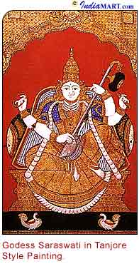
Tamil Nadu is known for its traditional ornate paintings, known as Tanjore paintings. This unique art form has its origin from Tanjore in South India. The portrayal of figures in these paintings is breathtakingly brilliant. The early paintings were embedded with real diamonds, rubies and other precious stones. Presently, pure gold foils and semi precious stones are used to adorn the paintings.
History Of The Art
Tanjore or Thanjavur as it is called today acquired its name from the ancient pronunciation of the place, which was then called "Thanjavoor". It was then the capital of the mighty Chola Empire. The Chola rulers besides being great warriors were builders of magnificent temples and great patrons of arts. It was against this setting that this highly specialised form of art with its characteristically beautiful ornamental relief work flourished.
The Tanjore School of Paintings dates back to the 16th century. However, there are only a few paintings that date back that far. The fact remains that most of the paintings that exist today are not even a hundred years old.
The Creation Of The Paintings
The creation of this painting involves a lot of dedication and several stages of meticulous work of art. The first step involves creating a base. The base is made of a cloth pasted over a wooden or a plywood base. Then a paste of chalk powder or zinc oxide mixed with some water-soluble adhesive is applied on the board. To create a smoother board a mild abrasive can be used.
After this begins the image making process. A preliminary sketch of the God is made on the board. After the drawing is made, decoration of the jewellery and the apparel is done with semi-precious stones. Semi-relief work is done with a paste of chalk powder and gum Arabic. Laces or threads are used to decorate the jewellery. On top of this, the gold foils are pasted. Finally, dyes are used to add vibrant colors to the figures in the paintings. A beautiful frame is then selected to accentuate the beauty of the painting.
The Paintings
The paintings are mostly of Gods and Goddesses because this art of painting flourished at a time when fine-looking and striking temples were being constructed by rulers of several dynasties. The figures in these paintings are large and the faces are round and divine. However, with the rebirth of this art in the 20th century, artists in addition to recreating the original Tanjore figures are also experimenting with more proportioned figures, birds, flowers, animals, etc.
The paintings are notable for their adornment in the form of semi-precious stones, pearls, glass pieces and gold. The rich vibrant colours, dashes of gold, semi-precious stones and fine artistic work are characteristics of these paintings. They add beauty and culture to a variety of surroundings and decor.

The Puppet Show
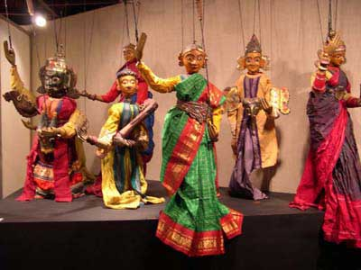
The shadowpuppets ('tol bommalatam') are manipulated by the group Selvaraja Shadow Puppet Group. Somewhat akin to shadowpuppets from Andra Pradesh and Karnataka, these puppets are smaller in size. The theme is taken from the Ramayana. Musical accompaniment is with a harmonium, a drum and cymbals
The string&rodpuppets ('bommalatam') are manipulated by the group Sri Murugan Sangeetha Bommalatta Sabha. They are closely related to the string&rodpuppets of Karnataka. Both strings and rods are used for manipulation. In addition to the strings, the puppets have an iron stick extending from each hand to form a rod, with the other end fixed in a wooden handle. The strings at one end are tied to the ears and the centre of the head of the puppet, and at the other end to a cloth-covered iron ring placed on the head of the manipulator. The play is based on the Ramayana. As in the traditional theater forms of the region, the play begins with an invocation to Ganesh, and includes the clowning of the jester. Two singers, one male and one female, along with a flute, drum and cymbals, accompany the performance.
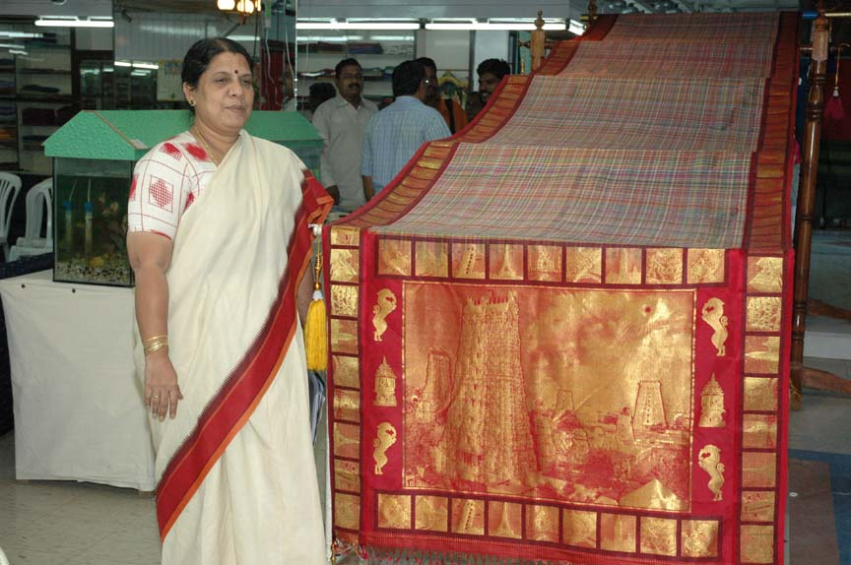
UNIQUE KANCHEEVARAM SAREE ON DISPLAY

Flowers

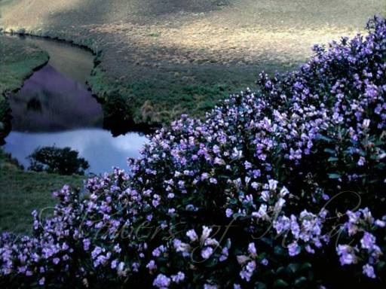
Kurinji flowers of Kodaikanal(Botanical name: Strobilanthes kunthiana, Phlebophyllum kunthianum)

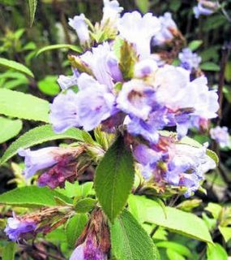
Kurinji flowers, the special flowers which grow in and around Kodaikanal cannot be found any where else in the world. Kurinji flowers are blooming on the declivity of the Kodaikanal hills, particularly near the Kurinji Andavar temple.
The Kurinji flower is native to South India, growing only in the Anamalai, Nilgiris and Palini hills in Tamil Nadu. It does not grow anywhere else in the world.

Though there are about 50 varieties of Kurinji, the blue coloured variety blooms only in 12 years, environmentalists say some plants started flowering in october2005 itself. But2006 is the peak season. Flowering of each plant commences after completing its cycle.
The peak flowering season will continue till 2006-end and may extend up to 2007, all plants do not flower at one time. With germination rate, multiplication of this species in this region will also be high. To protect and preserve the species, areas where the Kurinji grow should be protected and preserved feel botanists. A large valley with numerous Kurinji plants, between the Pambar river and Vattakanal below Coaker’s walk, was identified for creating a sanctuary in April 2004.
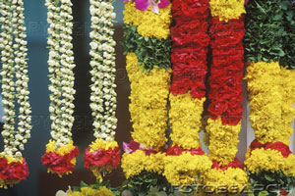
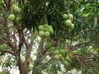
Mangoes

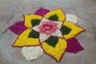

SEASONS
There are six ritus or Indian seasons in the Hindu calendar. The following table gives an overview about the partition of the year in the traditional Indian calendar.

No. | (Rutu)Hindu  calendar | Season | Gregorian months
1 | hemanta | pre-winter | December to February
2 | shishira | Winter | February to April
3 | vasanta | Spring | April to June
4 | griishma | Summer | June to August
5 | varsha | Rainy | August to October
6 | sharat | Autumn | October to December

Most of India has three seasons: a hot dry season (February to June)-summer, a wet monsoon season (June to October)-rainy, and the cool dry season (November to February)-winter.
Seasons | Festivals
Summer | Pongal, Ramanavami Tamil new year’s day
Rainy | Almost all other festivals
Winter | Deepavali., Karthigai Deepam

Tamil Script- A glimpse

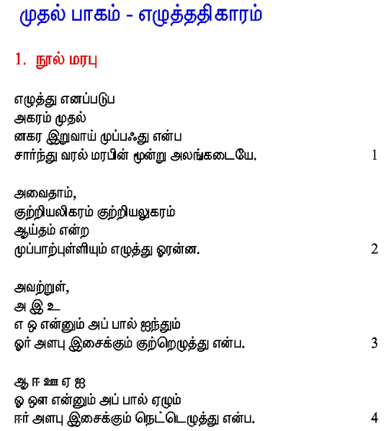

The End

