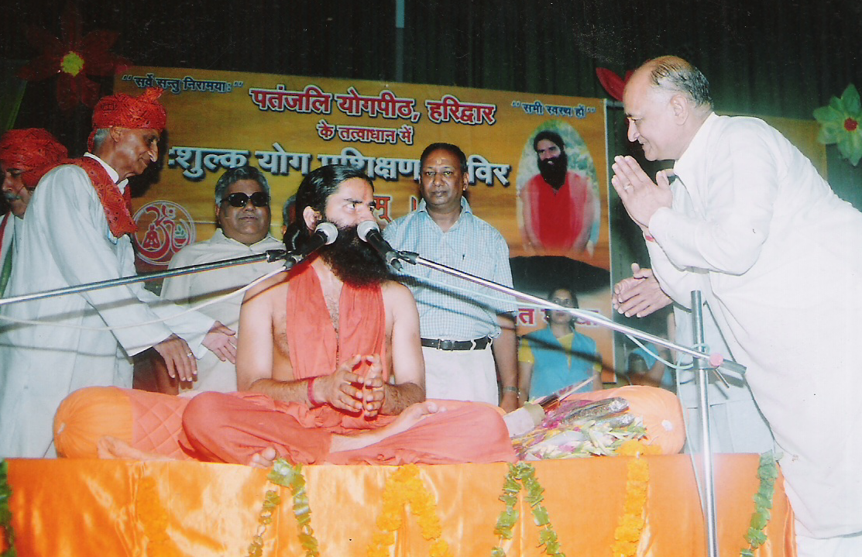
Mr Ram Niwas Gupta,Chairman, S.D.Vidya Mandir greeting Swami Ramdev, A renowned Yoga Guru
in the school. Such programmes are a routine feature here as he believes stronger the health and character of students ,stronger the nation be

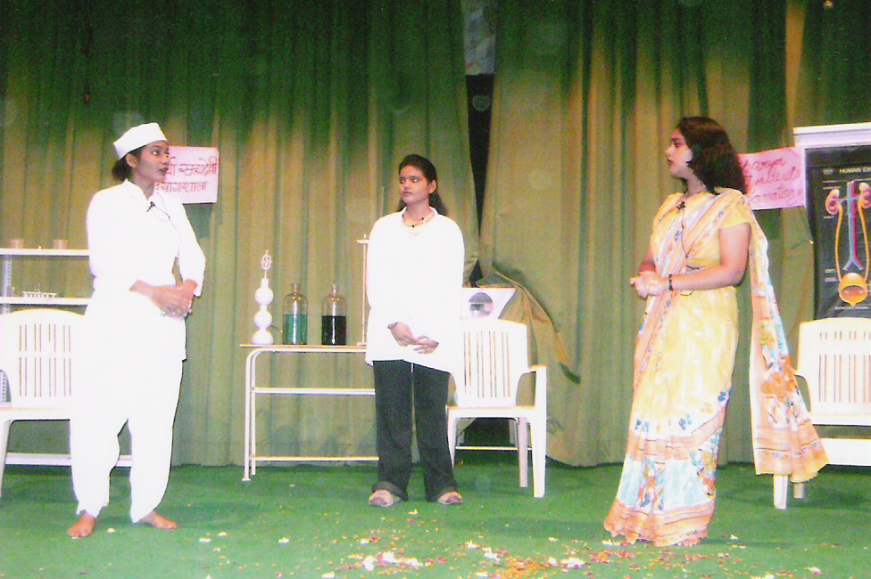
Return of the Prodigal Son (Laut ke Buddhu Ghar ko Aaye)
A play health awareness by the students of S.D. Vidya Mandir

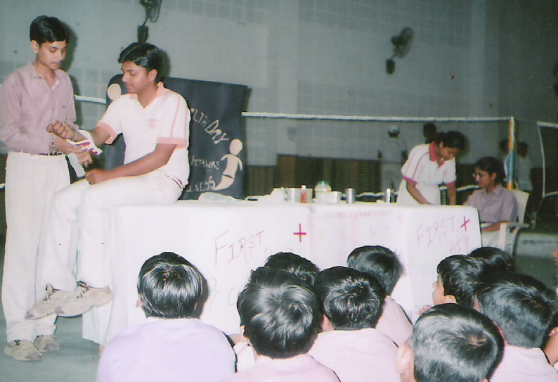
A Demo of the First Aid

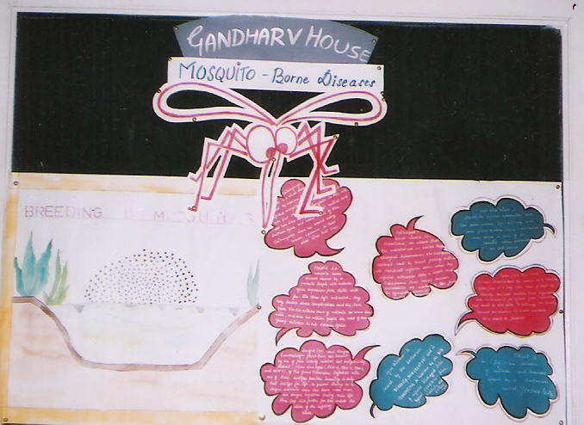
A still of school Display Board-Theme Mosquito-borne diseases

