In our beloved school some pupils come by
school buses.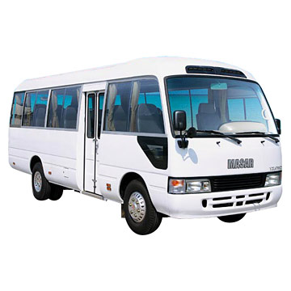
Some come by their cars or with the driver . 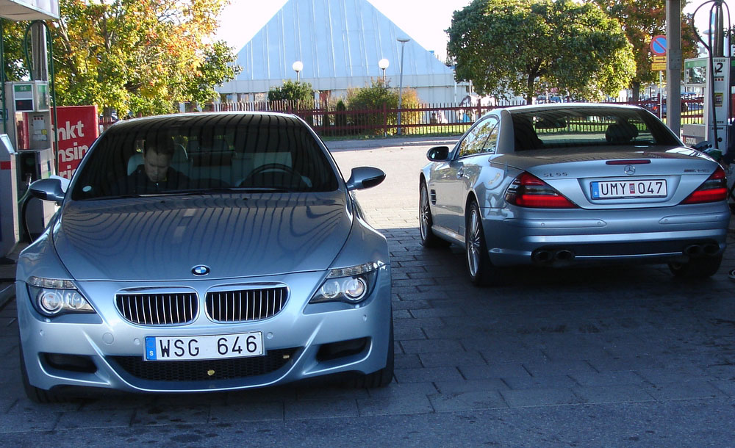 pupils have new friends and meet their new teachers. Teachers will ask students about their

vacation and candies are given to the children by the school as a welcome. Books are given from the first day and light lessons start. At the end of the day, some teachers stay waiting until the last student leaves.

