
A Play in the Intermediate Section
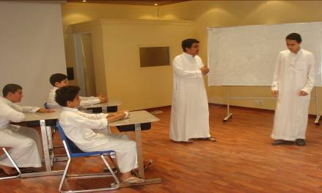
A group of middle school students in the English Department, along with Mr. Amir Al-Maagbeh, have spent the semester working on a play entitled, “The Educational Crisis”. The audience was introduced to two separate classes, a successful one and a failure, to compare and contrast the aspects of the educational environments, including the interaction between the teacher, students, and curriculum.
A news report is presented between the two classes to increase the awareness of the audience on the “Educational Crisis we are living in many classes throughout the nation”. The play ends with the reporter asking the audience the powerful question, “Education is no longer education; but who is to blame?”
T. Amir Al-Maagbeh

