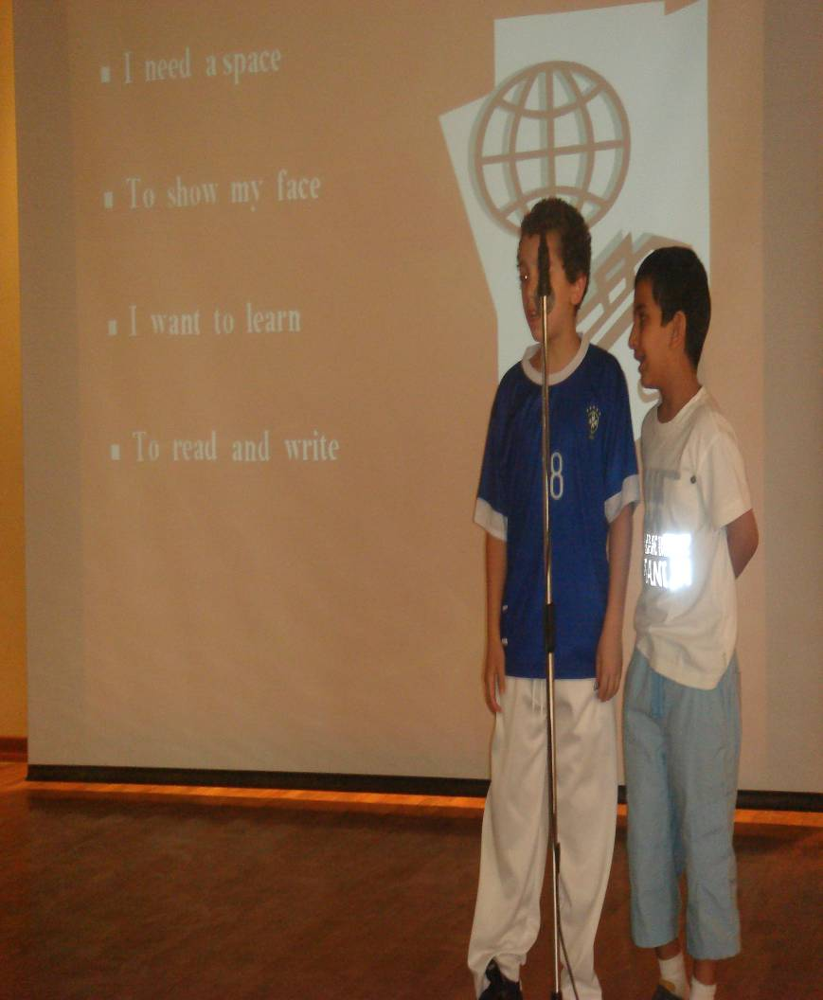

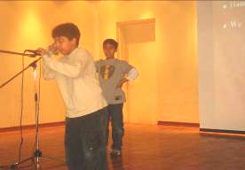
Hand in hand

- We all will stand

- To play and sing

- It is our right
- To feel and say

- It is my way

- I’m free to think

- It is my right
- Hand in hand

- We all will stand

- To play and sing

- It is our right

- To live secure

- I need for sure

- To be at home

- It is my right
- Hand in hand

- We all will stand

- To play and sing

- It is our right
- My mum and dad

- With them I’m glad

- They help me know

- What’s wrong what’s right
Some pupils sing songs on the school's stage.

