A day at school
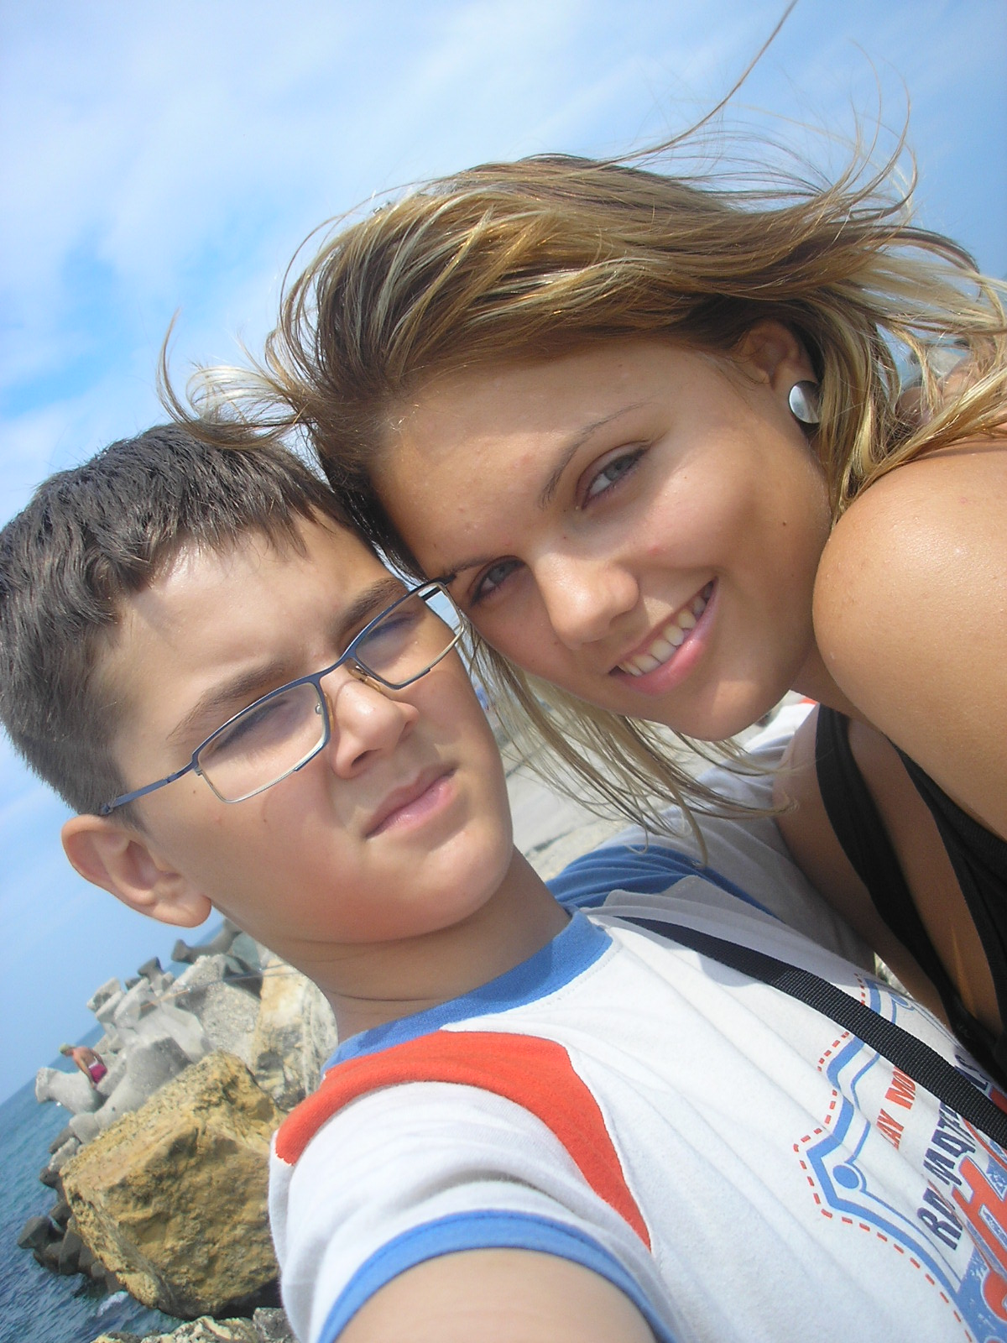

Hello everybody.My name is Alexandru and I’m twelve years old.I’m in the 6th grade at the School no.94.I live in Bucharest,Romania, with my parents and my older sister,Andreea.

I have a quite attractive lifestyle.Every morning during school I wake up at 9 o’clock a.m..The first thing I do is to brush my teeth and after that I wash my face. Usually,I take a shower. My favourite breakfast is made of cereals and milk.
After that I go watching TV,or most of the time I play computer games like Fifa2008,Lineage2,Conquiztador,Devil Pims with my friends on the internet.

In the rest of the time that remains me I do my homeworks.At 11 o’clock a.m I leave home and I’m going to my grandparents to take the lunch with them.My grandmother is an extraordinary cooker and her food is delicious.I dress up my red uniform and I do my hair.

The courses are starting at 12 a.m.At school I meet with my friends and classmates.Today,for example,I’ve had Mathematics,Novel,French,English and Geography.I’ve took a 10 at Novel because my teacher was delight of my composition about an imaginary world create on my own.During the breaks I play football with my fellows and I have a lot of fun.

I end the school day at 5 o’clock p.m.I get home and I sleep for 2 hours because in the evening I love watching movies with my sister on our PC.I took the dinner with my parents at about 9 p.m.After that I read a book(because my sister forces me) or I go to bed later in the night.
I hope you have enjoyed discovering one of my usually days at school.

THE END

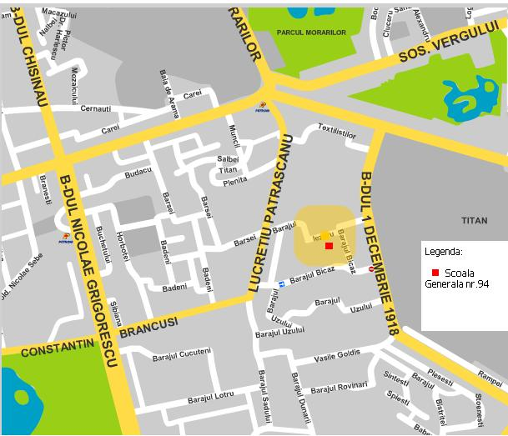

The map of my school:

