POTTER’S CLAY

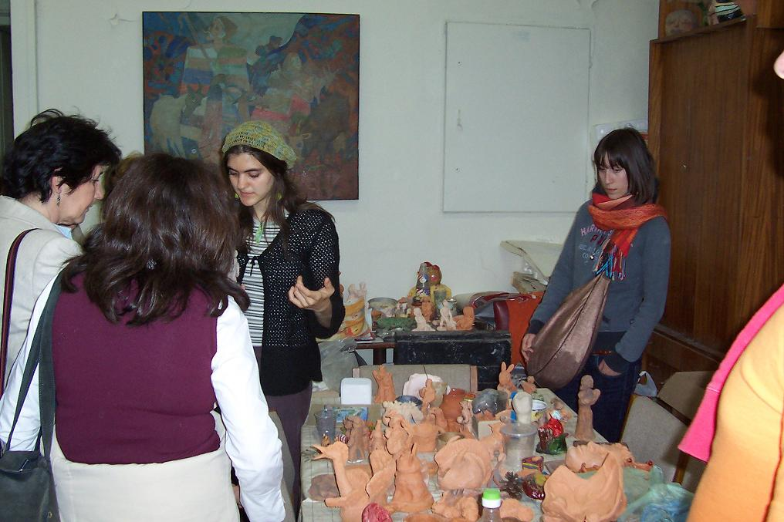

It wasn’t easy. It was difficult, to be telling about what I’m used to feel with the hands

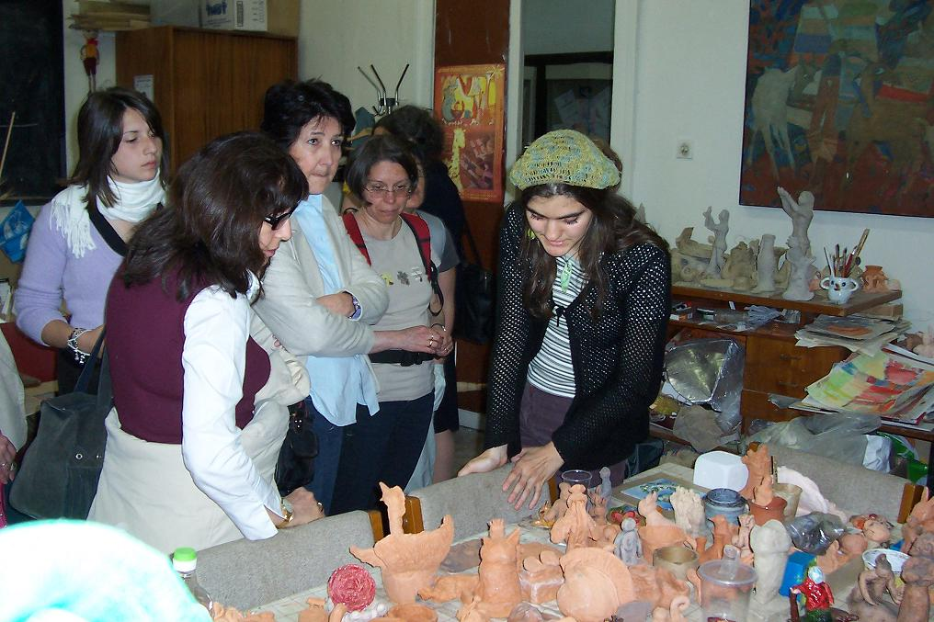

And yet, they were helping me – the numerous things of ceramics – creations, I would say, that can alone wonderfully speak for themselves and the way they were made – with love.

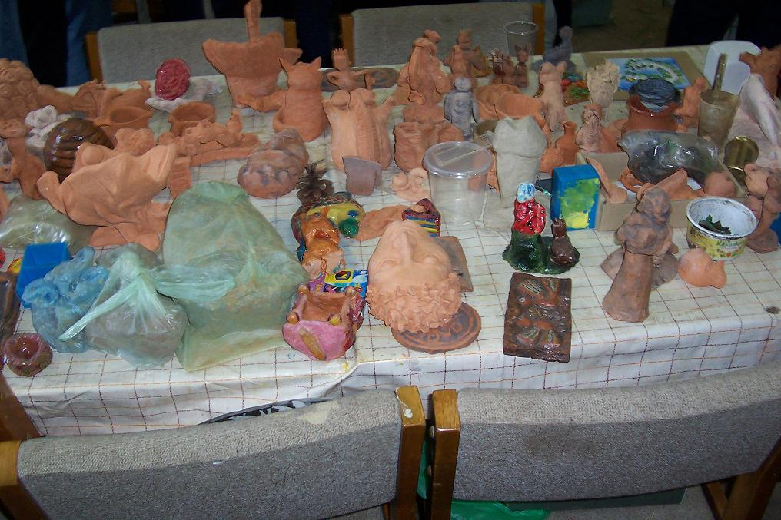

Yes – they are numerous – the baked masks, birds, vessels, human figures, coloured boxes and mugs.

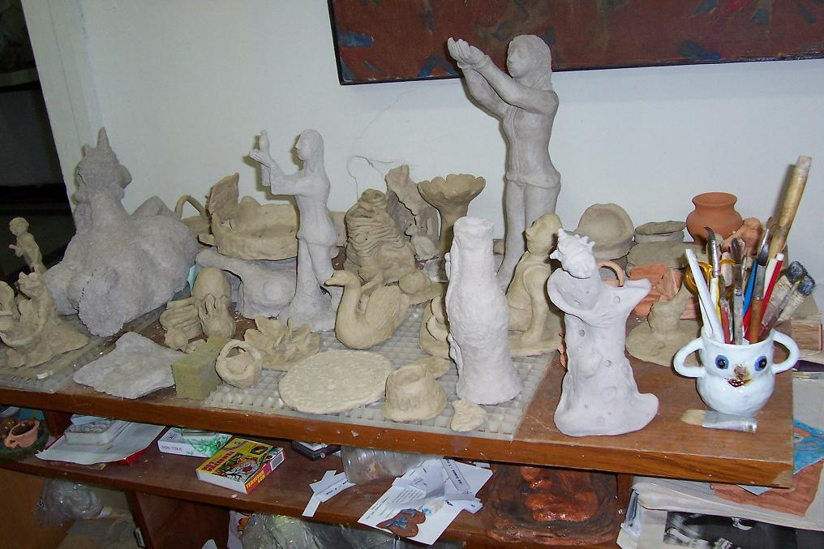

And also the (yet) unbaked.

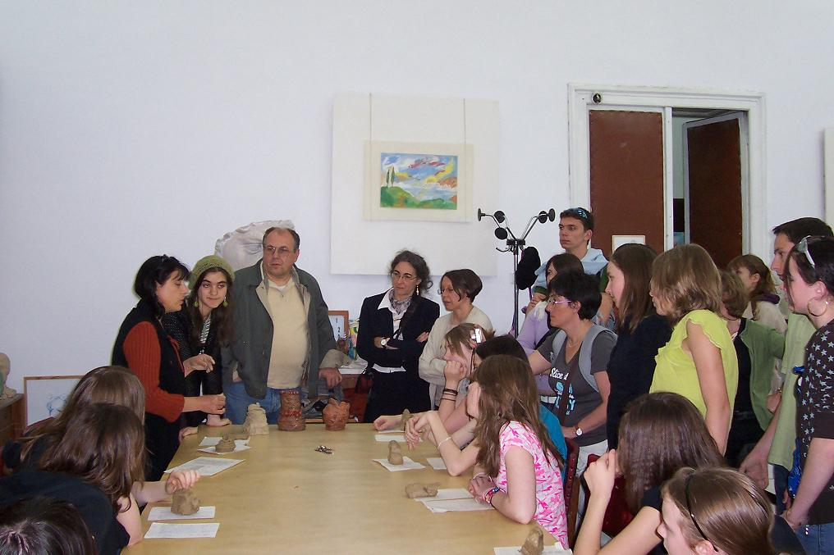

And still – there was Viara. Always a tower of strength in difficult times.

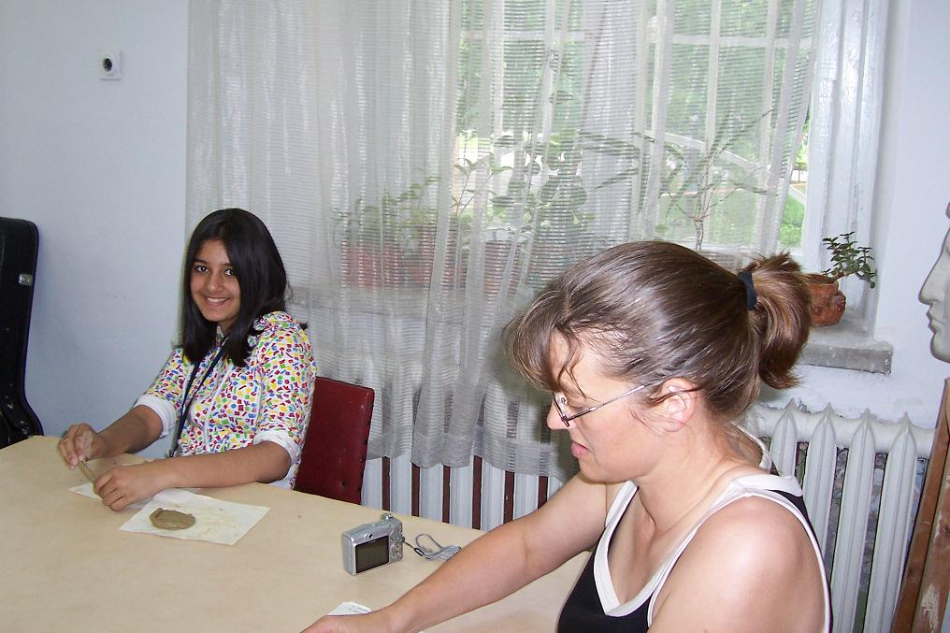

And with all these people, that, I think, now I can freely call friends, the task became really pleasant.

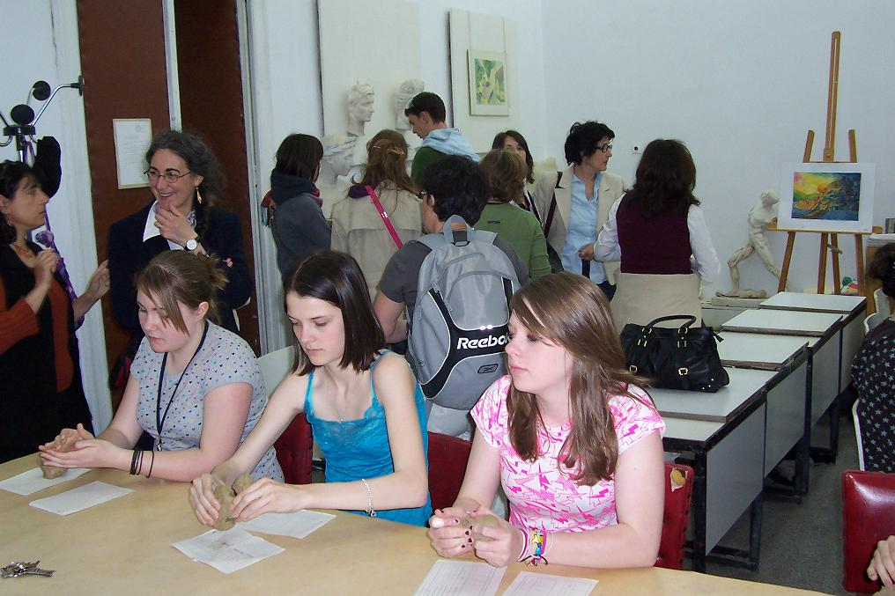

And I think that they were also interested – they seemed so thorough.

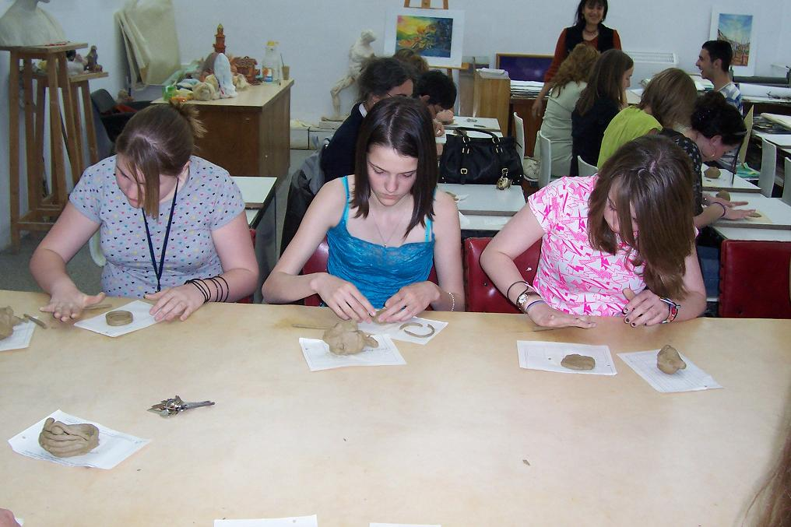

And hardworking.

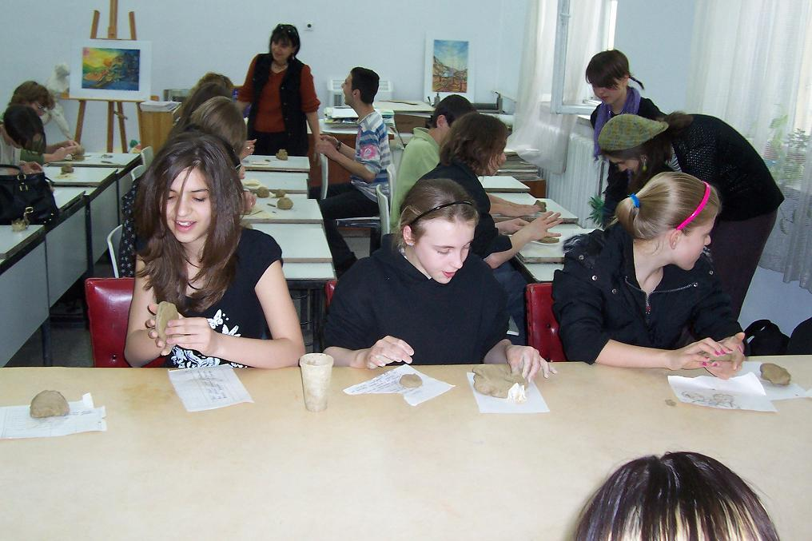

Really.

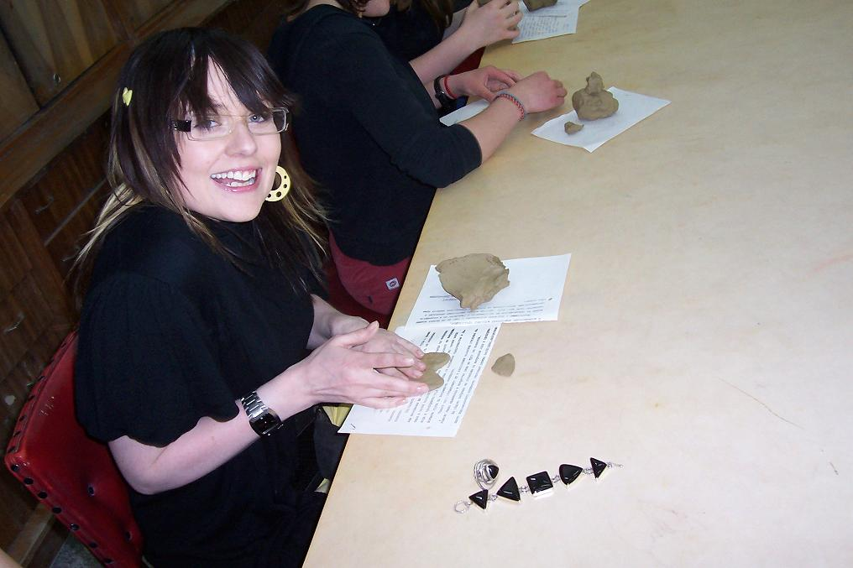

Their smiles clearly showed it.

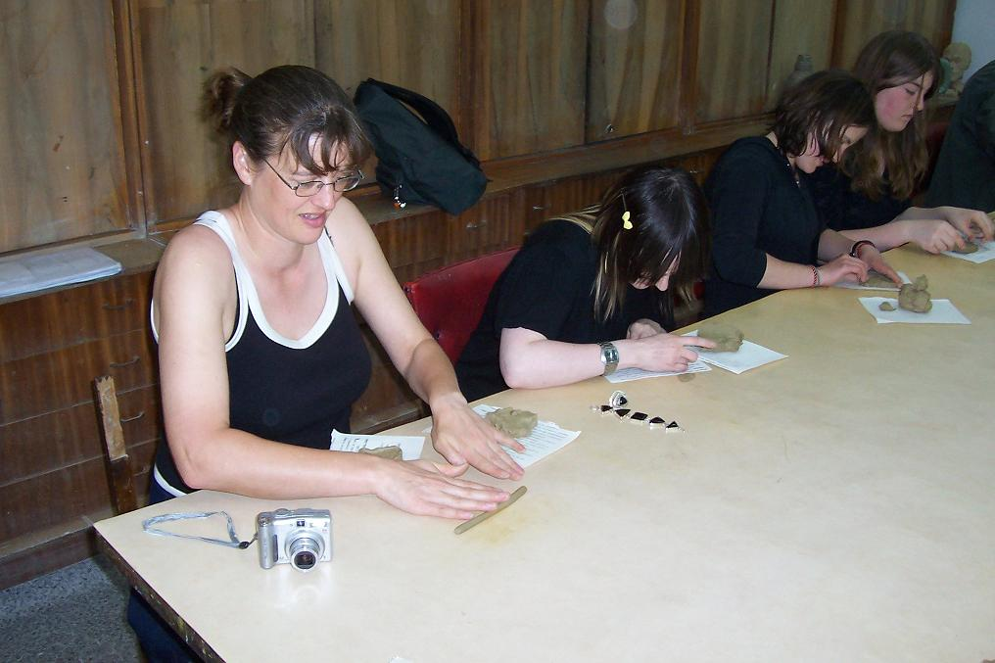

And their looks – pointed, thinking.

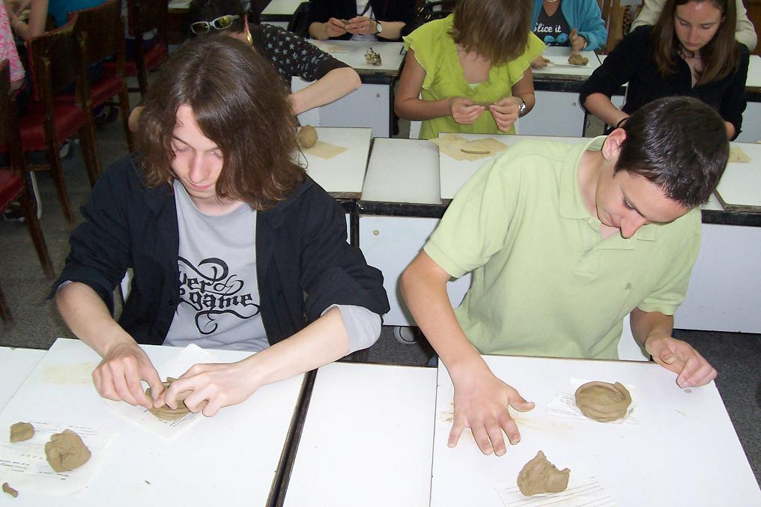

And indeed – wonderful things were being made.

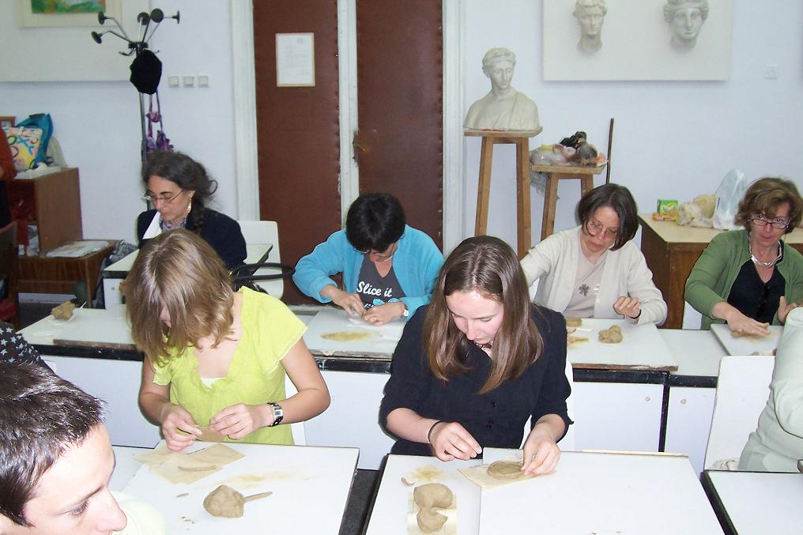

As Viara says, the more the children, the bigger the variety of the objects that are made.

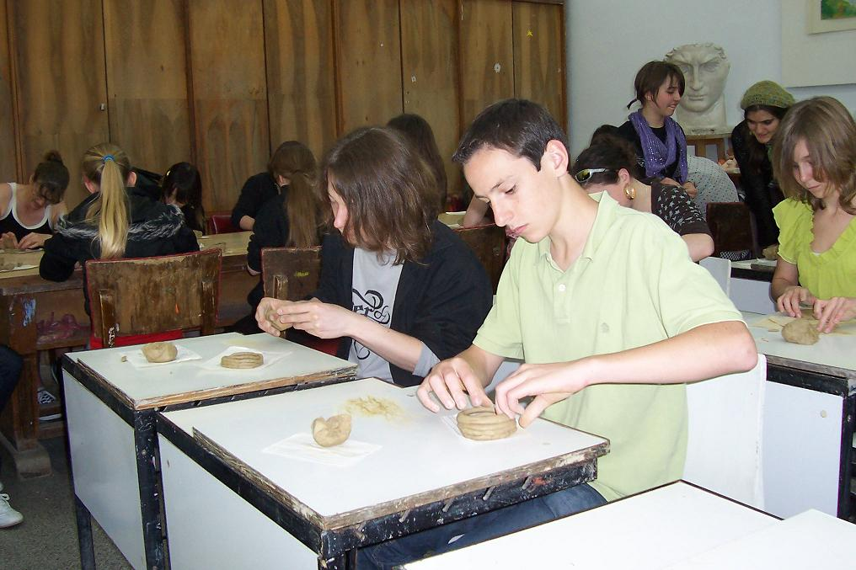

And there really were many creators.

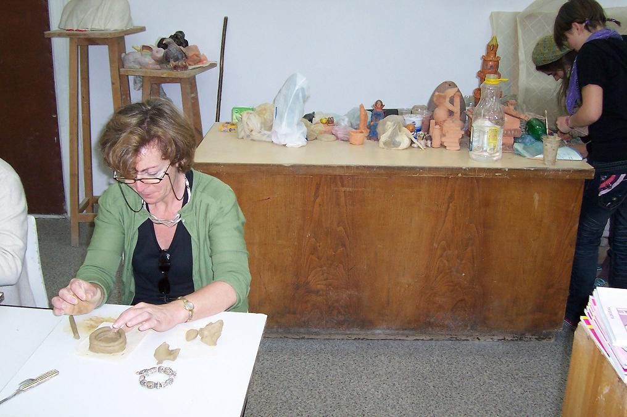

Among the adults too.

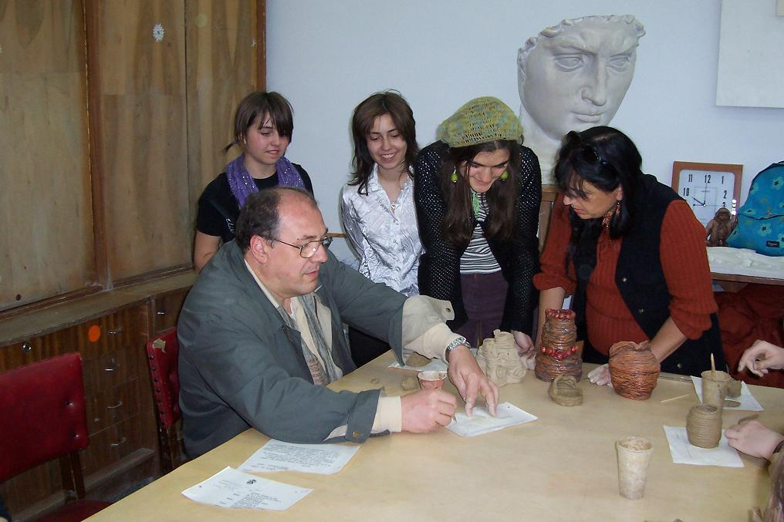

Even so very good that we all wondered how come they had not been dealing with art before.

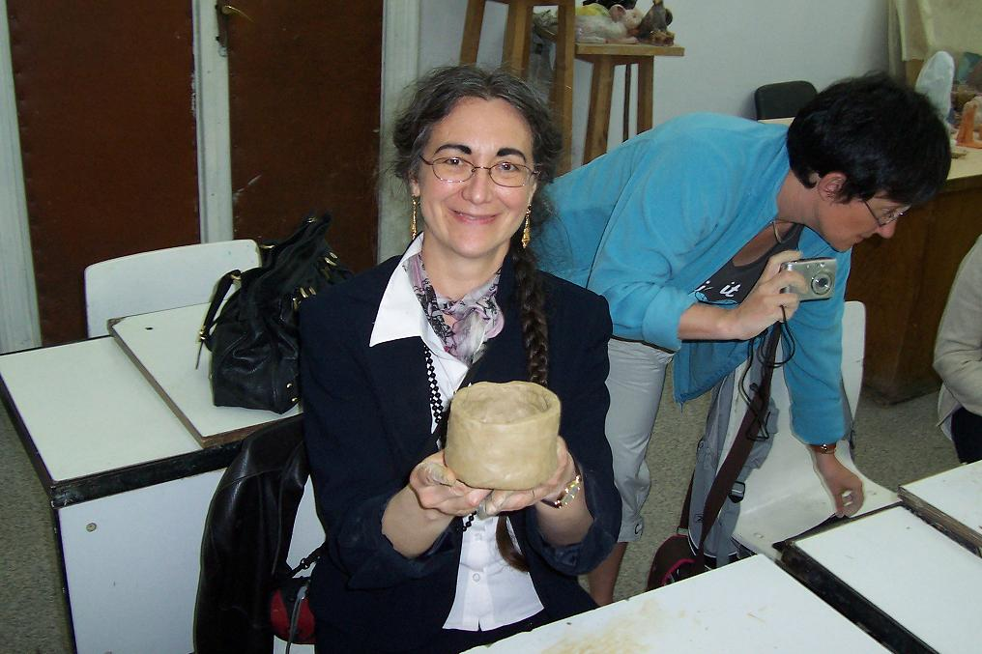

We leave it to you to say - whether you succeeded in making the perfect vessel,

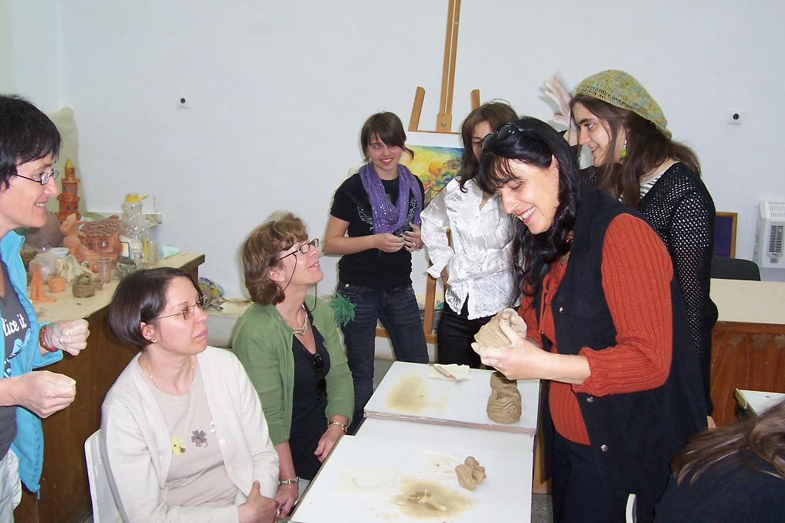

whether you enjoyed it all as much as we did,

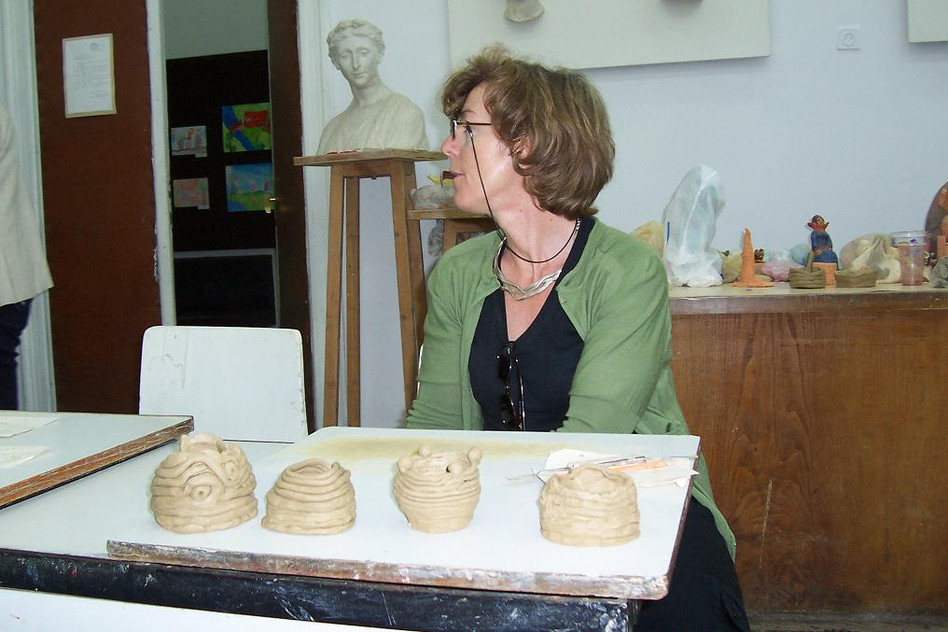

and you appreciated the beauty and uniquity of your own creations
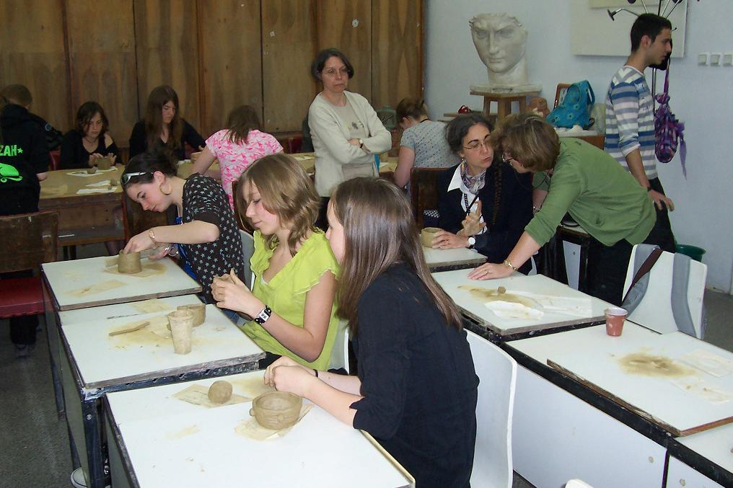

and the working process,

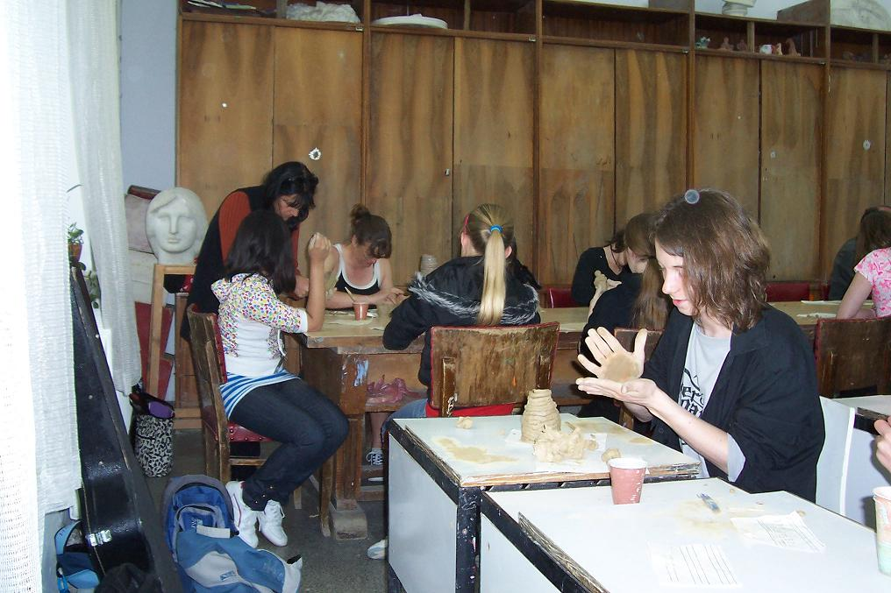

in which people who were touching clay for the first time in their life were making prehistoric ceramics and an atmosphere of joy and ease around them.

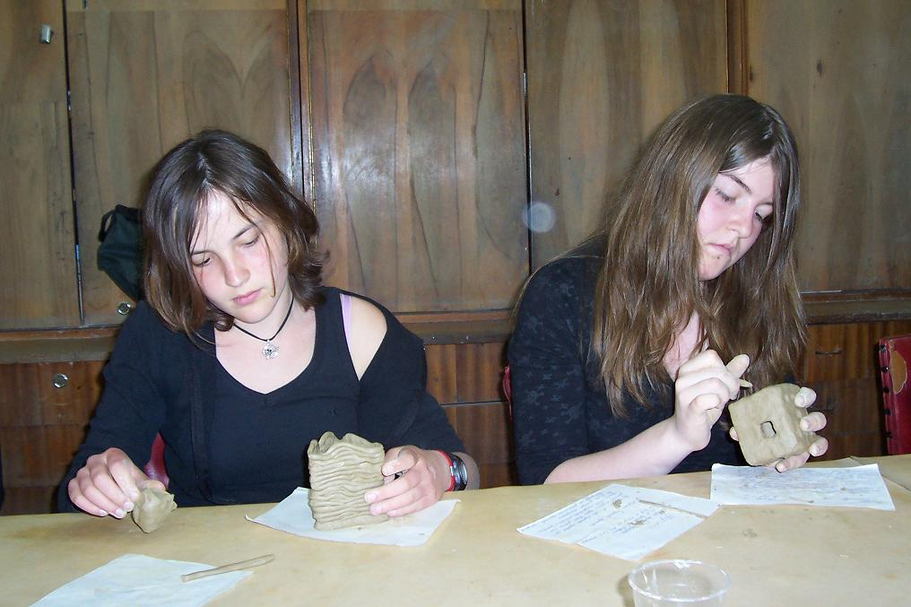

Vessels with pointed edges, with little windows,

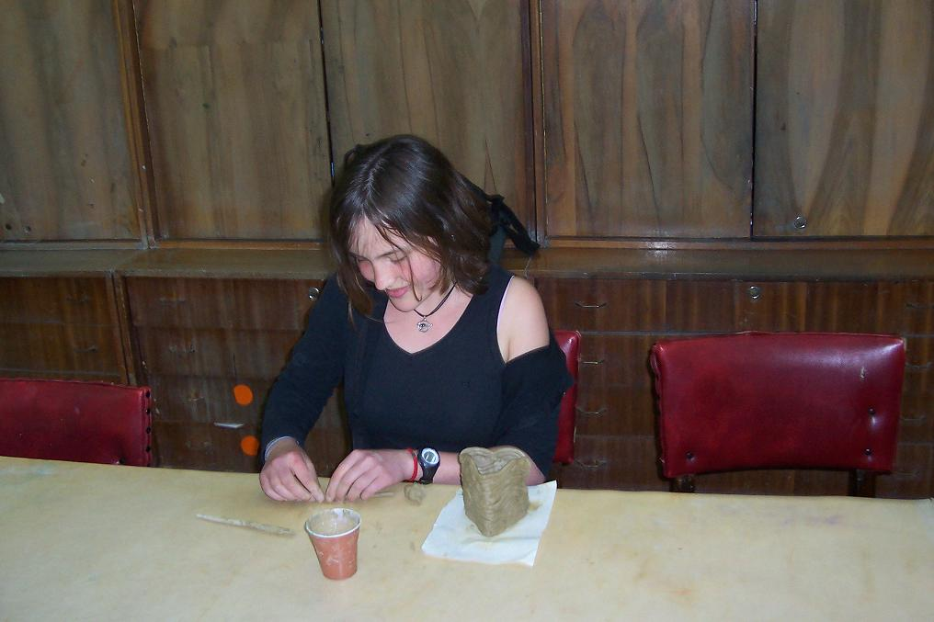

in the shape of a heart,

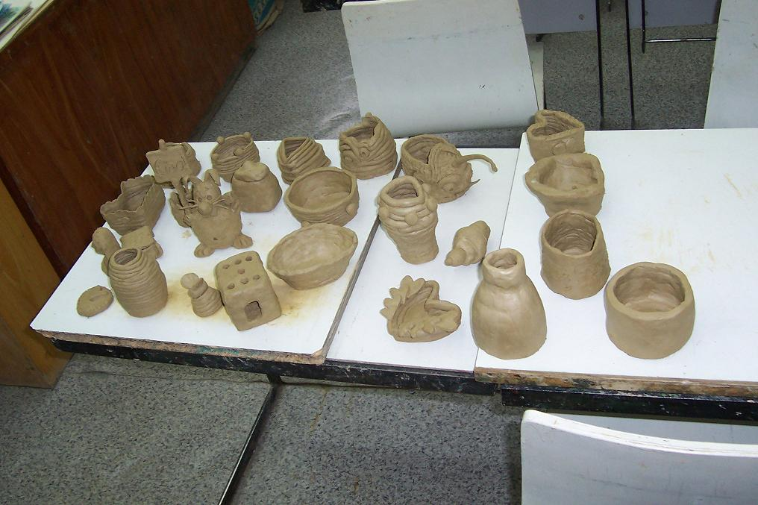

of all kinds.
Them we have as a memory of you.

Until the set off to their rightful place and possessors – are you expecting them?

Vesi and Roksana and Mariana Krachunova

