How to solve water problems at Home

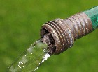

1. Learn When to Water
With landscaping season in full swing, prevent waste with tips for smarter ways to water your lawn and garden...



2. Recycling Water at Home
Get creative and save precious water by reusing your home's "gray water."..

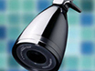

3. Low-Flow Showerhead
Keep comfort high and water usage low with an air-injected showerhead...

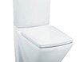

4. Upgrade Your Toilet
Low-flow toilets have gone high-tech. New models can trim up to $90 from your yearly water bill...
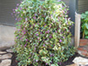

5. Rainwater Catchment System
Capture reusable rainwater and refresh your garden or lawn with this simple catchment system...

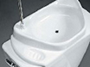

6. Recycling Bathroom Water
Reroute used sink water to your toilet with this unusual but waste-preventing addition...

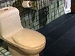

7. High-Tech, Low-Flow Toilets
An old toilet is a big water waster. Switch to a dual-flush, low-flow or even composting toilet and start saving...
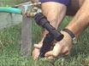

8. Drip Watering
Drip irrigation delivers water exactly where it's needed — the root zone — and spares the waste.

