Mlechna banica
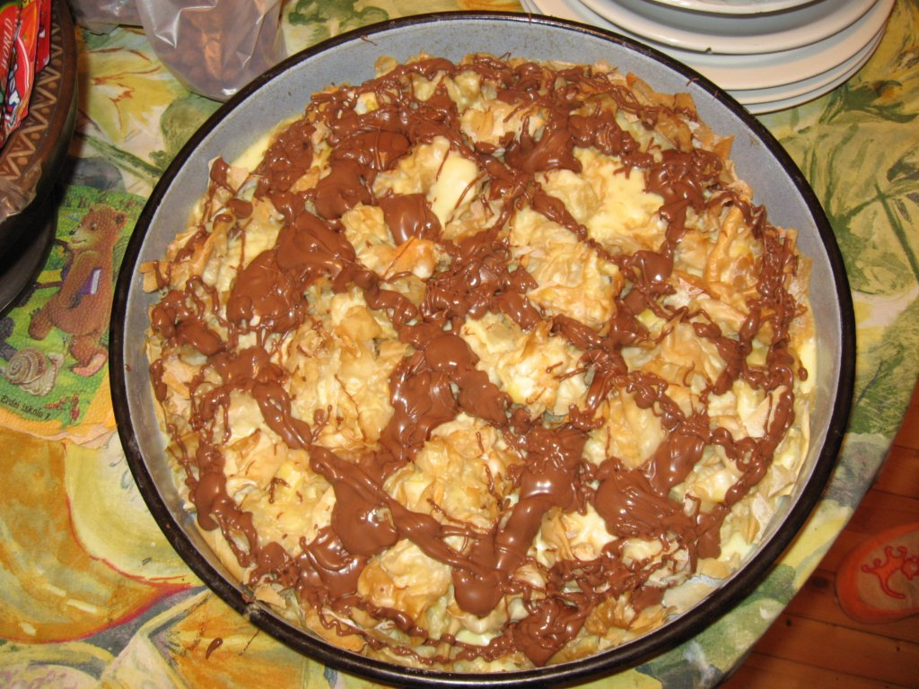
Products:
350 grams flour
1 / 2 teaspoon of salt
1 tea glass water
2 packets of butter
For pouring:
1 liter of milk
200 g sugar
5 eggs
1 vanilla
Method of preparation:
Put the flour, water and the salt and mix a dough. Leave it for a while and then divide it into small pastries. Smear hearty each crust /pastry/ with melted butter and cut strips. Spread in a large baking dish with butter each pastry strip. Set to bake in moderate oven until it becomes golden. Then remove from oven and leave to cool up. During this time in a pan beat the milk and sugar. Let the ingredients melt. Slightly, add the shattered eggs and vanilla and add the mixture on the baked pastry. The banitsa should be baked into a moderate oven until thickening of the pouring. The banitsa is served cool, cut into square pieces and if you like you can pour it with melted chocolate.

