SOME IDEAS HOW TO CREATE ACTIVITIES USING POSTAGE STAMPS
1. ELIMINATE THE INTRUDOR:

1. 2. 3. 4.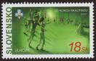 5 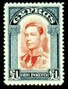

2. THREE IN LINE-BUT WHY?

  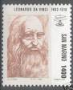 ______________

3.MAKE A MEANINGFUL SENTENCE WITH ONE STAMP

- 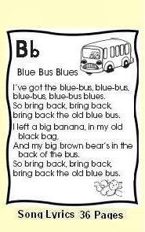 b) c) d) 
_____________ ______________ ___________ ___________
4. MAKE A SENTENCE using/choosing TWO STAMPS

a)  b) 
______________________ ____________________________
5. CREATE A SHORT POEM/ AN ESSAY/ A STORY /DESCRIBE/change form…

1. 2.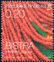 3. 4. 5.