To add your files to your project page follow these steps.

- Login to eLanguage

- Go to your project page

- Switch to edit mode

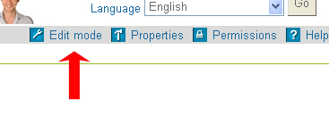

- Click on the add icon where you want to add your file

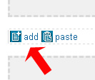

- From the add resource option choose the appropriate option. If it’s a Powerpoint then choose ‘file’

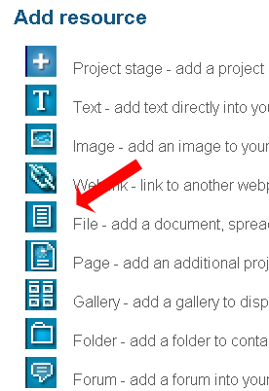

- Browse to where the file is on your PC, write a short description. Select the appropriate MIME type, for example if it’s a powerpoint file choose this option. Click save and the file will upload to the page.

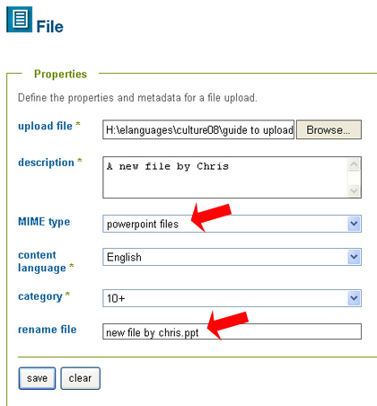

- Tell everyone that you’ve uploaded some new work. Tell them that your students are looking forward to seeing new work from the other schools. To do this click on the ‘Send email to all members’ link.
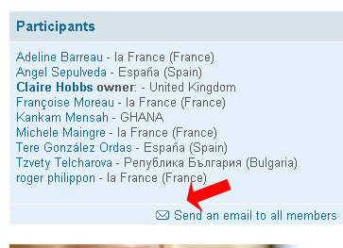

8. email elanguages@britishcouncil.org if you have any problems at all

