Sofia - The New European City

The Name
Once upon a time… This is how each fairytale begins. This is how our story begins too - the story of the capital of Bulgaria, Sofia. Once upon a time in The Roman Empire a beautiful princess lived, called Sofia. She was clever and kind and everybody loved her a lot. However, the happiness of the princess did not last for long, as she got ill. Doctors from all over the world tried to cure her but they didn’t have any success. Not very far from the capital of The Roman Empire there was a small town with magical therapeutic water. The ill princess understood about the qualities of this water, which was her last hope. Sofia came in the small town and not long after that she was cured. Her father was so happy and grateful that he built a church in the town and named this church after his daughter – Sofia. It was not long time after that and everyone started talking about the church of Sofia and the magical water in the town. Gradually everyone started to call this town Sofia. This is how it is called at present days. | 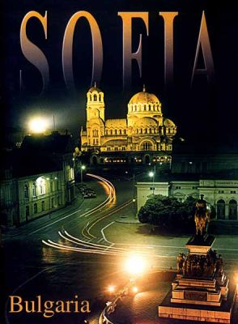

Politics
As the capital of Bulgaria, Sofia is not only a cultural but also political centre of the country. Sofia is the seat of the government, the council of ministers, the Parliament and the President of Bulgaria- Mr. G. Purvanov. Here are located the most important ministries- TheMinistry of Internal Affairs, The Ministry of Foreign Affairs, The Ministry of Defence, The Ministry of Education.

Education
In the capital, there are some of the best schools and universities in Bulgaria. We should mention:‘The English High-School’, ‘The German High-School’, ‘The High-School of Ancient Languages and Culture’ and “
‘The National School of Fine Arts’, ‘The American Gollege’,where some of the best and most talented young people of Bulgaria go to high- school.
There are prestigeous primary and middle schools – private and public;here we should mention one of the best private primary schools – ours :‘St.Sofia’. In Sofia is the oldest university in our country is located- “The University of Sofia St. Kliment Ohridski”. There are numerous of other qualified universities, where one can find not only education on a high European level, but also qualified teachers and some of the best libraries in Europe.

Rest And Vacantion
Not far from Sofia is one of the biggest, oldest and most beautiful national parks in Bulgaria is situated-The National Park Vitosha. Rich in flora and fauna the mountain offers not only excellent opportunities for ski tourism but also for rest of full value.

Culture
Sofia is a city with numerous theatres, concert halls, galleries, cinemas, museums, churches and other places of interest. There are a lot of tourist attractions in Sofia.
The National Theatre "Ivan Vasov" | 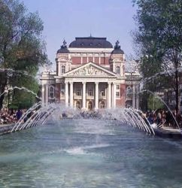

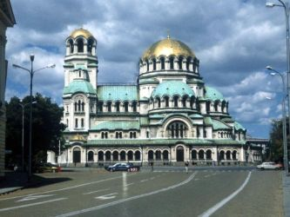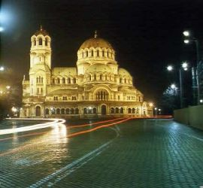

The Alexander Nevski Cathedral

