Ksenija Vidmar-Nincevic, Zadar, Croatia
ZADAR
- COASTAL TOWN ON THE ADRIATIC
- Surrounded by 4 National Parks
- 3 00 years old historic town
- Perfect combination of old and new sights:Roman Forum and Sea organs
- Inhabitants: 100 000
- Climate: mild, meditterranean
- The most beautiful sunsets
- BRANDS: Marascino, sea shells, lace from Pag, fish, olive oil, vine…..

2. 2 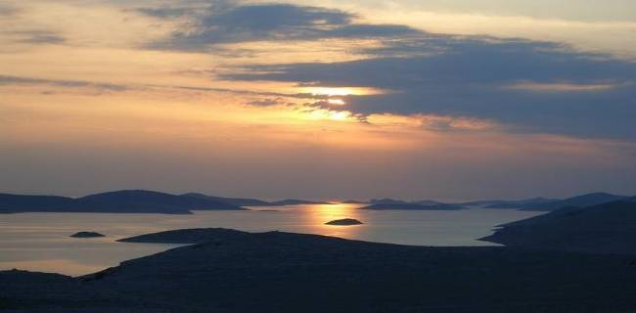 13  4. 
1.PLITVICE
2.KORNATI
3.KRKA
4.PAKLENICA

OLD ROMAN FORUM the SEA ORGANS
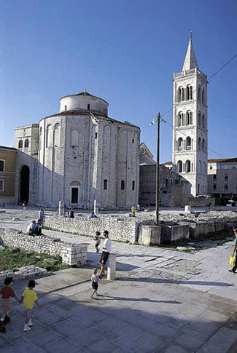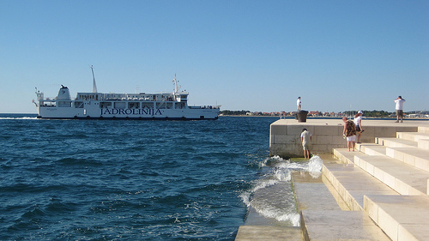

FOSA-a gate to old peninsula NIN-the smallest Cathedral in the worls
a) b) c)PROTECTED PLANT from Velebit
