Bulgarian Traditional
Food

Each country has its traditional food. The traditional food depends on the country’s customs, its climate, its nutrition needs or its location...
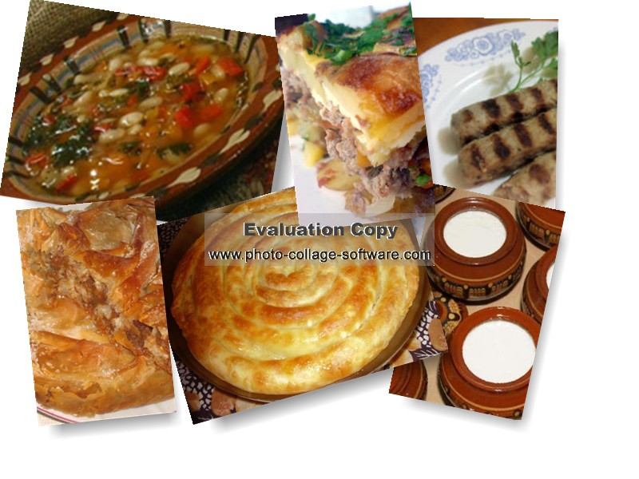 Bulgaria has food which is typical only for Bulgarians. We have a big choice of traditional food, but I will to introduce one of the most favorite Bulgarian dishes ,,musaka”.
Maybe it sounds strange, but is so delicious! How can we cook this dish?
The first stage is:
to have the following ingredients:
  - 500gr. Minced meat
  - 1 kg.peeled potatoes
  - 2 or 3 tomatoes
  - black pepper
  - paprika
  - salt
  - savory
  - some fat, oil and two bunches of onions

The second step is the covering mixture or the pouring.
What we need is:
  - one egg
  - 1cup of yogurt or milk
  - two spoonfuls of flour
  - 1\2 bunch of parsley
And now the last step of making it:
Cut the onion and fry it for a while in vegetable fat, add grated tomatoes and then mince. Mix in order not to leave large pieces of minced meat. Add the spices-black pepper, red pepper and savory. Potatoes are peeled and diced, put in the pan, salt is added to the mixture of tomatoes and minced, stirred and is flush with water while covering the flat mixture. Roast the mixture in an oven until it becomes red. Then pour the prepared mixture of eggs, flour, milk and some salt. Bake again until reddening of topping.
Good appetite !
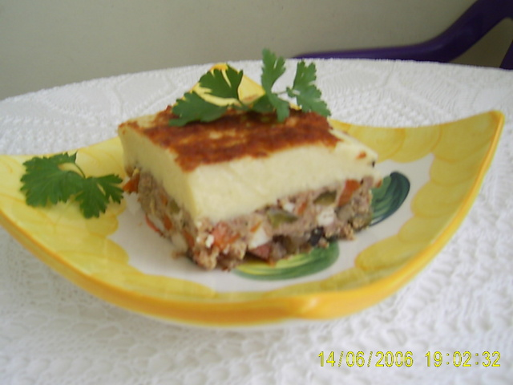

The recipe is done for you by Diana from the 7th A class.

