MY POSTAGE STAMP MESSAGE from ZADAR,CROATIA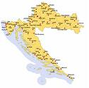


HELLO!The front of School, named after BARTUL BAŠIĆ, the great 16th century grammarian and the first translater of the Holy Bible from Latin. All around are olive plants!

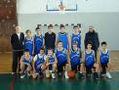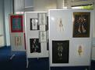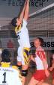

WE have 10 smaller classes (grades 1-4), 11 bigger ones(up to 14). School's staff/kids have planted many olive trees, lavaner bushes as well. Echology important, as well as sports; especially successful in handball and football, and arts. There is one central school and 4 country ones in a nearby area.(about 1000 kids attend School in two shifts: morning and afternoon))
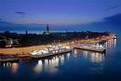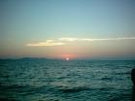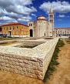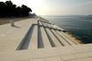
My hometown ZADAR lies on the Adriatic sea. It's famous for its sunsets, fascinating old Roman Forum in 2 000 year –old Zadar peninsula.
Its attraction are modern Sea organs and the unigue Solar ' Farewell to the Sun' project.
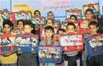
All Croatian children learn English as the first foreign language at the age of 7.Others are taught at 10(Italian and German). Our schoolbooks appreciate British English l.
WE ARE THRILLED TO SHOW our multiple beauties, cultural, traditional values- ASKING TO EXCHANGE THE BEAUTY OF MEETING DIFFERENCES WITH YOU!!!

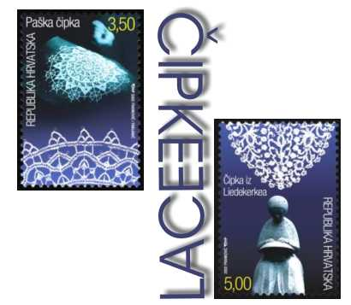

LACE-traditional Croatian BRAND ZADAR-my hometown
is marked in the middle
of the Adriatic-see the dot!

These are 4: National parks in surrounding area:
PAKLENICA
NATIONAL PARK
KORNATI National Park PLITVICE National park PAKLENICA
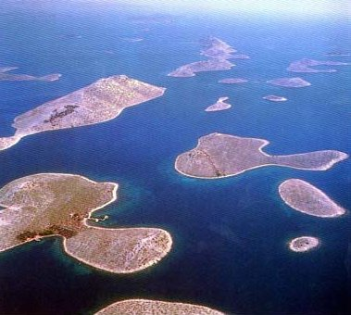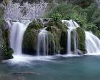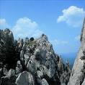

and KRKA National Park 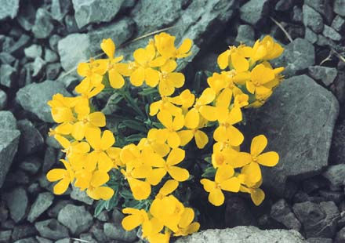

THESE FLOWERS :“VELEBIT DEGENIA “
is a protected floral species, growing
anywhere but on Velebit mountains.

