The origin of Cravat
CROATA KRAVATA (Croatian cravats - ties)

Would you like to be in the trend and in harmony with original
Croatian fashion, be sure to buy an original Croatian tie…

The cravat or tie has been a part of the Croatian national costume from ancient times, which up to recent times was preserved by Croatians who transferred it to Central Europe in the 16th century. Later it was adopted by Croatian soldiers who fought in Europe, and part of their uniform was adopted by the French in the 17th century.
Under the leadership of the French “Sun King” Louis XIV there way a cavalry unit, the so called Royal cravate, who wore mostly red ribbons around their neck. The custom of wearing ribbons from the Croata dates back to this and it spread through Europe and the world, and today it is unquestionably the most important detail of male fashion, and at the same time an original Croatian souvenir. As a work “cravat” was derived from the word “Kroate”, in Croatian, "Hrvat".
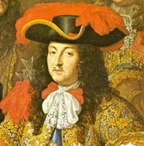French King Louis XIV, early cravat from 1667.
Croatian poet I.Gudulić, 16thcentury


