LIGHTHOUSES ON THE ADRIATIC COAST

1. 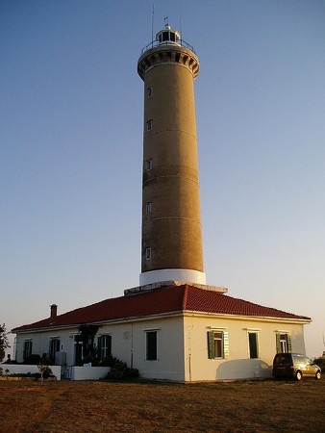 2. 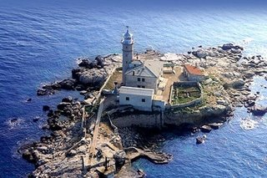 3. 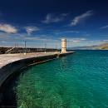

4.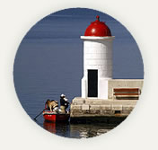 5.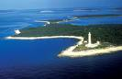 6. 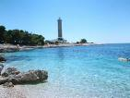 7. 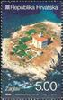 8. 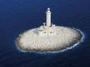

9. 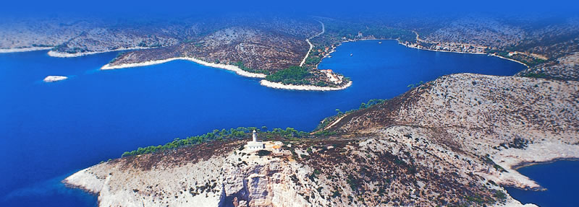
1.VELI RAT('Long Island'),2ROVINJ,3.SENJ,4.ZADAR,5.V.RAT,6. a view to V.RAT,7. ZAGLAV ,8. PORER, PULA, 9. PALAGRUZA
LIGHTHOUSES ON POSTAGE STAMPS

1. 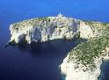 2. 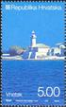 3. 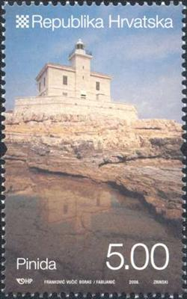 4. 5. 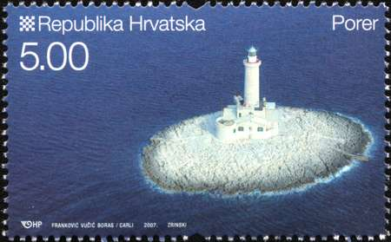

1.St John Lighthouse
2. Lastovo Lighthouse
3.Pinida Lighthouse
4.Zaglav Lighthouse
5.Porer Lighthouse

